Accessible MS Word version

Status and Insights for Seaweed in the
United States: Report from the
2023 National Seaweed Symposium

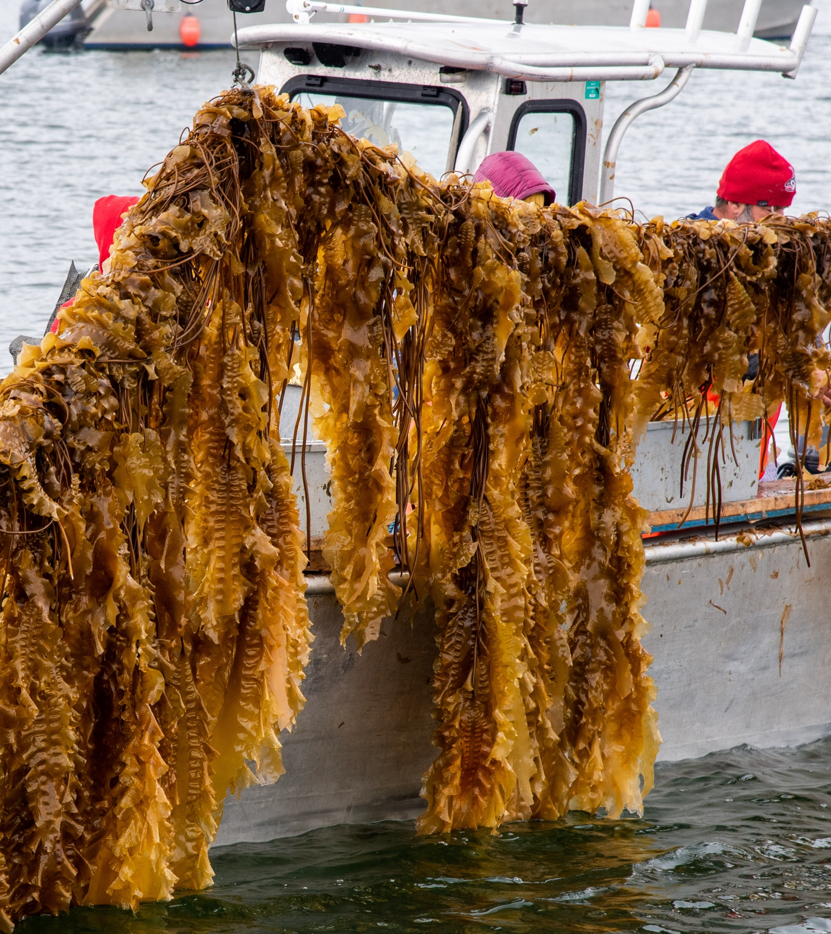
Within the past decade, the United States has seen significant developments in seaweed production, with seaweed farming becoming the country's fastest-growing aquaculture sector, according to NOAA. Interest in seaweed has been fueled by its high potential to provide environmental, economic, and social benefits, and the United States is well-positioned to tap into emerging opportunities to advance seaweed production.
To explore these opportunities and accelerate collaboration in the U.S. seaweed sector, the 2023 National Seaweed Symposium brought together over 250 leaders in seaweed research, development, and production from across the United States to Portland, Maine, from April 24-27, 2023. The event was hosted and organized by Maine Sea Grant as part of the NOAA Sea Grant National Seaweed Hub initiative.
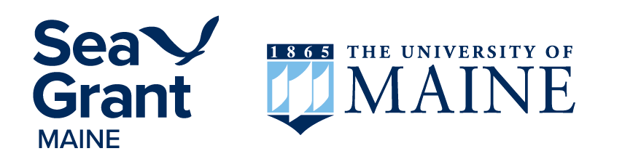

The National Seaweed Hub
The National Seaweed Hub is a collaboration of Sea Grant programs from across the United States that work to support the growing seaweed sector through the development of science-based resources and community-driven initiatives that address emerging needs and opportunities. Initially funded through the 2019 NOAA/Sea Grant Advanced Aquaculture Collaborative Program, the National Seaweed Hub is a partnership of 11 Sea Grant Programs including:
Connecticut Sea Grant (lead)
Alaska Sea Grant
California Sea Grant
Hawai’i Sea Grant
Maine Sea Grant
New Hampshire Sea Grant
New York Sea Grant
Oregon Sea Grant
Rhode Island Sea Grant
Woods Hole Sea Grant (MA)
The National Sea Grant Law Center

Credits
Citation | Robidoux, J. and A. Concepcion. 2023. Status and Priorities for Seaweed in the United States: Report of the 2023 National Seaweed Symposium.
Editors | Robidoux, J., A. Concepcion, G. Bradt
Writers | Robidoux, J.
Symposium Organizing Committee | Jaclyn Robidoux, Anoushka Concepcion, Kathy Villarreal, Bobby MacLeod, Gabriela Bradt, Angee Doerr, Amy Erhart, Annie Fagan, Parker Gassett, Dana Morse, Hannah Robbins, Natalie Springuel
Sea Grant National Seaweed Hub | Anoushka Concepcion (CT), Gabriela Bradt (NH), Michael Ciaramella (NY), Angee Doerr (OR), Melissa Good (AK), Robbie Hudson (RI), Rachel Hutchinson (WHOI - MA), Catherine Janasie (National Sea Grant Law Center), Emily Miller (CA), Jaclyn Robidoux (ME), Stephanie Showalter Otts (National Sea Grant Law Center), Theresa Talley (CA), Barry Udelson (NY)
Seaweed Symposium Notetakers | Notes were taken by the 2023 Seaweed Symposium Organizing Committee, the National Seaweed Hub extension partners, and partners with the World Wildlife Fund-US Aquaculture Team.
Photos | Headshots provided by presenters
Symposium Sponsors
Maine Sea Grant
Acadian Sea Plants
Coastal Enterprises, Inc.
Greenwave
Maine Aquaculture Innovation Center
Maine Coast Sea Vegetables
The Maine Seaweed Council
Nautical Farms
New Hampshire Sea Grant
North American Kelp
World Wildlife Fund

Acknowledgements
This report documents the current efforts of a broad and growing community working within the seaweed sector in the United States. Among these voices are seaweed farmers, harvesters, processors, businesses, researchers, students, community leaders, tribal representatives, state and federal agencies, extension professionals, entrepreneurs, artists, support organizations, and more. Thanks to the presenters and attendees who contributed their insights and expertise during the 2023 National Seaweed Symposium, and to the extended network of partners and collaborators who support this work. Thanks also to the session note takers who did their best to characterize each session as accurately as possible.
Maine Sea Grant’s work across Maine, from the Piscataqua River to Passamaquoddy Bay, is carried out on the lands and waters of the Penobscot, Passamaquoddy, Maliseet, and Mi’kmaq, collectively known as the Wabanaki people. We thank the Wabanaki, people of the Dawn Land, for their stewardship and continued strength and resilience in protecting it. We support all efforts for healing and protecting the land and water we share.
The University of Maine is an EEO/AA employer, and does not discriminate on the grounds of race, color, religion, sex, sexual orientation, transgender status, gender expression, national origin, citizenship status, age, disability, genetic information or veteran’s status in employment, education, and all other programs and activities. The following person has been designated to handle inquiries regarding non-discrimination policies: Director of Equal Opportunity, 101 Boudreau Hall, University of Maine, Orono, ME 04469-5754, 207.581.1226, TTY 711 (Maine Relay System).

Table of Contents
The National Seaweed Hub 1
Credits 2
Acknowledgements 2
Report Introduction 4
Report Goals 4
Report Content 4
Symposium Overview 5
Symposium Goals 5
Symposium Participants 6
Highlights and Insights 8
National Updates 12
Seaweed for Culture and Community 16
Regulations: Food Safety and Permitting 19
Production Systems: Nursery Operations 27
Seaweed Farmer Panel 34
Economics and Business Planning 37
Social License: Exploring Challenges and Opportunities in Social License 40
Post-harvest and Processing 44
Market Opportunities 51
Global Production and Innovation 61
Seaweed and Climate 67
Lightning Talks 74
Resources for Farms and Businesses 75
Innovations in Technology, Gear, and Production 78
Markets and Ecosystem Services 81
Symposium Events and Activities 83
Opening Reception 83
Field Trips and Workshops 84
The Seaweed Showcase 89
Closing Seaweed Social 91
Participant Feedback and Recommendations 92

Report Introduction
With the seaweed industry as a relatively young sector in the United States, there have been limited opportunities to date that bring together the country's diverse and growing seaweed expertise to focus specifically on the domestic sector. The National Seaweed Symposium has provided the space for this needed information sharing and collaboration. This report aims to document and advance the impacts of the 2023 National Seaweed Symposium.

Report Goals
The goals of this report are to:
- Provide a recap of the symposium content and format, including summaries of all presentations and panels.
- Collect and generate priorities and insights that can inform future funding, research, investments, and initiatives.
- Organize and share current information and usable resources.
- Serve as a reference document for the status of the U.S. seaweed sector in 2023.
- Acknowledge and celebrate the progress of the sector and efforts of the community to date.
This report will be relevant to:
- Attendees of the 2023 symposium who are looking to refresh their knowledge or access information for follow-up.
- Non-attendees who are looking to follow the symposium proceedings.
- Those seeking practical, organized information and resources for seaweed in the United States.
- Decision-makers seeking to inform future efforts, research, and innovation.

Report Content
This report organizes information by topic-based sessions, summarizing all presentations and panels. Each presentation summary includes presenter bios, submitted abstracts, and resources shared, as well as information generated from notetakers, including takeaways, highlights and insights, and quotes. Panel discussions are captured in Q&A format, and these summaries are also drawn from symposium notes. Following the topic-based sessions, the report includes lightning talk summaries and information about the event activities including field trips, workshops, and networking opportunities.

Symposium Overview
During the 2023 National Seaweed Symposium, three days of targeted presentations, unique field trips, and engaging networking sessions provided attendees with usable knowledge and meaningful connections to advance innovation and collaboration in the U.S. seaweed sector. The event brought together seaweed leaders from across the U.S. including farmers, harvesters, processors, businesses, researchers, students, tribal representatives, state and federal regulators, support organizations, community leaders, and more. The symposium addressed and was organized by the priority topics identified by the National Seaweed Hub over a five-year, sector-wide effort. The event was held alongside Maine Seaweed Week, the largest seaweed food and drink festival in the United States, offering additional firsthand opportunities for attendees to experience local seaweed products and markets.

Symposium Goals
Goals of the 2023 National Seaweed Symposium were to:
- Spark innovation and collaboration within the growing U.S. seaweed sector.
- Identify emerging research and development priorities and needs.
- Highlight the broad and unique range of ongoing efforts - from research to industry to community initiatives.
- Provide a forum for information sharing, connection, and creativity, and develop professional networks for attendees.
- Expose and engage attendees in an active seaweed industry in the United States, through firsthand experiences in Maine.
- Acknowledge and celebrate successes to date, while looking toward the future.
Venue | The Westin Portland Harborview. 157 High Street, Portland, Maine
Event Webpage | 2023 National Seaweed Symposium
Agenda | 2023 National Seaweed Symposium Agenda

Session Overview

Topic-based Sessions
- National Updates
- Seaweed for Culture and Community
- Regulations (Food Safety and Permitting)
- Production Systems: Nursery Operations
- Production Systems: Seaweed Farmer Panel
- Economics and Business Planning
- Social License to Operate
- Post-harvest and Processing
- Market Opportunities
- Global Production and Innovation
- Seaweed and Climate

Lightning Talk Themes
- Resources for Farms and Businesses
- Innovations in Tech, Gear, and Production
- Markets and Ecosystem Services

Event Engagement
- Over 250 attendees
- 20 U.S. states and 5 countries represented
- 29 targeted presentations
- 6 interactive expert panels
- 16 submitted lightning talks
- 7 field trips, boat tours, and workshops

Symposium Participants
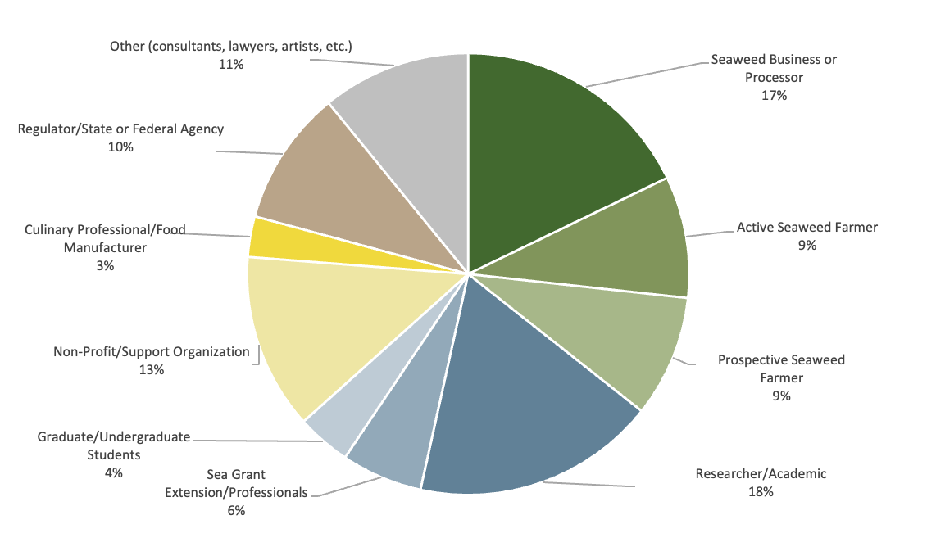

Industry (35%)
- 17% Seaweed Businesses or Processors
- 9% Active Seaweed Farmer
- 9% Prospective Seaweed Farmer

Research and Extension (28%)
- 18% Research/Academic
- 6% Sea Grant Extension/Professionals
- 4% Graduate/Undergraduate Students

Support and Community (16%)
- 13% Nonprofit/Support Organizations
- 3% Culinary Professionals/Food Manufacturers

Regulation/State and Federal Agencies (10%)

Other (11%)
- 11% Consultants, lawyers, suppliers, artists, etc.

Representatives from:
Alaska
California
Connecticut
D.C.
Delaware
Florida
Hawaii
Kansas
Maine
Maryland
Massachusetts
Mississippi
New Hampshire
New York
Oregon
Pennsylvania
Rhode Island
South Carolina
Texas
Washington
Puerto Rico
British Columbia, Canada
Nova Scotia, Canada
Quebec, Canada
Mexico
Denmark
Iceland

Highlights and Insights
A goal of the 2023 National Seaweed Symposium was to identify emerging research and development priorities and needs across the sector. The following highlights and insights are drawn from each of the expert presentations, panels, and group discussions at the symposium, and are intended to help identify and inform emerging research and development efforts. These selected highlights and insights target seaweed efforts that are applicable across the United States and are action-focused where possible. This information is organized by the topic-based sessions, where further specifics and details are recorded later in the report and can also be accessed by clicking the links below. These highlights and insights provide a snapshot of the new information and emerging opportunities generated at the national symposium.

1. National Updates
- Support of collaborative national initiatives is key to information sharing and relationship building in the growing domestic seaweed sector.
- The seaweed sector of each state is unique; state-specific conditions and factors must be considered in evaluating the future potential of seaweed farming in the United States.

2. Seaweed for Culture and Community
- Efforts to grow the seaweed sector should center community, using local resources to educate by intertwining western science and traditional ecological knowledge.
- Uplifting and utilizing the expertise of coastal communities is key to supporting the growth of a thoughtful and responsible seaweed industry.

3. Regulations
- Seaweed operations and processors can use new informational resources to better understand and navigate U.S. food safety regulations, helping seaweed reach the market as a safe and wholesome food.
- Seaweed operations and processors should be familiar with how their current and planned processing activities line up with FDA food safety regulations to ensure compliance and food safe production.
- To advance science-based information about pathogen risks in seaweed, a quantitative risk assessment will need to be conducted, and will require large-scale sampling, metadata collection, and funding support.
- New efforts are working towards the development of food safety trainings for seaweed producers to expand opportunities for current and prospective industry members to build knowledge of food safety research and regulation.
- Transparent and streamlined permitting processes and proactive outreach to communities are top priorities for regulators and industry.

4. Production Systems: Nursery Operations
- Sourcing reliable, high-quality seed continues to be a priority for the industry and new information is available to connect farmers to nurseries across the United States.
- Marshaling of appropriate resources to improve kelp gametophyte nursery culture and selective breeding has the potential to cut seed costs in half and double harvestable yields to enable competition in new and larger markets.
- Utilizing innovative substrates like artificial microstructures in nursery production may improve attachment and encapsulation and promote healthy growth of seaweed spores and seedlings to improve production yields.
- In areas of nutrient-limited tropical waters, cultivation of seaweeds may be enhanced through novel methods that supplement nutrients, like the utilization of Deep Sea Water or co-cultivation with finfish.

5. Seaweed Farmer Panel
- Seaweed farmers across the United States are deeply invested in their communities and feel strongly about regenerating the environment. Farmers are excited about the future outlook of the industry.

6. Economics and Business Planning
- Industry benchmarks provide key production metrics that are useful sector-wide, informing both established seaweed farmers looking to scale and improve farm efficiency, and new farmers interested in launching a seaweed business.
- Comprehensive and adaptive business planning tools are critical to build a robust and sustainable seaweed aquaculture industry and should be developed for and informed by industry.

7. Social License
- Social license is an essential tool for building a socially sustainable seaweed industry, to benefit both farmers and communities.
- More outreach is needed to enhance public education, ideally through coordinated, statewide efforts to build greater public understanding of aquaculture - utilizing “boots on the ground” approaches that meet communities where they are.

8. Post-harvest and Processing
- Post-harvest processing and infrastructure remains a key barrier for the seaweed industry in the United States, and tapping into new markets and opportunities will require producers to ensure their seaweed products meet market standards.
- Establishing standards for seaweed will be important to advance markets, and industry can and should lead the way in setting these standards.
- New and innovative seaweed products can move the needle on market demand and expand the impact to seaweed farming communities and the planet.
- As a link between farmers and end-consumers, seaweed processors drive product innovation and market development, and are investing in the infrastructure necessary to support and grow the industry.

9. Market Opportunities
- Market growth and development for seaweed remains necessary to realize industry potential in the United States and is supported though consumer-focused outreach and marketing efforts.
- Intentions to purchase seaweed products differ between current consumers and non-consumers and distributors and retailers should consider these differences in developing targeted market strategies to increase sales.
- Research and development that optimizes the nursery and ocean cultivation stages of seaweed aquaculture may reduce farm-gate production costs and address economies of scale, opening up new market channels for growers.
- Understanding global seaweed markets will help producers, investors, regulators, and researchers identify future opportunities and inform the development of the sector in the United States.
- Across the United States, successful marketing strategies have built awareness and excitement for seaweed by telling the seaweed story, from coastal communities to women in leadership to climate-friendly products.

10. Global Production and Innovation
- Cooperative, international networks can help the U.S. sector engage in and align with global seaweed policy discussions and development efforts.
- On-the-ground methodology and research that’s focused on seaweed production is critical to building a comprehensive understanding of seaweed farming within and across species and countries.
- In the EU, the Food Authority looks to the industry to make guidelines for best practices, a process which the United States can observe and learn from.

11. Seaweed and Climate
- Directed by Congress, an interagency effort is identifying and documenting gaps in research related to the capacity for seaweeds and seagrasses to deacidify the oceans and opportunities to use farmed seaweeds and seagrasses as feedstock.
- Given the decline in abundance of kelp, documentation and a better understanding of the genetic diversity of kelp are needed to inform science-based decisions for natural kelp beds and aquaculture farms.
- For seaweed farms to meaningfully contribute to carbon sequestration and tap into emergent carbon markets, the impacts, ethics, and societal benefits of the end-use and sequestration method must be considered.
- Cultivation of seaweed is a promising strategy for mitigating local acidification, and co-cultivation alongside shellfish expands this impact, improving shellfish health and bringing additional benefits to farmers.
- By efficiently capturing anthropogenic inorganic nitrogen, kelp may be an asset for nutrient credit programs, though the conditions of this nutrient capture need to be further explored.
- Development of seaweed feed additives to reduce methane emissions has potential global impacts on greenhouse gas reduction while also linking local sustainable aquaculture to sustainable agriculture.

Topic-Based Sessions
Eleven sessions during the National Seaweed Symposium were organized according to key priority areas for the U.S. seaweed sector, identified through the coordinated efforts of the National Seaweed Hub over the past five years. Within these topic-based sessions, this report includes details about each of the 35 targeted presentations and expert panel discussions, including presenters, key takeaways, resources shared, and insights applicable across the U.S. sector.

Sessions Included
- National Updates
- Seaweed for Culture and Community
- Regulations (Food Safety and Permitting)
- Production Systems: Nursery Operations
- On-Farm Production: Seaweed Farmer Panel
- Economics and Business Planning
- Social License to Operate
- Post-harvest and Processing
- Market Opportunities
- Global Production and Innovation
- Seaweed and Climate

National Updates
Over the last five years, the U.S. seaweed sector has seen significant developments in production, supply chains, research, technology, and more. In this session, Sea Grant Extension professionals welcomed conference attendees, provided information about the National Seaweed Hub, and discussed the current state of the seaweed sector across the United States.

In this session
- Collaborative national efforts and events help advance seaweed in the United States.
- A snapshot of the status of eleven U.S. states currently producing seaweed.

Presentations
- Updates from the National Seaweed Hub | Anoushka Concepcion, Connecticut Sea Grant.
- 2023 State of the States: Status of U.S. Seaweed Aquaculture | Jaclyn Robidoux, Maine Sea Grant, and Melissa Good, Alaska Sea Grant.

Updates from the National Seaweed Hub

Presenter: Anoushka Concepcion
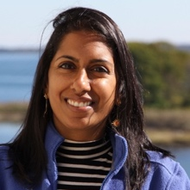Associate Extension Educator, Connecticut Sea Grant. Anoushka’s programming focuses on supporting aquaculture stakeholders in Connecticut, including the seaweed industry, regulators, and the public. In addition to developing resources that focus on seaweed food safety, market development, and permitting, Anoushka provides one-on-one support to farmers, conducts research, and organizes workshops for the industry and public.

Key Takeaways
- Established in 2019 by the National Sea Grant Program, the National Seaweed Hub is a collaboration of 11 Sea Grant programs that works across the United States to support the growing seaweed sector.
- Through the development of science-based resources and multi sector-driven initiatives, the activities of the National Seaweed Hub respond to emerging needs and opportunities.
- Examples of resources developed to address emerging needs include a state by state report of U.S. seaweed production, the National Seaweed Nursery Directory, the Seaweed Parameter Testing Resources Report, the digital Seaweed Marketing Toolkit, and a regulatory reference guide for seaweed food safety. These publicly accessible resources are available on the National Seaweed Hub website.
- Since 2023, activities of the National Seaweed Hub have included supporting the 2023 National Seaweed Symposium, virtual sector meetups, high-priority topic-based webinars, and the continued development of publicly accessible resources.
- The National Seaweed Hub has engaged hundreds of seaweed farmers, businesses, regulators, researchers, and community leaders across the United States, fostering long-term relationships and collaboration and producing key resources that advance the U.S. seaweed sector.

Highlights and Insights
Support of collaborative national initiatives is key to information sharing and relationship building in the growing domestic seaweed sector.

Resources Shared
The National Seaweed Hub
“The goal of the National Seaweed Hub is to get a better understanding of the needs of the industry and figure out the next steps.”
— Anoushka Concepcion

2023 State of the States: Status of U.S. Seaweed Aquaculture

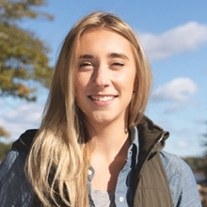Presenter: Jaclyn Robidoux
Marine Extension Associate, Maine Sea Grant. As Maine Sea Grant’s seaweed extension specialist, Jaclyn focuses on the development of Maine’s seaweed sector, including on-farm technical support, farmer training programs, and exploring new infrastructure and market opportunities. Jaclyn works directly with seaweed businesses, regulators, researchers, and folks on the water to develop new solutions for seaweed aquaculture in the United States.

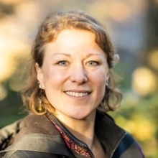Presenter: Melissa Good
Mariculture Specialist, Alaska Sea Grant. Melissa works actively with industry, Alaska Native Tribes and corporations, seafood processors, regulators, community members, and leaders to support sustainable marine aquaculture in Alaska. Her recent work has involved connecting consumers to locally grown oysters and seaweed products, developing educational materials, and a global market assessment of technologies for primary processing and manufacturing of seaweed.

Key Takeaways
- The State of the States is an annually updated report of seaweed production in the United States., which includes the number of farms, landings, regulatory authorities, primary markets, and key facts for all seaweed-producing states. This data is compiled by Sea Grant extension specialists in Alaska, California, Connecticut, Hawai’i, Maine, New Hampshire, New York, Oregon, Rhode Island, Washington, and Massachusetts (Woods Hole).
- Seaweed farming in the United States is a young industry that has emerged over the last decade, with production primarily occurring in the Northeast and Northwest. Specifically, Maine and Alaska have seen significant developments, with seaweed landings approaching or exceeding 1,000,000 pounds per year.
- Most U.S. seaweed operations are early stage with limited, seasonal production, and are closely linked to, or reliant on, preexisting working waterfront and fisheries infrastructure.
- The number and size of active farms, landings, regulations, processors, and primary markets vary significantly from state to state (refer to table below for more information).
- The current primary market for seaweed produced in the United States is food and food products, and market demand has been driven by processors that create, market, and sell value-added seaweed products.

Region | East Coast |  |  |  |  |  | West Coast
State | ME | NH | MA | RI | CT | NY | AK | WA | OR | CA | HI
Landings, wet pounds | 1,000,000+  (2022) | N/A | 9,500 (2023) | 14,500 (2023) | 3,800 (2023) | N/A | 871,000+  (2023) | 10,000 (2023) | N/A | N/A | 250,000+ (2023)
Landings, wet MT | 454+ | N/A | 4.3 | 6.6 | 1.7 | N/A | 395+ | 4.5 | N/A | N/A | 113+
Number of ocean farms and use | 40+ active commercial farms (100+ permitted sites) | 5 (2 active, 2 research) | 5  commercial  farms | 10 farms  (3 active) | 15 farms (10 active in 2023) | 1 permitted farm as of 2023 | 50 permitted farm sites (30 active) | 3 farms (ocean and land-based farms) | 3 land-based farms | 4 farms (ocean and land-based farms) | 7 farms  (all tank cultivation)
Source: National Sea Grant Seaweed Hub State of the State Report, 2023

Highlights and Insights
The seaweed sector of each state is unique; state-specific conditions and factors must be considered in evaluating the future potential of seaweed farming in the United States.

Resources Shared
State of the States: Status of U.S. Seaweed Aquaculture Presentation
“The U.S. seaweed industry is projected to grow alongside significant investments in research and development.”
— Jaclyn Robidoux

Seaweed for Culture and Community
The symposium’s keynote address focused on seaweed’s role in our culture and communities, highlighting the knowledge and leadership of tribal communities and women in the seaweed space, and the importance of seaweed for all people.

Keynote Speakers
- Keolani Booth, Tribal Councilman, Metlakatla Indian Community
- Briana Warner, CEO, Atlantic Sea Farms

Keynote: Seaweed for Health, Culture, and Community

Presenter: Keolani Booth
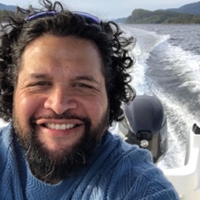Tribal Councilman, Metlakatla Indian Community. Keolani is a Tribal Councilman at the Metlakatla Indian Community. Located on Annette Islands, the Metlakatla Indian Community is the only Indian Reserve in the state of Alaska. Keolani has been proactive in representing Metlakatla in climate and mariculture initiatives, which he hopes will create jobs in ocean farming for Metlakatla and its people, who are deeply connected to the water through culture and tradition. Keolani is also active in energy, broadband, and infrastructure initiatives, which he hopes will build a vibrant, sustainable future for the people of Metlakatla.

Key Takeaways
- Metlakatla is a federally recognized Tribe on Annette Island Reserve in Southeast Alaska, with about 1,500 residents. Tribal control of the island and marine resources, as well as existing infrastructure, such as a deep-sea port and cargo runway, position Metlakatla to engage in new mariculture research and development.
- The spring seaweed harvest is a community event, where knowledge of the health benefits and importance of seaweed is passed down through generations. Seaweed was traditionally traded with other tribes of the Pacific Northwest, with trade routes extending down to California.
- Black seaweed (la’axsk) is harvested in late April or early May in remote areas, sometimes requiring overnight travel by boat to access. Harvested black seaweed is dried outside and in ovens or dehydrators, often shaped into square sections based on the traditional practice of storing black seaweed in bentwood boxes.
- The tribe also relies on the kelp (gyoos) beds which provide breeding grounds for herring, collecting herring eggs as a source of food for the community. During the collection and distribution of herring eggs on kelp, community volunteers go to great lengths to ensure a fair and equitable process, with the sick and elderly served first. This practice faces challenges including the decline of herring populations and the significant cost of acquiring the eggs.
- Common foods prepared with seaweed include seaweed and salmon eggs over rice, seaweed ChexTM mix adaptation, herring eggs on kelp blanched with soy sauce, and nutrient-rich bowls of smoked salmon, seaweed over rice, and herring eggs.
- The Metlakatla seaweed farm site consists of a 400ft grow line and supports the Metlakatla High School marine biology students, who receive an introduction to careers in mariculture, preparing them for direct workforce placement.
- There are ongoing efforts to establish the cultivation of black seaweed (Pyropia abbotiae) in partnership with the Southeast Sustainable Partnership. As natural black seaweed beds face declining abundance and have become more difficult to access, establishing cultivation of this important species is a high priority for the tribe.

Highlights and Insights
Efforts to grow the seaweed sector should center community, using local resources to educate by intertwining Western science and traditional ecological knowledge.
“The love and importance of seaweed for health and healing in
Metlakatla culture is in our artwork, songs, and dances.”
— Keolani Booth

Keynote: Seaweed for Culture and Community

Presenter: Briana Warner
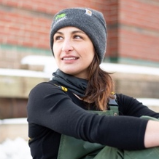CEO, Atlantic Sea Farms. Bri has dedicated her life to doing well by doing good. As the CEO of Atlantic Sea Farms, she and her team have forged a new path for seaweed aquaculture in the U.S. by working with fishermen to grow kelp as a climate change adaptation strategy–- and building national demand for that kelp. The ASF team and partner farmers are proving that a model that puts farmers, planet, and people first can drive an entirely new way of producing food. Bri is passionate about her incredible home state of Maine and working with partner farmers to create a more resilient and thriving coast.
Key Takeaways
- Atlantic Sea Farms is a women-run, vertically integrated seaweed aquaculture company working directly with partner farmers (commercial fishermen) in Maine to produce fresh, ready-to-eat kelp products for consumers across the United States.
- In Maine, kelp farming is diversifying the incomes of fishermen and fishing communities, which have become increasingly reliant on the lobster fishery. Growing and harvesting kelp provides jobs and supplements income for these fishermen in their winter off-season.
- Maine has a long history and expertise in harvesting and producing seaweed and seaweed products. In the 1970s locals in Maine brought seaweed to markets, packaging it as sea vegetables, and many of these early pioneers and companies are still active and continue to guide the industry.
- With growing attention on seaweed, it’s important to acknowledge and be realistic about both its benefits and limitations. While seaweed is not the answer to climate change, it is a second chance to do better and represents a sense of hope and redemption.
- One of the challenges facing kelp farmers is community misconceptions of aquaculture. Overcoming this will require work and engagement with coastal landowners to continue developing social license for aquaculture.
- Sustainable growth for this industry will require permitting farms to responsible, qualified farmers; thoughtful and strategic investment that does not expect huge returns quickly; communication that does not overblow or overpromise what seaweed is; outreach and dialogue with our coastal communities; and empowering existing fishing industries to be part of the growing kelp industry.

Highlights and Insights
Uplifting and utilizing the expertise of coastal communities is key to supporting the growth of a thoughtful and responsible seaweed industry.
“Seaweed is not the answer to climate change and it’s not going to save the world, but it is an opportunity for us to do better.
Specifically, it’s an opportunity to regenerate the planet by producing food and to diversify the incomes of coastal fisheries.”
— Briana Warner

Regulations: Food Safety and Permitting
This session addressed national priorities related to regulations, including permitting and food safety. The session included invited presentations focused on food safety and ended with a panel of federal and industry experts focused on permitting.

In this session
- New food safety and permitting resources help inform current and future businesses.
- What we know vs. what we need to know when it comes to food pathogens and seaweed.
- Experts discussed the connection between regulations and industry scale.

Presentations
- The National Seaweed Hub Regulations Workgroup | Cathy Janasie, National Sea Grant Law Center
- FSMA Preventive Controls for Human Foods, With Emphasis on Seaweed | Manny Hignutt, US FDA
- Current understanding of domestic kelp safety and continuing research gaps | Jennifer Perry, University of Maine
- Seaweed Food Safety Regulation Resources and Trainings Update | Mike Ciaramella, New York Sea Grant

Permitting and Regulations Panel
- Sebastian Belle, Executive Director, Maine Aquaculture Association
- Alicia Bishop, Aquaculture Coordinator, Alaska Regional Office, NOAA Fisheries
- Kevin Madley, Aquaculture Coordinator, Greater Atlantic Region, NOAA Fisheries

The National Seaweed Hub Regulations Workgroup

Presenter: Cathy Janasie
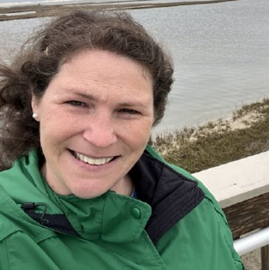Senior Research Council, National Sea Grant Law Center. Cathy’s research focuses on water quantity and quality issues as well as on the regulation of seaweed as a food source and offshore aquaculture. As a Law School Faculty member, Cathy teaches Environmental Law, Natural Resources Law, Agricultural Law, Land Planning and Water Law.

Abstract
Since 2020, the National Sea Grant Seaweed Hub Regulations Workgroup has engaged state and federal regulators, researchers, industry, and extension to collaboratively identify challenges and opportunities related to regulations. Among these, food safety and permitting, including navigating state/federal jurisdictions, and permitting for selected strains were highlighted as priorities.

Key Takeaways
- Since 2020, the Seaweed Hub Regulations Workgroup has collaboratively identified and documented over 30 challenges and opportunities related to regulations. The group prioritized three of these topics for future discussions: multiple jurisdictions/permitting efficiencies for lease sites, food safety hazards, and markets and processing facilities - and focused collaborative project efforts on food safety hazards.
- Facilitated by the National Sea Grant Law Center, the workgroup developed an interactive, comparison document for Hazard Analysis Critical Control Points (HACCP) and Preventative Controls for Human Foods (PCHF). This resource includes an overview of the Food Safety Modernization Act (FSMA), Qualified Facilities and Farm examples, the comparison of HACCP to PCHF, and a checklist for transitioning from HACCP to PCHF.
- The National Sea Grant Law Center has also conducted a seaweed food hazard literature review, which compiles and indexes the primary, peer-reviewed literature related to seaweed food safety hazards to increase accessibility for policymakers.

Highlights and Insights
Seaweed operations and processors can use new resources to better understand and navigate U.S. food safety regulations, helping seaweed reach the market as a safe and wholesome food.

Resources Shared
- Regulatory Reference Guide on Seaweed Food Safety
- Seaweed Food Safety Peer-Review Literature Database
Seaweed Hub Regulations Workgroup Information

Food Safety Modernization Act (FSMA) Preventive Controls for Human Foods, with Emphasis on Seaweed

Presenter: Manny Hignutt
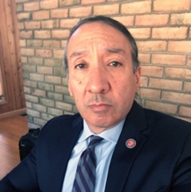Office of Food Safety, Center for Food Safety and Applied Nutrition, FDA. As a Subject Matter Expert with the U.S. FDA, Manny focuses on policy development related to chemical contaminants in seafood and seaweed. Manny earned a Bachelor of Arts in Chemistry from the University of California, Davis, and a Master of Public Health from the University of North Carolina, Chapel Hill.
Abstract
Seaweed establishments that meet the definition of a “facility” in subpart A of 21 CFR Part 117 are regulated under the Preventive Controls for Human Foods role, 21 CFR Part 117 A. A “facility,” as defined by subpart A, is engaged in the manufacturing/processing, packing, or holding of food for consumption in the United States. Farms, as defined in 21 CFR Part 1.227, are not required to register with the FDA and are exempt from 21 CFR Part 117. In addition, very small businesses are qualified facilities exempt from requirements for hazard analysis and risk-based preventive controls but have some modified requirements.

Key Takeaways
- The FDA classifies seaweed as a raw agricultural commodity (RAC) and does not currently consider seaweed to be either produce, under the Produce Safety Rule (PSR), or seafood, under Seafood HACCP.
- The FDA defines a farm as “an operation devoted to the growing of crops, harvesting and raising of animals (including seafood), or any combination of these activities.” According to the FDA, most seaweed farms are not required to register with the FDA and, without registering, may conduct manufacturing/processing activities that fall under the farm definition (e.g., washing, trimming, drying/dehydrating, packaging, labeling).
- Seaweed processing operations (including farms engaged in further value-added processing) may or may not be exempt from FDA’s requirements for hazard analysis and risk-based preventive controls, but are still subject to FSMA, required of all food facilities and operations.
- Seaweed processing operations that meet the definition of a “Qualified Facility” are exempt from certain PCHF requirements. The Qualified Facility exemption is for very small businesses and is based on the monetary value of human food sold by the operation.

Highlights and Insights
Seaweed operations and processors should be familiar with how their current and planned processing activities line up with FDA food safety regulations to ensure compliance and food safe production.

Resources Shared
FSMA Technical Assistance Network (TAN)

Current understanding of domestic kelp safety and continuing research gaps

Presenter: Jennifer Perry
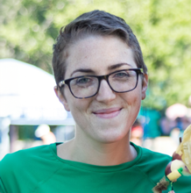
Associate Professor of Food Microbiology, University of Maine. Jennifer Perry is the Associate Professor of Food Microbiology at the University of Maine School of Food and Agriculture. Research conducted by Dr. Perry’s lab group focuses on microbial safety of fresh and minimally processed foods, as well as food fermentation.

Abstract
Multiple reports have now demonstrated the potential for kelps to harbor foodborne pathogens. Previous research has provided significant advancements in our understanding of the behavior of pathogens on kelp and the extent to which processing may mitigate risks. Despite the progress made in recent years, considerable uncertainty with regards to a number of aspects of food safety still exists. The state of this work, ongoing research, as well as critical gaps in knowledge, were summarized.

Key Takeaways
- Microbial pathogens may occur during pre- and post-harvest activities, and vary based on species, handling, processing, and storage methods. As such, seaweed operations can work to minimize contamination and reduce pathogen levels through processing.
- Handling and storage before and after processing also must be considered. The final product may not resist microbial pathogens, which can survive during storage.
- Recent research has looked at the effect of different processing methods on the pathogen loads of sugar kelp - specifically freezing, blanching, drying, fermentation, and salting. Processing methods that worked well to reduce microbial pathogens are fermentation, blanching, and drying (although effectiveness of drying varied by pathogen). Methods that are less effective are salting (resulting in long survival of pathogens) and freezing (results show this was not antimicrobial).
- It’s challenging to determine an acceptable level of microbial contamination and baselines on a new food product like seaweed. To move from possibility to probability when it comes to microbial hazards, we need to know: What factors make it likely that pathogens will be found? What levels of pathogens do we expect to find? And which processes are sufficient to ensure safety? Large-scale sampling with quantitative analysis and metadata collection will be needed to assemble a risk assessment that can inform these questions.

Highlights and Insights
To advance science-based information about pathogen risks in seaweed, a quantitative risk assessment will need to be conducted, and will require large-scale sampling, metadata collection, and funding support.
“It’s challenging to determine baselines on a new
food product, like seaweed. Anything you can do to make products safer is better.” — Jennifer Perry

Resources Shared
- Akomea-Frempong, S., Perry, J.J. & Skonberg, D.I. Effects of pre-freezing blanching procedures on the physicochemical properties and microbial quality of frozen sugar kelp. J Appl Phycol 34, 609–624 (2022). https://doi.org/10.1007/s10811-021-02610-0​
- Akomea-Frempong, S., Skonberg, D.I., Arya, R., and Perry, J.J. Survival of Inoculated Vibrio spp., Shigatoxigenic Escherichia coli, Listeria monocytogenes, and Salmonella spp. on Seaweed (Sugar Kelp) During Storage. J. Food Protection (2023). https://doi.org/10.1016/j.jfp.2023.100096
- Akomea-Frempong, S., Skonberg, D.I., Camire, M.E., and Perry, J.J. Impact of Blanching, Freezing, and Fermentation on Physicochemical, Microbial, and Sensory Quality of Sugar Kelp (Saccharina latissima). Foods 10, 2258 (2021). https://doi.org/10.3390/foods10102258
- Barberi, O.N., Byron, C.J., Burkholder, K.M. et al. Assessment of bacterial pathogens on edible macroalgae in coastal waters. J Appl Phycol 32, 683–696 (2020). https://doi.org/10.1007/s10811-019-01993-5
Vorse, J.G., Moody, C.T., Massoia, L.C. et al. Effect of post-harvest processing methods on the microbial safety of edible seaweed. J Appl Phycol (2023).

- https://doi.org/10.1007/s10811-023-02937-w

Seaweed Food Safety Regulation Resources and
Trainings Update

Presenter: Mike Ciaramella
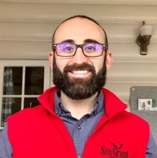Seafood Safety & Technology Specialist, New York Sea Grant. Mike is the Seafood Safety and Technology Specialist with New York Sea Grant and Cornell Cooperative Extension. For over seven years, he’s managed the online seafood HACCP training program and regularly conducts seafood safety trainings to support safe seafood.

Abstract
This presentation provides a brief update on the National Seaweed Food Safety Training Workgroup efforts. Seaweed food safety resources that are currently available, those in development, and additional proposed resources will be shared or introduced to participants.

Key Takeaways
- Since 2022, New York Sea Grant, in collaboration with Connecticut Sea Grant and the National Sea Grant Law Center, has coordinated a group of national and international food safety professionals to discuss seaweed food safety and regulations, with the goal of providing clarity and guidance on how to bring seaweed safely and effectively to market as food.
- The workgroup priorities are clarity on regulatory structure, seaweed food safety hazards and controls, and seaweed food safety training programs.
- In 2023 the workgroup began drafting a Seaweed Hazards and Controls Guide which will outline: species specific hazards; process related hazards; biological, chemical, physical radiological hazards; commercially relevant species; and general controls. Additional authors and reviewers for this work are wanted.

Highlights and Insights
New efforts are working towards the development of food safety trainings for seaweed producers to expand opportunities for current and prospective industry members to build knowledge of food safety research and regulation.
“We hope to provide clarity and guidance on how to safely and effectively bring seaweed to market as food.”
— Mike Ciaramella

Permitting and Regulations Panel
This panel focused on federal and state permitting resources, industry perspectives, and current permitting considerations for the sector, with experts from NOAA and the Maine Aquaculture Association.

Panelist: Kevin Madley
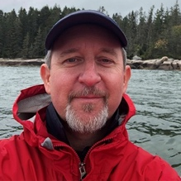Aquaculture Coordinator, Greater Atlantic Region, NOAA Fisheries. Kevin works with state and federal agencies, industry, and members of the scientific, academic, and NGO communities on marine aquaculture issues. He has over 15 years of federal policy and regulatory experience. Kevin previously worked as a biologist and for consulting companies, providing marine habitat mapping, GIS services, in-water site assessments, and regulatory assistance to businesses and property owners.

Panelist: Alicia Bishop
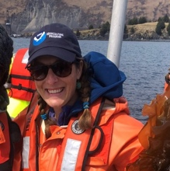Aquaculture Coordinator, Alaska Regional Office, NOAA Fisheries. Ms. Bishop has over 11 years of federal regulatory experience with NOAA Fisheries. Previously, she worked as the Endangered Species Act Section 7 Coordinator for the Alaska Regional Office, ensuring consistency among consultations, improving consultation efficiencies, standardizing migration measures, and partnering with stakeholders to find creative approaches to endangered species conservation.

Panelist: Sebastian Belle
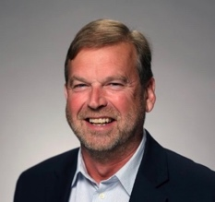Executive Director, Maine Aquaculture Association. A longtime leader in aquaculture, Sebastian has dedicated his career to demonstrating global leadership in aquaculture and advocating for sustainable working waterfronts. He started his career as a commercial fisherman and went on to work in aquaculture, establishing and managing farms all over the world before coming back to Maine to advocate for and serve Maine’s aquatic farmers.

Panel Facilitator: Mike Ciaramella, New York Sea Grant

Panel Introduction
The panel began with an introduction of the speakers, including presentations from NOAA experts on new resources and remarks about the sector from the Maine Aquaculture Association.
- Alongside the Alaska Aquaculture Interagency Working Group, NOAA Fisheries reviewed existing permitting guides and developed the online Alaska Aquaculture Permitting Portal and PDF to respond to stakeholder needs for a central clearinghouse for permitting and regulatory information. The portal outlines the necessary steps to receive state and federal authorizations for a farm, including a flow chart that demonstrates the multiple levels of authorization and specific agencies.
- At the national level, NOAA Fisheries has developed a Guide to Permitting Marine Aquaculture in the United States, which provides an overview for individuals navigating the federal permitting process for marine aquaculture including finfish, shellfish, invertebrates, and seaweed. NOAA Fisheries has also developed a State by State Summary of Seaweed Aquaculture Leasing/Permitting Requirements (2021) which outlines seaweed leasing/permitting information by state.
- Based on decades of experience, the Maine Aquaculture Association commented on regulations, scale, and the importance of economically viable businesses for the seaweed sector. The industry association advised that rules and regulations need to be based on accurate information about risks and that permitting processes need to be predictable. The association urged caution around constructing rules that create barriers for small businesses and may inadvertently select for larger companies, as scale will be an important factor in the near future. Finally, the association highlighted the need for economically viable businesses for long term success of the sector and caution around large investments/funding for non-commercial products.

Discussion
The panel discussion focused on permitting in federal waters, available funding, and emerging considerations for farms (seed regulations, prospective markets, training opportunities). Below are questions posed to the panelists along with their general responses.
Can industry support dialogues between state and federal agencies for applications in federal waters?
In federal waters, states don’t have authority, so the NOAA Regional Aquaculture Coordinators role is to coordinate this permitting process. Formally, the Coastal Zone Management Act allows states to be involved. Informally, NOAA participates in interagency meetings with federal and state agencies and encourages industry to take on outreach and communication roles.
What are the current sources of large streams of funding for the industry?
Both government and private/non-profit funding are available to support sector development. As funding increases, it’s important that funding is going toward long-term, economically viable businesses that will not collapse after the funding ends.
What is being done to make sure the rules and regulations around seed sourcing are based on science?
In Alaska, where seed sourcing regulations (including restrictions) exist, the state is seeking funding to look at the necessity of these regulations.
Can a seaweed operation have a license to sink seaweed for carbon sequestration?
It is not clear whether you need a license to sink seaweed. If considered ocean dumping/discharge, EPA would be the agency with authority for sinking seaweed but would not be involved in farm permitting itself. However, carbon sequestration claims need to be based on good, robust science and this doesn’t exist yet - as such, the industry should be careful not to overpromise the benefits of seaweed sinking.
Are there training opportunities for those that are underserved to assist them through the permitting process?
Training activities are largely being spearheaded by Sea Grant at varying levels. State Sea Grant extension may be able to point to upcoming opportunities.
Are federal agencies prepared to permit aquaculture alongside offshore wind?
The Bureau of Ocean Energy Management (BOEM) would have the authority to permit aquaculture farms in offshore wind leases, and NOAA would be a consulting agency. In discussing the current offshore wind permitting processes, the aquaculture industry expressed concerns that the commercial fishing community has not been able to get much input into these permitting discussions.

Highlights and Insights
Transparent and streamlined permitting processes and proactive outreach to communities are top priorities for regulators and industry.

Resources Shared
- Alaska Aquaculture Permitting Portal and PDF
- NOAA Fisheries Guide to Permitting Marine Aquaculture in the United States (2022)
- State by State Summary of Seaweed Aquaculture Leasing/Permitting Requirements (2021)
- NOAA Regional Aquaculture Coordinators

Production Systems: Nursery Operations
This session featured presentations from experts and industry on nursery innovations, new seed string technology, and alternative species for cultivation and commercialization.

In this session
- Selective breeding trials show significant improvements in harvest yield.
- Seeding technology highlight: Substrates inspired by nature.
- Lessons learned and innovative approaches to cultivating tropical seaweeds.

Presentations
- The National Seaweed Hub Production Systems Workgroup | Anoushka Concepcion, Connecticut Sea Grant
- Selectively breeding high-yield and “seedless” sugar kelp (S. latissima) | Scott Lindell, Woods Hole Oceanographic Institution
- Improvements in seaweed cultivation and growth through unique microstructure substrates - an approach inspired by nature | Norman Clough, W.L. Gore & Associates
- Tropical macroalgae cultivation in Hawai’i - prospects and challenges | Simona Augyte, Ocean Era, Inc.

The National Seaweed Hub Production Systems Workgroup

Presenter: Anoushka Concepcion
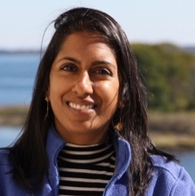Associate Extension Educator, Connecticut Sea Grant. Anoushka’s programming focuses on supporting aquaculture stakeholders in Connecticut, including the seaweed industry, regulators, and the public. In addition to developing resources that focus on seaweed food safety, market development, and permitting, Anoushka provides one-on-one support to farmers, conducts research, and organizes workshops for the industry and public.

Abstract
The National Seaweed Hub Production Systems Workgroup focuses on challenges, opportunities, and recommendations across the U.S. seaweed supply chain, including accessible and reliable seed, guidance for site selection and farm design, improved efficiency in gear and operations, and best management practices for farms.

Key Takeaways
- Since 2020, The National Seaweed Hub Production Systems Workgroup engaged industry, researchers, support organizations, extension, and state and federal regulators to collaboratively identify over 30 challenges and opportunities related to seaweed production systems.
- Of these, the top three topics identified as priorities included improving seed stock supply, improving guidance for site selection/farm design, and improving efficiency of gear and operations. After generating research and development ideas for each, the workgroup focused later efforts on the priority to improve seed stock supply.
- The workgroup created an opt-in National Seaweed Nursery Directory, hosted publicly on the National Seaweed Hub website, to help address the priority of improving seed stock supply. This directory is organized by state and includes species produced, ordering and shipping information, and key details about each of the nursery operations listed.

Highlights and Insights
Sourcing reliable, high-quality seed continues to be a priority for the industry and new information is available to connect farmers to nurseries across the United States.

Resources Shared
- National Seaweed Nursery Directory
- Seaweed Hub Production Systems Workgroup Page

Selectively breeding high-yield and “seedless” sugar
kelp (S. latissima)

Presenter: Scott Lindell
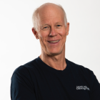Research Specialist, Woods Hole Oceanographic Institution. Scott leads an R&D program at WHOI that takes a multi-disciplinary approach to practical ocean farming challenges that require cooperation between commercial and academic partners. Current projects include demonstrations for farming sugar kelp in Alaska, tropical seaweeds in Puerto Rico, and a selective breeding program for sugar kelp in New England.

.Abstract
We are conducting a selective breeding program to improve the productivity and composition of sugar kelp, which could serve new markets for food, animal feeds, bio-products, and eventually biofuels. We have generated about a thousand monoclonal gametophyte cultures for a publicly available repository (Bigelow Labs) that can be used for generating crosses. A summary of 4 years of trait measurements for >1,000 family plots and >12,000 individual kelp blades will be presented. One highlight is that several crosses exceeded 20 kg/m harvest weight with the top plot weighing 28 kg/m or 4 kg/m dry weight - about four times the commercial average. We have sequenced the whole genome of ~500 parents, tested their crosses, and phenotype harvests to begin building a publicly available database for cooperative breeding (sugarkelpbase.org). We have also identified natural mutations on targeted genes to create non-reproductive sporophytes. Farming infertile, or “seedless” high-yield sporophytes opens opportunities for more productive farms while protecting natural genetic diversity.

Key Takeaways
- Current challenges facing kelp breeding programs include uneven control of gametophyte cultures transitioning to seedling development (i.e., asynchronous fertility and uneven density of seedlings in the hatchery) and regulatory barriers that prevent the use of selectively bred strains on farms in Maine and Alaska.
- Ongoing WHOI-led research characterizes the variation and performance of sugar kelp germplasm and uses this data to inform selective breeding. This selection process includes statistical modeling for genomic prediction and field testing selectively bred crosses, which allow for improvement of the next generation.
- Results showed that genomic selection allowed for significant improvements in harvest yield (kg/m) in 2021 and 2022. Eighteen crosses yielded over 15 kg/m (10 lb/ft wet weight), which is more than two times the current industry average for commercial farms in Maine.
- Breeding infertile “seedless” kelp involves genetically screening and crossing parents that have the same natural mutations (no GMOs) that prevent offspring from being fertile. Seedless kelp addresses regulatory concerns and commercial pathways by avoiding potential interbreeding with, and protecting, wild kelp populations, and allowing for accelerated development of improved commercial crops.
- WHOI researchers maintain publicly available comprehensive breeding tools and databases including germplasm of > 1,000 strains (at the National Center for Marine Algal at Bigelow Labs - ncma.bigelow.org), and a database for advanced kelp breeding (sugarkelpbase.org), and a Reference Genome (to be published soon).
- WHOI research is also addressing production challenges like rapid and efficient gametophyte growth, development of heat-tolerant kelp, biodegradable materials for seeding, and robotic in-water seeding to reduce seeding time and effort.

Highlights and Insights
Marshaling of appropriate resources to improve kelp gametophyte nursery culture and selective breeding has the potential to cut seed costs in half and double harvestable yields to enable competition in new and larger markets.
“By screening for and rapidly crossing natural mutations, we’re doing for kelp what we did for land-based crops hundreds of years ago.”
— Scott Lindell

Resources Shared
Publications from the ARPA-E MARINER breeding project:
- Augyte et al. 2020. The application of flow cytometry for kelp meiospore isolation. Algal Research 46, 5pp. https://doi.org/10.1016/j.algal.2020.101810​
- Huang et al. 2022. Simulation of sugar kelp (Saccharina latissima) breeding guided by practices to prioritize accelerated research gains. G3: Genes, Genomes and Genetics. https://doi.org/10.1093/g3journal/jkac003​
- Huang et al. 2023. Genomic selection for sugar kelp (Saccharina latissima) with a biphasic life cycle. Frontiers in Marine Science. https://doi.org/10.3389/fmars.2023.1040979
- Li et al. 2022. Skinny kelp (Saccharina angustissima) provides valuable genetics for the biomass improvement of farmed sugar kelp (Saccharina latissima). Journal of Applied Phycology. https://doi.org/10.1007/s10811-022-02811-1​
- Mao et al. 2020. Population genetics of sugar kelp in the Northwest Atlantic region using genome-wide markers. Frontiers in Marine Science. https://doi.org/10.3389/fmars.2020.00694​
- Umanzor et al. 2021. Comparative analysis of morphometric traits of farmed sugar kelp and skinny kelp, Saccharina spp., strains from the Northwest Atlantic. Journal of the World Aquaculture Society http://doi.org/10.1111/jwas.12783

Improvements in seaweed cultivation and growth through unique microstructure substrates — an approach inspired
by nature

Presenter: Norman Clough
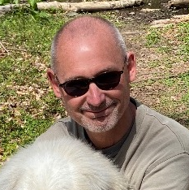Technical Leader, W.L. Gore & Associates. Norman has been at W.L. Gore for 29 years and has been involved in the successful development and commercialization of products including medical devices, dental floss, architectural fabrics, filters, fishing line, deep sea ropes and waterproof footwear. Norman holds over 30 granted patents and a PhD in Polymer Thermodynamics.

Abstract
The presentation discussed the features of a new family of cultivation substrates incorporating unique microstructures for improved growth and consistency. Species that were discussed are Saccharina, Palmaria, and Pyropia.

Key Takeaways
- Gore, a company that has developed over 5,000 inventions in fabrics, medical, and consumer products, has applied their core technology to manipulate microstructures to develop seeding substrates for seaweed.
- Inspired by the natural interaction of seaweed spores and rock surfaces, Gore is working to develop a series of tailored microstructures which can provide an optimal growth environment for sugar kelp (Saccharina latissima), dulse (Palmaria palmata), and nori (Porphyra umbilicalis) spores and seedlings.
- Trials that have utilized these microstructures versus control substrates have seen more uniform seeding density and faster, earlier growth for dulse spore seeding, and more stable spore catchment, better sporophyte attachment, and faster earlier growth in sugar kelp seeding, due to extensive holdfast incorporation into the microstructure.
- This technology has the potential to provide multiple benefits to seaweed cultivators including increasing plant/substrate attachment strength, more reliable seed germination and fertilization, greater yield, and reduced biofouling due to nurturing healthy fast-growing plants, new cultivation processes for difficult-to-cultivate species, and substrates that are designed for new species and a changing environment.

Highlights and Insights
Utilizing innovative substrates like artificial microstructures in nursery production may improve attachment, encapsulation, and promote healthy growth of seaweed spores and seedlings to improve production yields.
“Our goal is a seaweed-microstructure interaction inspired by nature.”
— Norman Clough

Tropical macroalgae cultivation in Hawai’i - prospects and challenges

Presenter: Simona Augyte
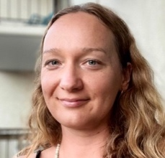Macroalgae Science Lead, Ocean Era, Inc. As the Macroalgae Science Lead at Ocean Era on Hawai’i Island, Simona oversees the pioneering tropical offshore mariculture program and the macroalgae utilization research using the microbiome of herbivorous reef fish as a model. Simona completed her PhD at the University of Connecticut with a focus on kelp genetics, ecophysiology, and aquaculture.

Abstract
The cultivation of tropical macroalgae is modestly constrained by the oligotrophic (low nutrient) nature of tropical oceanic waters. To overcome this, we conducted land-based trials where we tested different approaches to optimize growth rates, including adding nutrients from deep-sea water and using a co-culture model using fish effluent. Based on these results, the presentation discussed the potential for production and commercialization of several macroalgae, explored new markets, and identified the most cost-effective and efficient cultivation methods. Ultimately, this research has the potential to contribute to the development of sustainable and profitable aquaculture practices, addressing the increasing demand for food and other products while minimizing negative impacts on the environment.

Key Takeaways
- Ocean Era is a Hawai’i-based mariculture company, conducting research to support commercialization of open water cultivation for macroalgae in Hawai’i. At Ocean Era’s R&D facility cultivation is land-based (primarily tumble culture) and seaweed can be produced year-round due to the high amount of sunshine and deep seawater pumped to the site.
- The oligotrophic nature of most tropical oceanic waters is a significant hurdle to cultivation in these regions. Ocean Era’s research focuses on how to provide adequate nutrients and optimize growing conditions (shading, starting biomass, reduction of fouling, etc.) for tropical seaweeds, to address the cultivation challenges presented by nutrient-limited tropical waters.
- Trials tested the addition of nutrient-rich Deep Sea Water (DSW) at varied concentrations (10-20%) and co-culture using fish tank effluent to provide nutrients for the macroalgae. The addition of DSW resulted in improved yields and Specific Growth Rates, indicating the potential for commercialization in the future at offshore operations.
- Current species under cultivation include three red macroalgal species (Halymenia hawaiiana​, Grateloupia filicina​, Gracilaria parvispora)​ and two green species (Ulva lactuca, Caulerpa lentillifera​).
- In addition to production research, Ocean Era is working with local chefs, supermarkets, and culinary professionals to trial products and test post-harvest storage and drying methods.

Highlights and Insights
In areas of nutrient-limited tropical waters, cultivation of seaweeds may be enhanced through novel methods that supplement nutrients, like the utilization of Deep Sea Water or co-cultivation with finfish.

Resources Shared
California Seaweed Festival
“Limu (seaweed) is very important to Hawaiian people, both culturally and culinarily. Year of the Limu was in 2022 and was a statewide effort to raise awareness about the importance of limu to Hawai’i’s culture and environment.”
— Simona Augyte

Seaweed Farmer Panel
In this farmer-focused panel, farmers from across the United States talked about the realities of kelp farming, including farm operations, innovations, lessons learned, and opportunities for this growing industry. Panelists included kelp farmers from the East and West Coasts, representing a diversity of farming techniques, operations and scales, and experiences.

In this session
- Successes in starting small, having a plan, and building community.
- Farmers talk about finding buyers for their kelp.
- How kelp farmers are engaging the next generation.

Seaweed Farmer Panelists

Jamie Bassett, Chatham Kelp
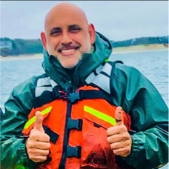Massachusetts. Chatham Kelp started in 2018 with five kelp lines in the waters off Chatham, MA. Owned and operated by Chatham fishermen Jamie Bassett, Richard Curtiss, and Carl Douglass, Chatham Kelp is one of only a few farms permitted off Cape Cod and is specifically focused on seaweed farming, with an eye towards expanding their kelp lines and operations in the future.

Donna Collins-Smith, Shinnecock Kelp Farmers
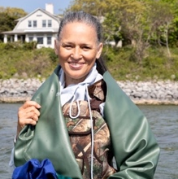New York. Donna is a Shinnecock Tribal member and a board member, hatchery tech, and farmer with the Shinnecock Kelp Famers. “My passion today is working with my sisters to clean up the waters that surround the ancestorial lands of my people. It is an honor and pure joy to be able to do my part in the cultivation of sugar kelp to help restore health and life to the shores that have fed my people for many, many generations.”

Joth Davis, Blue Dot Sea Farms
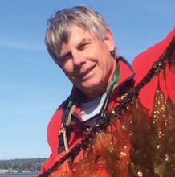Washington. Joth has been living the sea farming life for over 30 years, beginning in 1990 with the founding of Baywater Shellfish Company in Washington’s Hood Canal. These days, Joth focuses his time on climate change research, shellfish breeding, and assisting in the development of Blue Dot Sea Farms. Joth’s daily dilemma is whether to put on hip boots or don a white lab coat (an issue he hopes is never resolved).

Nick Mangini, Kodiak Island Sustainable Seaweed
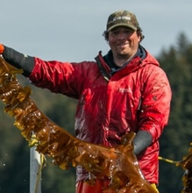Alaska. Nick Mangini is a kelp farmer from Kodiak, Alaska, who has been farming kelp since the infancy of Alaska’s budding industry. His roots of fishing and love for the ocean drove him to try to make a living in mariculture, while creating new economic opportunities for fishermen in his state. Nick’s farm, Kodiak Island Sustainable Seaweed, has housed DOE research projects using catenary arrays, and has grown both sugar and ribbon kelp.

Matt Moretti, Bangs Island Mussels
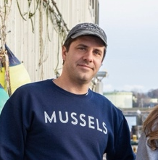Maine. Matt is a co-founder and CEO of Bangs Island Mussels, a family-owned and operated mussel and kelp farm in Maine. For over a decade, Bangs Island has been commercially farming kelp alongside shellfish as an integrated, multi-trophic farm. As a business committed to ocean stewardship and sustainability, Bangs has been an industry partner on national and international aquaculture and climate research.

Panel Facilitator: Jaclyn Robidoux, Maine Sea Grant

Discussion
Each panelist provided an introduction, a description of their background, seaweed farming operation, and where they are based. The panel discussion then focused on lessons learned, the challenges facing farmers, how kelp farmers build social license and interact with the public, navigating marketing and demand, and future outlooks. Panelists were asked questions to guide the discussion.
Over the past years in farming kelp, what are some of your biggest lessons learned?
Panelists shared many lessons in common including the importance of starting small, having a plan, and engaging in the community. For starting small, panelists highlighted how kelp farming is a constant learning experience and things do not always go as you expect (permitting timelines, farm design, seed and grow out, etc.). Panelists emphasized that economics can be a big risk in starting a farm and having a well-thought-out plan through the final point of sale can minimize this. Finally, panelists all agreed that getting their communities onboard was extremely important and recognized that, for some communities, seaweed holds cultural importance as a way of life.
What challenges are kelp farmers currently facing?
Panelists highlighted permitting, opposition to aquaculture, and finding buyers as current challenges. For permitting, panelists discussed the amount of time it takes to initially lease or expand a farm site (can take multiple years), and the costs involved. Many panelists discussed how opposition to aquaculture and misinformation about farming practices may lead to pushback from community members, many of whom farmers hope to form positive, long-term relationships with (e.g., commercial fishermen). Depending on the region and operation, farmers indicated that finding buyers for kelp can also be a challenge. Finally, farmers highlighted some unique additional challenges, including seed sourcing, optimal line spacing, and designing farms to reduce potential interactions with endangered species in areas of concern.

How are kelp farmers building and maintaining social license in their communities?
For building and maintaining social license, all panelists highlighted the importance of community-specific approaches and that there is “no one size fits all” pathway when it comes to social license. West Coast kelp farmers shared that they are doing community outreach, specifically with schools, tribes, and commercial fishermen. In places where opposition comes from fishermen, being a kelp farmer and a commercial fisherman has helped to bridge the gap. East Coast kelp farmers also emphasized that communication is key and that they are working to be as space efficient as possible with their farm sites. In addition, Shinnecock Kelp Farmers are exercising their sovereign right to water, which does not require a permit. They are reclaiming the area and being mindful of other users but are asserting their tribal rights.
What are important topics that you bring up when you’re working with the public/next generation?
Farmers discussed a number of topics and strategies for educating the public/next generation including highlighting seaweed’s role in food security (in remote areas and globally), using physical models to help people who are not on the water visualize kelp farms and understand how they work, inspiring a sense of accomplishment around growing and creating useful products from kelp, and emphasizing the many ecosystem services that seaweeds provide to people and the environment.
What should folks know about the demand side of the kelp business?
Farmers highlighted processing and product development as opportunities to grow demand for kelp and discussed effective practices they’ve used to develop their markets. Panelists agreed that processing is key and were interested in methods like drying kelp to reduce shipping costs from remote areas, as well as creating value-added products that are consumer-friendly to drive demand. Effective practices and strategies panelists had used included being persistent and following up with potential buyers, contracting with established kelp processors, working with local companies (like breweries), and growing their business in a controlled, consistent way that matches their market demand. Though farmers described different stages of selling their kelp (some not selling yet, some selling high volumes for 5+ years), all farmers agreed that demand is on the rise.
What were some of your biggest surprises in starting the business?
Panelists had similar and unique surprises in starting their businesses. Similar surprises included the initial lack of demand for their kelp and limited processing options, with many panelists describing experiences where they had grown kelp but couldn’t find a buyer or processor. Surprises that were unique to panelists included early challenges in drying their own kelp (leading them to work with a processor), an unexpectedly high volume of kelp produced on one farm site, and the amount of support received in starting their farm.
What are you most excited about? (4 words or less)
Biggest harvest ever
Developing alternative products
Success!
Cleaning our toxic waters
Just keep going

Highlights and Insights
Seaweed farmers across the United States are deeply invested in their communities and feel strongly about regenerating the environment. Farmers are excited about the future outlook of the industry.
“Social license is critical to getting anything out on the water.”— Joth Davis
“Being a commercial fisherman, I was interested in new
opportunities and ways to grow.”— Nick Mangini
“This is not a get rich thing for sure.
We’re looking at it as a 15 to 20-year project.”— Jamie Bassett

Economics and Business Planning
This session featured two presentations highlighting new economic tools and business resources available to the industry.

In this session
- Economies of scale and profitability in kelp farming
- New, farm-focused business planning tools

Presentations
- Farming Seaweed - Is It Worth It? Using Financial Benchmarking to Assess Seaweed Farming Profitability in Maine | Christian Brayden, Maine Aquaculture Association
- Business and Economic Planning for Seaweed Aquaculture in the U.S. | Bob Pomeroy, University of Connecticut

Farming seaweed — is it worth it? Using financial benchmarking to assess seaweed farming profitability in Maine

Presenter: Christian Brayden
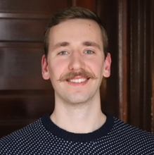 Project Manager, Maine Aquaculture Association. Christian’s work focuses on aquaculture economics, including business planning, production planning, and financial benchmarking. Other work revolves around seafood distribution, marketing, and workforce development - including the development of the nation’s first aquaculture apprenticeship.

Abstract
Maine’s farmed seaweed harvest has grown exponentially over the last 5 years. To characterize how the recent expansion of the sector has impacted the financial and production efficiency of individual seaweed aquaculture businesses, we calculated a comprehensive set of sector-wide benchmarks. This presentation explored the 2022 Maine Seaweed Benchmarking Report, identifying improvements between the 2017 and 2022 harvest season in production, expenses, breakeven prices/yields, profitability, financial, loan repayment, and efficiency (labor, capital, financial).

Key Takeaways
- Benchmarking is a standard practice in agriculture, providing a snapshot of sector averages (production, profit, farm size) that farmers can use to track, compare, and improve performance, and lenders and investors can use to assess farms.
- Using quantitative and qualitative methods, this study interviewed and analyzed production metrics from 16 Maine farmers, representing over 90% of the seaweed farmed in the state.
- Compared to 2017 metrics, results showed significant improvements in efficiency and yields (per farm and sector-wide), a greater percentage of profitable farms, a decrease in product loss, and reductions in the breakeven price.
- The study also found that, as the scale of production increases, so does productivity, efficiency, and profitability - demonstrating the significance of economies of scale in seaweed production. Nearly all farms harvesting over 75,000 lbs./year were profitable, while only 4 of the 10 farms harvesting less than 75,000 lbs./year were profitable.
- These results indicate that seaweed farming is not a get rich quick scheme but can provide a seasonal, secondary source of income for fishermen and others working on the waterfront.

Highlights and Insights
Industry benchmarks provide key production metrics that are useful sector-wide, informing both established seaweed farmers looking to scale and improve farm efficiency and new farmers interested in launching a seaweed business.
“There is a lot aquaculture can learn from agriculture.” — Christian Brayden

Resources Shared
- Maine Seaweed Benchmarking Report (Brayden and Coleman, 2023) (direct link to PDF here)
- Benchmarks for Mussel, Oyster, Scallop, and Seaweed Culture in Maine (Engle et al., 2020)

Business and Economic Planning for Seaweed Aquaculture
in the U.S.

Presenter: Bob Pomeroy
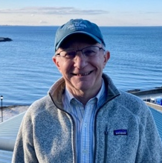Professor Emeritus, University of Connecticut, Department of Agriculture and Resource Economics. Bob is an emeritus professor and fisheries extension specialist with Connecticut Sea Grant. Bob’s areas of professional interest are marine resource economics and policy, specifically small-scale fisheries management and development, aquaculture economics, international development, policy analysis, and seafood.

Abstract
Business planning and management tools for kelp aquaculture systems can improve the economics and financial viability of this industry. These tools provide kelp farmers with support for business planning and improve industry knowledge for investors, financers, and potential market entrants. In addition, an analysis is currently being conducted that will provide for a comprehensive economic assessment of the ecosystem services provided by seaweed aquaculture.

Key Takeaways
- This 3-year project is working with resource economists, business planners, aquaculture extension professionals, and industry partners to develop comprehensive business planning and management tools specific to kelp farms and kelp nursery operations.
- Project deliverables are a business planning guidebook, an integrated financial model for kelp (spreadsheet-based Excel workbook), and an ecosystem services economic assessment using Life-Cycle Assessment (LCA) methodology (integrated into the workbook and generated via Open LCA).
- The business planning guidebook will focus on the mechanics of business planning and financial modeling and will provide considerations specific to investing in U.S. kelp operations.
- The integrated financial model allows users to input key data (revenue models, startup costs, operating expenses, sources and uses of funds, etc.) and generates standard reports for business decision-making. These outputs include an enterprise budget (allowing users to do breakeven and sensitivity analysis), cash flow projections, pro forma profit and loss statements, and pro forma balance sheets.
- Using LCA methodology and open-access databases, this unique model will also allow users to conduct a “cradle to gate” ecosystem services economic assessment of their operation, quantifying impacts on global warming potential, acidification, eutrophication, and marine toxicity.

Highlights and Insights
Comprehensive and adaptive business planning tools are critical to build a robust and sustainable seaweed aquaculture industry and should be developed for and informed by industry.
“We’re going to incorporate a lot of
outreach and extension so that these business tools can be useful and broadly adopted.”— Bob Pomeroy

Resources Shared
- Business planning and economic tools will be available on the National Seaweed Hub website in 2024.

Social License: Exploring Challenges and Opportunities
in Social License
Facilitated by partners from the World Wildlife Fund-US Aquaculture Team, this interactive workshop session presented social license research and tools for the industry and followed up with breakout groups to get attendees involved in the discussion.

About: The World Wildlife Fund
As a global conservation organization, WWF works in nearly 100 countries - collaborating with people around the world to develop and deliver innovative solutions that protect communities, wildlife, and the places in which they live. WWF is working to grow the seaweed industry to bring the benefits of seaweed farming for nature, people, and climate to scale - driving new markets and investing for impact around the world.

In this session
- What is social license? And why should the growing seaweed sector care?
- Tools needed to help farmers navigate community relations.
- How can communities and farms benefit each other?
“It felt good to have interaction around the table during the social license session.”
— Participant Feedback

Session Leads

Emily Whitmore
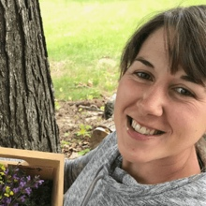Social Scientist, Maine Aquaculture Innovation Center. Emily Whitmore is a social scientist at the Maine Aquaculture Innovation Center focused on the community dynamics of aquaculture. She is currently working on developing a co-created community relations guide for Maine shellfish and seaweed farmers using a social license to operate framework.

Annie Li
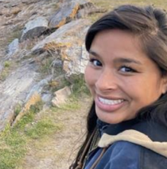Program Associate, WWF-US Aquaculture Team. Annie supports and manages a variety of projects under the aquaculture team at WWF. She is currently developing a tool to track U.S. and European Aquaculture import refusals, driving the Social License Holdfast Network, and co-leading a new project alongside the Maine Aquaculture Innovation Center.

Todd Paige
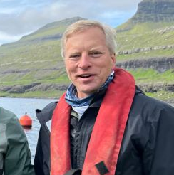Director of Communications, Seaweed and Shellfish Programs, WWF-US. As a communications professional in aquaculture, Todd seeks stories and creates content for WWF grantees, highlighting and amplifying their messages and efforts in seaweed and shellfish farming - particularly their positive impact on climate and coastal communities.Social License to Operate for Shellfish and Seaweed Aquaculture in Maine

Presenter: Emily Whitmore

Key Takeaways
- Social License to Operate (SLO) is the informal, ongoing approval or acceptance of a project granted by communities. SLO exists on a continuum and is centered around trust.
- As an industry tool, SLO can help businesses gain security, manage ‘social risk,’ and provide protective benefits in which supportive communities act with a company's best interests in mind.
- As a community empowerment tool, SLO allows communities to have more say over what happens to their shared resources, influencing how they want companies and governing officials to act.
- Earning social license requires gaining trust with stakeholders. For Maine shellfish and seaweed farmers, generating trust requires:
- Learning about what is locally meaningful.
- Aligning with local values.
- Respectfully communicating with all relevant stakeholders.
- Being transparent and honest.
- Operating responsibly.
- Providing tangible community benefits.
- These recommendations and more are captured in the Maine Aquaculture Innovation Center’s SLO Guidebook, which was co-created with Maine shellfish and seaweed farmers. After this work in Maine, the research team hopes to expand the guidebook regionally.

Highlights and Insights
Social license is an essential tool for building a socially sustainable seaweed industry, to benefit both farmers and communities.
“Social license is really about active support for a project. When you have
‘full’ social license, you reach the point where the community psychologically identifies with the activity—like a ‘mining town’—and will actively
protect it if threatened.”— Emily Whitmor

Resources Shared
- Maine Aquaculture Innovation Center Social Dimensions Webpage
- SLO Guidebook for Shellfish and Seaweed Farmers in Maine
- SLO 101 Infographic Series
- Information about upcoming SLO workshops and ongoing research
- MAIC Webinar Series Recording: Social License for Shellfish and Seaweed Aquaculture in Maine

Interactive Session: Social License to Operate Workshop
Following the presentation, attendees self-selected into breakout groups (industry, research, and community) to share experiences around social license. Facilitators for each breakout table included WWF staff and Sea Grant extension.

Industry
Starting Prompt
Identify industry resource needs that would help farmers navigate community relations, social license challenges, and would help improve public perceptions.
Discussion Summary
Some of the biggest challenges facing industry are:
- Lack of knowledge among the public, misinformation, and scientific knowledge gaps.
- Use-conflict, primarily between fishermen and farmers.
- Vocal opposition that is not representative of the community.
- Permitting process: length of process, public comments.
Solutions and specific recommendations included:
- Increasing awareness and knowledge surrounding seaweed aquaculture helps reduce fears, uncertainty and misinformation.
- Farmers: conduct on-the-ground social license work.
- Industry associations: provide communications support, amplify stories, assist with farmers’ social media and PR.
- Research institutions: communicate digestible science to the public.
- Communities: increase engagement and participation in coastal planning, municipalities incorporate aquaculture into economic development plans, community members skilled in science communication can help increase awareness.

Research
Starting Prompt
Identify research that could help our community better understand the social challenges of to create a more socially sustainable industry.
Discussion Summary
Some of the main social challenges are:
- Lack of knowledge among the public, misinformation, and scientific knowledge gaps.
- Perceptions of environmental impacts (impacts on the ecosystem, visual & noise pollution, safety.)
- Consumer challenges, acceptance of new product ideas, markets, etc.
- Social opposition from landowners and other ocean users.
What research is needed:
- Ecosystem services of aquaculture and environmental impacts
- The global role of aquaculture in climate and climate resilience
- Community impacts and benefits
- Consumer research, product development
- We should prioritize collaborative research (farmers, communities, students, extension, researchers)

Who should be involved in research:
- Farmers
- Communities
- Stakeholders
- Educators
- Students
- Social scientists
- Economists
- Market researchers
- Food safety scientists
- Research institutions
- Grant organizations

Community
Starting Prompt
Identify ways that communities and farmers could work better together/benefit from each other.
Discussion Summary
How do communities and farms benefit from each other?
- Communities:
- Food production
- Jobs/economy
- Preventing out-migration
- Diversification options for fishermen
- Ecosystem benefits
- Preservation of working waterfronts
- Public education
- Farms:
- Supportive communities look out for farms
Customers in the community
How could these benefits be expanded?
- More community engagement and growing the number of farms
How can communities and farmers work better together?
- Initiate proactive outreach and social license work
- Add aquaculture staff/capacity at state level to provide support
- Engage with municipalities, zone councils, and other local and regional entities on leasing/aquaculture education
- Identify shared space on working waterfront, bolster working waterfronts
- Involve third parties to coordinate dialogue about aquaculture in communities

Highlights and Insights
- More outreach is needed to enhance public education, ideally through coordinated, statewide efforts to build greater public understanding of aquaculture - utilizing “boots on the ground” approaches that meet communities where they are.

Post-harvest and Processing
During this session, invited presentations and a panel discussion addressed national post-harvest and processing priorities including product composition, processing at scale, product development, and processing for food and non-food markets.

In this session
- Where we are when it comes to seaweed standards, and what’s next?
- Product-driven processing moves the needle on the market for seaweed.
- Processors talk logistics and product quality (and freezers!)

Presentations
- The National Seaweed Hub Post-Harvest Opportunities and Infrastructure Workgroup | Melissa Good,
Alaska Sea Grant
- Setting Seaweed Standards and Navigating the Gaps | Steve Eddy, Maine Coast Sea Vegetables/University of Maine
- Kelp Processing: Food Safety and Food Innovation on a Mission | Peter Rahn, Atlantic Sea Farms

Processor Panel
- Jessica Chalmers, Co-Founder, Everything Seaweed
- Mitch Lench, CEO & Co-Founder, Ocean’s Balance
- Peter Rahn, Director of Quality and Food Innovation, Atlantic Sea Farms

The National Seaweed Hub Post-Harvest Opportunities and Infrastructure Workgroup

Presenter: Melissa Good
Mariculture Specialist, Alaska Sea Grant. Melissa works actively with industry, Alaska Native Tribes and corporations, seafood processors, regulators, community members and leaders to support sustainable marine aquaculture in Alaska. Her recent work has involved connecting consumers to locally grown oysters and seaweed products, developing educational materials, and a global market assessment of technologies for primary processing and manufacturing of seaweed.

Abstract
Focusing on post-harvest challenges and opportunities, this workgroup has identified priorities which span education, technology, and operations - including aligning processing to markets, opportunities for regional distribution and processing, and product standards/testing.

Key Takeaways
- In 2020, the National Seaweed Hub Post-Harvest Opportunities and Infrastructure Workgroup engaged producers, regulatory authorities, and processors to collaboratively identify challenges and opportunities in seaweed post-harvest and processing.
- The following three goals were developed by the workgroup: to educate U.S. producers and consumers (education), to ensure innovations in processing are readily available to industry (technology), and to establish an economically sustainable industry for processing seaweed (operations). Under each goal, objectives and “low-hanging fruit” that could be accomplished in the short-term were determined. The need for accessible information about lab product testing rose to the top of the list.
- The workgroup developed the Report for Seaweed Parameter Testing Resources hosted publicly on the National Seaweed Hub website. This report helps producers better understand seaweed tissue testing and become familiar with environmental laboratories that conduct such testing, and provides an example inquiry for producers seeking laboratory services.

Highlights and Insights
Post-harvest processing and infrastructure remains a key barrier for the seaweed industry in the United States, and tapping into new markets and opportunities will require producers to ensure their seaweed products meet market standards.

Resources Shared
- Seaweed Hub Report for Seaweed Parameter Testing Resources (direct link to 2023 PDF here)
- Seaweed Hub Post-Harvest Opportunities and Infrastructure Workgroup Information

Setting Seaweed Standards and Navigating the Gaps

Presenter: Steve Eddy
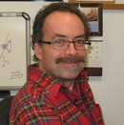Director of the University of Maine’s Center for Cooperative Aquaculture Research/Science Advisor for Maine Coast Sea Vegetables. Steve has worked in aquaculture since 1996, growing various finfish such as flounder, Atlantic halibut, amberjack, and other marine finfish species, sea urchins, and macroalgae. In 2018 he began working with Maine Coast Sea Vegetables to run their testing program and to help the company navigate the many regulatory and scientific issues surrounding the processing and sale of wild-harvested dried sea vegetables for human consumption.

Abstract
Although seaweed has been safely consumed for centuries, uniform safety and quality standards remain a work in progress in Western nations. The development of seaweed aquaculture in these nations has brought attention to this issue and led to increased research and policy discussion of seaweed food safety. Meanwhile, both new and established seaweed companies continue to refine quality standards informed through traditional use, those developed for other foods, and the need to adapt to evolving consumer expectations and a changing regulatory environment.

Key Takeaways
- Product standards are important to industry, regulators, and consumers, as well as for quality benchmarks, product safety, regulatory certainty, fair trade (harmonization), import/export, testing criteria, consumer acceptance, and product specification sheets.
- Though progress is being made when it comes to seaweed standards, gaps including harvest and mariculture methods, nomenclature and botanical identity, purity standards, microbial standards, heavy metals, allergens, iodine content, testing standards, and serving sizes still exist.
- Currently, many entities are involved in setting “standards” but standards for seaweeds are not consistent between countries, or even among U.S. states. Though some centralized sites for information about seaweed exist, information about seaweed standards is difficult to find, presenting an opportunity for the seaweed industry to lead the way in setting standards.
- Models including international standards (e.g., seaweed microbial standards in France) and guidance from other industries (e.g., American Herbal Products Association’s microbial limits for botanical ingredients, Tea & Herbal Infusions Europe’s microbial and metals limits) can inform the development of U.S. seaweed standards.
- Many distributors and manufacturers require Product Specification Sheets, which include a product description (botanical identity, physical attributes, sensory attributes), storage and handling suggestions, microbiological specifications, heavy metals and other contaminants, nutritional information, allergens, certifications (e.g., organic, kosher, etc.), and disclaimers. Seaweed product producers will need time, resources, and detailed information to assemble specification sheets for their products.
- Establishing allowable levels for lead and agreement on microbial standards are current regulatory gaps that could be addressed through efforts in the short term.

Highlights and Insights
Establishing standards for seaweed will be important to advance markets, and industry can and should lead the way in setting these standards.
“Currently, industry must navigate an unclear and confusing landscape: Where to go for standards and whose standards are best to follow?” — Steve Eddy

Resources Shared
- Maine Coast Sea Vegetables Webpages and Blog
- FAO and WHO. 2022. Report of the expert meeting on food safety for seaweed – Current status and future perspectives. Rome, 28–29 0ctober 2021. Food Safety and Quality Series No. 13. Rome. https://doi.org/10.4060/cc0846en
- National Institute of Standards and Technology: Supporting the Standardization of Seaweed Measurements project
- Marinalg International (industry standards for seaweed-derived hydrocolloids)

Kelp processing: Food safety and food innovation
on a mission

Presenter: Peter Rahn
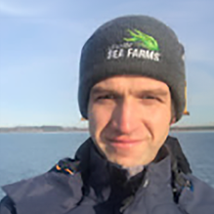Director of Quality and Food Innovation, Atlantic Sea Farms. Pete has 17 years of experience in food manufacturing as a Quality Assurance, Food Safety, and Operations leader and is excited to support the seaweed sector through his work at Atlantic Sea Farms.

Abstract
The mission of Atlantic Sea Farms is to diversify the incomes of coastal fishing communities as they adapt to climate change. ASF does this by teaming up with partner farmer-fishermen to grow line-grown kelp and guaranteeing the purchase of every pound of kelp harvested. To expand the farmer network and mission, ASF grows the market for its award-winning seaweed products. Expanding this market through national retail, food service, and ingredients outlets requires a robust food safety plan, from harvest to processing and storage, and continuous innovation in product development. Food safety, innovation, and our mission drive the post-harvest processing story at Atlantic Sea Farms.

Key Takeaways
- Domestic production and seaweed markets are still new in the United States and companies like Atlantic Sea Farms (ASF) are working to develop products that appeal to the U.S. consumers and focus on flavor, quality, price point, and innovation. ASF products include retail, food service, and ingredients.
- Globally recognized food safety programs, certifications, and standards are important to in tapping into into several segments of the food marketplace and create awareness and access for consumers.
- Inclusion of in-house food safety experts, protocols, and processing standards within seaweed companies is a best business practice that can facilitate expansion into several segments of the food marketplace.
- Food innovation is key and has helped seaweed businesses launch and grow over time. For example, initially collaborating with chefs to develop condiments and then expanding product lines to center of the plate items, like kelp burgers, has increased retail reach.
- To take new products from concept to consumer, it’s important to understand consumer wants and needs, engage R&D teams in product development and processing, and utilize expert sales teams to develop strategies to access major retail outlets or end customers.

Highlights and Insights
New and innovative seaweed products can move the
needle on market demand and expand the impact to seaweed farming communities and the planet.
“Product innovation really drives our post-harvest processing.”
— Peter Rahn

Seaweed Processor Panel
In this processor panel, we heard from folks about their businesses and processing operations, product development for food and non-food markets, and new and needed infrastructure to target processing bottlenecks.

Panelist: Jessica Chalmers
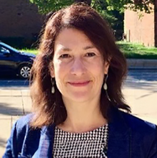Co-Founder, Everything Seaweed. Jessica is the co-founder of Everything Seaweed, a B2B startup planning to build a seaweed biorefinery in Maine, with a focus on the production of nanofibers/biomaterials that can replace fossil fuel-based synthetics.

Panelist: Mitch Lench
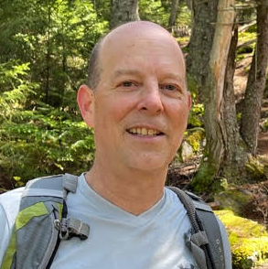CEO and Co-Founder, Ocean’s Balance. As co-founder and CEO of Ocean’s Balance, Mitch manages strategic and business aspects of the company and is working toward scaling commercial processing for dried kelp in North America.

Panelist: Peter Rahn
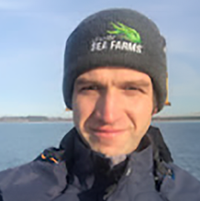Director of Quality and Food Innovation, Atlantic Sea Farms. Pete has 17 years of experience in food manufacturing as a Quality Assurance, Food Safety, and Operations leader and is excited to support the seaweed sector through his work at Atlantic Sea FarmsPanel Facilitator: Melissa Good, Alaska Sea Grant

Processor Introductions
- Jessica Chalmers is a co-founder of Everything Seaweed. Everything Seaweed is a start-up biorefinery in Maine, which is currently in the fundraising stage. Their goal is to source 4 million pounds by 2028 and bioengineer this seaweed into nanofibers to replace plastics and synthetics. They hope to establish a non-edible market and supporting infrastructure in the state and support the production and use of biodegradable everyday materials.
- Mitch Lench is the CEO and co-founder of Ocean’s Balance. Ocean’s Balance is a Maine-based, vertically integrated seaweed company, working in cultivation, farming, processing, product development, and marketing. Their product line includes ingredients as well as stand-alone, value-added products. This year, Ocean’s Balance invested in a new industrial-scale seaweed dryer and created Seaweed Farmer Services, LLC, in the hopes of establishing cooperative drying infrastructure in the region.
- Peter Rahn is the Director of Quality and Food Innovation at Atlantic Sea Farms, a mission-based company dedicated to expanding opportunities for coastal communities by creating craveable and innovative products from farmed seaweeds. Within the last few years, ASF has significantly expanded their processing capacity and product line, as well as their partner farmer network, who produce most of the kelp farmed in the United States.

Discussion
Panelists shared their expertise in a discussion that focused on product quality and sourcing, processing infrastructure and needs, secondary markets, biorefinery processing models, and interest in diversifying to process and utilize new species. Panelists were prompted with questions to drive the discussion.
How do you maintain product quality when sourcing from across a large geography?
Panelists discussed a number of strategies, including those related to processing and infrastructure as well as personnel and logistics. Processors shared that they have dedicated logistics teams to manage transport and logistics during the harvest season, which is necessary to coordinate with many producers across a large area. Within the short harvest season, processors also work to bulk freeze product, which can then be processed throughout the year. However, panelists noted that it’s costly to store frozen product for the long term, and there was interest in drying kelp as a method to extend the shelf life and minimize costs. All processors highlighted the short harvest season and rapid processing turnaround time as a challenge.
There is lots of excitement around drying seaweed. What infrastructure exists or is needed?
The discussion primarily focused on the recent installation of an industrial-scale dehydrator in Maine. The custom-designed equipment was transported from South Africa and has an estimated processing capacity of 30,000 lbs/day. The dehydrator utilizes low temperatures to preserve ingredients, reuses hot air to lower the cost of operation, and may in the future incorporate heat pumps to bring the cost down further. Co-located with a well-established processing facility for wild harvested seaweeds, there are hopes that this dehydrator will further establish cooperative processing options in the state. Panelists noted that other regions of the United States can learn from or utilize similar technology in addressing processing bottlenecks. Finally, panelists highlighted milling as a key processing need after kelp is dried - adding that prospective ingredients buyers often want to purchase dried kelp in milled and finely milled form.
Are there secondary markets for farmed kelp that can’t be used as food?
Due to the costs of production, panelists shared that they are currently focused on high-grade farmed kelp for the food market because it’s a higher value commodity market. Some secondary markets that panelists reported interest in were fertilizer and animal feed, although it was noted that it may be difficult to compete in those markets where wild harvested seaweeds, such as rockweed (Ascophyllum nodosum), are already well established.
How does a seaweed biorefinery model work and what types of products will be produced?
The discussion outlined two processes within a seaweed biorefinery model – one biorefinery process that separates the desired components from the seaweed biomass and another process that isolates the nanoparticles and cellulose. Nanoparticles and cellulose from seaweeds may be used as the building blocks for other products, including plastic replacements, replacements for PFAS coatings on food packaging, and more. Panelists discussed how start-up biorefineries will require infrastructure and facilities, and will need to consider the cost, available volume, and attributes of domestic farmed seaweed versus the wild and internationally farmed sources (ex. Eucheuma) that currently make up the global supply.
Currently, the U.S. sector is farming primarily kelp species. Is there interest in processing and working
with other seaweeds?
All panelists agreed that there is interest in and enthusiasm for working with new species, though which species would depend on a number of factors including farming technology, cost to produce, prospective products, and market. For food markets, processors were interested in exploring the attributes of different seaweeds to develop consumer-appropriate products, as well as supporting new farming technologies for species with established food markets, like dulse. For non-food markets, the discussion turned to Sargassum and green algae. Panelists shared that Sargassum would not be a good candidate for biorefinery products due to contaminants and green algae was highlighted as higher in cellulose, which may present a future opportunity to source and utilize wild nuisance species, like Codium fragile.

Highlights and Insights
As a link between farmers and end-consumers, seaweed processors drive product innovation and market development, and are investing in the infrastructure necessary to support and grow the industry.

Market Opportunities
This session addressed emerging seaweed markets and feasibility, included current global and domestic seaweed market reports, and highlighted new initiatives and resources. The session began with presentations and was followed by a seaweed marketing panel, where industry experts discussed their efforts to advance markets for U.S. seaweed products.

In this session
- What are seaweed consumers (and non-consumers) looking for?
- New research evaluates the potential for high volume markets.
- 10 high-growth market opportunities for seaweed.
- Women leading the seaweed industry talk about why the future of seaweed is promising.

Presentations
- The National Seaweed Hub Market Opportunities Workgroup | Jaclyn Robidoux, Maine Sea Grant
- U.S. consumer preferences and attitude towards seaweed and value-added products | Qiujie ‘Angie’ Zheng, University of Maine
- Quantifying baseline costs and potential for kelp aquaculture carbon dioxide removal | Adam St. Gelais, Aquaculture Research Institute at the University of Maine
- New and emerging global seaweed markets - an analysis of high-growth market opportunities by Hatch Innovation Services | Karlotta Rieve, Hatch Innovation Services

Marketing Panel
- Lia Heifetz, Co-Founder, Barnacle Foods
- Julia Marsh, CEO and Co-Founder, Sway
- Briana Warner, President and CEO, Atlantic Sea Farms

The National Seaweed Hub Market Opportunities Workgroup

Presenter: Jaclyn Robidoux
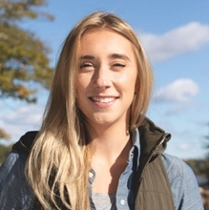Marine Extension Associate, Maine Sea Grant. As Maine Sea Grant’s seaweed extension specialist, Jaclyn focuses on the development of Maine’s seaweed sector, including on-farm technical support, farmer training programs, and exploring new infrastructure and market opportunities. Jaclyn works directly with seaweed businesses, regulators, researchers, and folks on the water to develop new solutions for seaweed aquaculture in the United States.

Abstract
As expanding markets continue to be a high priority for the U.S. seaweed sector, this National Seaweed Hub Market Opportunities workgroup identified related opportunities in product development, trade representation, and consumer outreach and education, resulting in the production of an accessible and customizable seaweed marketing toolkit for farmers, businesses, and folks working to market U.S. seaweed.

Key Takeaways
- The Market Opportunities workgroup is a national collaborative effort that has worked with seaweed businesses, marketing professionals, researchers, and support organizations to capture and organize information about seaweed market challenges and opportunities across the United States.
- The workgroup categorized and prioritized challenges and opportunities based on market size (small-volume “niche markets,” large-volume “commodity” markets, shared challenges across market size), and narrowed ideas to identify actionable needs, determining consumer outreach and education to be a top priority.
- The workgroup determined that reaching U.S. consumers will require marketing and awareness campaigns and unified and consistent messaging about seaweed that can be adapted to meet individual business needs and evolving markets.
- These efforts resulted in the creation and launch of the Seaweed Marketing Toolkit and marketing campaign, “Let Seaweed Surprise You!” The digital toolkit organizes public-facing, seaweed-specific marketing language into major marketing areas of focus (culinary, nutrition, environment, economy) and provides free downloadable print and digital assets, like posters, social media images, seaweed photos and graphic elements, that seaweed businesses and support organizations can utilize and adapt to their marketing needs.

Highlights and Insights
Market growth and development for seaweed remains necessary to realize industry potential in the United States and is supported though consumer-focused outreach and marketing efforts.
“Seaweed is a triple bottom line product that aligns with major consumer movements, but most U.S. consumers don’t know seaweed exists.”
— Jaclyn Robidoux

Resources Shared
- The Seaweed Marketing Toolkit
- Seaweed Hub Market Opportunities Workgroup Information Page

U.S. consumer preferences and attitudes towards seaweed and value-added products

Presenter: Qiujie Angie Zheng
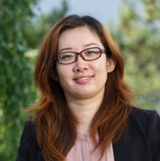Associate Professor of Business Analytics, Maine Business School, University of Maine. Trained as an economist, Angie’s research focuses on consumer choice and preference, consumer behavior, food marketing, and agricultural and aquaculture businesses. This work seeks to understand drivers and factors affecting food choices as they relate to food safety, food security, environmental sustainability, climate change, and COVID-19 impacts.

Abstract
Seaweed farming in the United States has grown substantially in recent years, especially in the waters off New England, the Pacific Northwest, and Alaska. However, there is limited understanding of U.S. consumer’s preferences for seaweed. Using survey data collected from a large-scale U.S. national sample, this study analyzed U.S. consumers’ preferences and attitudes toward seaweed products using exploratory and econometric analysis. The findings provide insights to help seaweed producers design potential business strategies for producing and promoting seaweed products to meet U.S. consumers’ needs, expanding the seaweed consumer pool, and penetrating the seaweed market.

Key Takeaways
- Though understanding consumers is critical to evaluating and expanding market potential for seaweed, research is currently limited. This study conducted an analysis of two distinct consumer groups - those who consume seaweed and those who do not - to compare their attitudes toward seaweed consumption and investigate their purchase intentions separately.
- The exploratory analysis of over 5,400 respondents showed that, for seaweed consumers (36% of the total surveyed), more than half had used seaweed as a topping for salads/soups, sushi, and snack. In the analysis of consumer knowledge, the top three seaweeds identified by consumers were laver (60.0% identifying), Irish moss (58.4%), and dulse (57.7%).
- For non-consumers (64% of the total surveyed), the top three barriers to consuming seaweed were “unaware of them,” “not sure how to prepare them,” and “taste,” and the top three factors that would motivate them to try seaweeds were “recipes,” “easy-to-use products,” and “fresh products easily available from grocery stores.”
- Purchase intentions of seaweed consumers were greatest among consumers who were older, female, or have a graduate or professional degree, as well as for those with higher objective or subjective knowledge of seaweed and positive perception of the price, quality, and availability of seaweed. For non-consumers, purchase intentions were highest among consumers in the west, those with higher incomes, those with children, as well as those who do not consume seaweeds due to availability, who are unaware of seaweed products, or who are not sure how to prepare seaweeds.
- These results indicate that expanding seaweed product availability, educating consumers about seaweed, and providing guidance on how to prepare seaweed at home could be effective marketing tactics.

Audience Discussion
How do we deal with negative perceptions of “seaweed” when they are built into major systems like regulation, research, industry?
Results have shown that some non-consumers find the “seaweed” name to sound unappealing. Perhaps there is work to be done in terms of helping people understand what seaweed actually is and producers should consider attractive names/brands for their products. Globally, some languages have more positive associations for seaweed - not associating with “weed” at all - while still others have even more negative connotations.

Highlights and Insights
Intentions to purchase seaweed products differ between current consumers and non-consumers and distributors and retailers should consider these differences in developing targeted market strategies to increase sales.

Resources Shared
Zheng, Q., Davis, C. V., Noll, A. L., Bernier, R., & Labbe, R. (2024). US consumer preferences and attitudes toward seaweed and value-added products. Agribusiness, 1–26. https://doi.org/10.1002/agr.21915

Quantifying baseline costs and potential for kelp aquaculture in carbon dioxide removal

Presenter: Adam St. Gelais
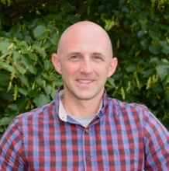Aquaculture Innovation Specialist, Aquaculture Research Institute. As the Aquaculture Innovation Specialist at the Aquaculture Research Institute, Adam’s work focuses on ecosystem-based approaches to aquaculture. Adam’s research works to develop innovative, climate-friendly production and processing methods, improve efficiency, and evaluate emerging opportunities for seaweed and carbon dioxide removal.

Abstract
To evaluate the potential of macroalgae CDR, we developed a kelp aquaculture bio-techno-economic model in which large quantities of kelp would be farmed at an offshore site, transported to a deep water “sink site,” and then deposited below the sequestration horizon (1,000 m). We estimated the costs and associated emissions of nursery production, permitting, farm construction, ocean cultivation, biomass transport, and Monitoring, Reporting, and Verification (MRV), based on the current systems of kelp cultivation in deep water exposed sites. Kelp CDR may be limited by high production costs and energy intensive operations, as well as MRV uncertainty, and we present R&D opportunities that may resolve these challenges.

Key Takeaways
- The cost of production will determine market availability for farmed kelp in the U.S. Domestic seaweed farmers are currently sell into the “whole foods” markets using current technology. However, challenges remain that may hinder future cost-effective scaling.​
- The Phase I research, which developed a baseline techno-economic model to estimate production costs and carbon footprint at scale, found that the current, widely used culture methods preclude high volume market access (including carbon markets), are not emission-free and are prohibitively expensive without optimization and innovation.
- The baseline model was optimized utilizing the maximum or minimum literature values that reduced levelized sequestration costs. With optimization, costs were shown to come down significantly and, with strategic innovations, could potentially be further reduced.
- The main cost drivers in the model, which were prohibitively expensive, were farm labor, nursery seed, and transport. Nursery operations were also found to be prohibitively expensive, and optimizing this stage through innovative production technologies and selective breeding may result in cost savings.
- Phase II of the research is exploring optimization and innovation, targeting aspects of production that showed potential for high impact in the Phase I results. Projects currently being conducted are assessing nursery efficiency, crop yields, and low carbon materials to inform Phase II techno-economic analysis (TEA) and life cycle assessment modeling (LCA) efforts.
- Scaling will require full spectrum modeling of sustainability beyond LCA and TEA - analyses will need to be augmented or developed to address other issues, particularly social factors.

Highlights and Insights
Research and development that optimizes the nursery and ocean cultivation stages of seaweed aquaculture may reduce farm-gate production costs and address economies of scale, opening up new market channels for growers.
“How can we scale the industry to tap into the “future of the blue economy”
and larger markets?”— Adam St. Gelais

Resources Shared
Phase I associated publications:
- St. Gelais, A. T., Fredriksson, D. W., Dewhurst, T., Miller-Hope, Z. S., Costa-Pierce, B. A., & Johndrow, K. (2022). Engineering a low-cost kelp aquaculture system for community-scale seaweed farming at nearshore exposed sites via user-focused design process. Front. Sustain. Food Syst, 6. https://doi.org/10.3389/fsufs.2022.848035
- Coleman, S., Gelais, A. T. S., Fredriksson, D. W., Dewhurst, T., & Brady, D. C. (2022). Identifying scaling pathways and research priorities for kelp aquaculture nurseries using a techno-economic modeling approach. Frontiers in Marine Science, 9, 894461.​ https://doi.org/10.3389/fmars.2022.894461
- Coleman, S., Dewhurst, T., Fredriksson, D. W., St Gelais, A., Cole, K., MacNicoll, M., ... & Brady, D. C. (2022). Quantifying baseline costs and cataloging potential optimization strategies for kelp aquaculture carbon dioxide removal. Frontiers in Marine Science, 1460.​ https://doi.org/10.3389/fmars.2022.966304

New and emerging global seaweed markets — an analysis of high-growth market opportunities by Hatch Innovation Services

Presenter: Karlotta Rieve
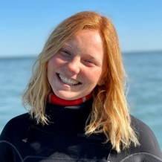Project Manager, Hatch Innovation Services. Karlotta works as a project manager for the Innovation Services business of Hatch Blue - a global accelerator; investment and consultancy company that promotes sustainable aquaculture. Her focus is to support the growing seaweed sector with original industry intelligence, gleaned from on-the-ground research in both principal and emerging seaweed producing nations.

Abstract
As part of our work to support the growing global seaweed sector, Hatch has assessed market opportunities for new and emerging forms of seaweed biomass utilization. This work identifies short, medium, and long term market entry points across a number of industrial sectors, such as agriculture, health, textile, and chemical industry. By providing information relevant to the decision making of the public and private sector, we hope this report can guide efficient industry development and catalyze innovation along new seaweed supply chains.

Key Takeaways
- Hatch Innovation Services, the in-house consulting unit of the global accelerator Hatch Blue, has recently analyzed 10 emerging seaweed markets and ecosystem services in the Global Seaweed New and Emerging Markets Report published by The World Bank. Each market was analyzed using market data, literature, and expert stakeholder interviews.
- For each of the 10 markets, the report details the total global market and projected global market growth to 2030, the market share for seaweed and projected seaweed market growth to 2030, key market drivers and challenges, and an overall market outlook.
- Short term markets (before 2025) from highest probability of market establishment and greatest market size are: biostimulants, animal feed (additives), pet food, and methane additives.
- Medium term emerging market opportunities (from 2024-2028) from highest probability of market establishment are: nutraceuticals, alternative proteins, fabrics, and bioplastics.
- Long term emerging market opportunities (past 2028) include pharmaceuticals and construction materials, although these are still uncertain and some “deal breaker” challenges exist.
- The main challenge across all markets is the availability of seaweed, due to current limitations in volume, consistency, and quality of supply. Related key findings for all markets include significant competition with commodity and commodity-derived products (e.g., plastic, construction materials), opportunities in biorefining, competition between markets utilizing the same compounds, regulations, the reliance on sustainability premiums to generate profit, and monetizing ecosystem services.

Highlights and Insights
Understanding global seaweed markets will help producers, investors, regulators, and researchers identify future opportunities and inform the development of the sector in the United States.
“What applications for seaweed biomass present the greatest opportunity?”— Karlotta Rieve

Resources Shared
- Global Seaweed New and Emerging Markets Report 2023 (direct link to PDF here)
- Hatch Accelerator Program

Seaweed Marketing Panel
In this panel, women leading in the seaweed industry discuss their businesses, marketing successes and lessons learned, misconceptions, and their hopes for the future of the sector. Panelists were asked questions to guide the discussion.

Panelist: Lia Heifetz
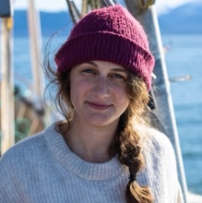Co-Founder, Barnacle Foods. Lia’s a lifelong Alaskan, born and raised in Juneau. In 2016, she co-founded Barnacle Foods. Along with business growth and strategy, Lia focuses on marketing and communications - telling the story of Alaska-grown kelp. Lia’s motivation to grow Barnacle Foods comes from her interest in helping to scale the kelp industry’s positive impacts to rural communities and our collective future.

Panelist: Julia Marsh
CEO and Co-Founder, Sway. Julia is the CEO & cofounder of Sway, a California-based clean tech startup scaling next generation packaging made from seaweed. Julia spent over a decade designing brand and packaging systems for consumer goods companies, technology startups, and design studios around the world.

Panelist: Briana Warner
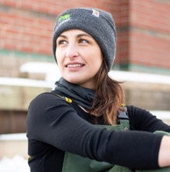President and CEO, Atlantic Sea Farms. As CEO of Atlantic Sea Farms, Bri and her team have forged a new path for seaweed aquaculture in the U.S. by working with fishermen to grow kelp as a climate change adaptation strategy - and build national demand for that kelp. Bri has followed a mission-driven path to kelp, including time as a diplomat in the U.S. Foreign Service and work in coastal economic development.

Panel Facilitator: Jaclyn Robidoux, Maine Sea Grant

Panelist Introductions
- Briana Warner is CEO and president of Atlantic Sea Farms, a woman-run, mission-driven seaweed company that works with partner farmers (commercial fishermen) to produce value-added food products from farmed kelp. ASF produces fermented seaweed salads, kelp cubes, veggie burgers, and powder, and is a B2C and B2B company. ASF highlights the relationship with their 27 partner farmers in Maine, Rhode Island, and hopefully Alaska in the next year, as the core part of ASF’s mission and one of their biggest successes thus far.
- Julia Marsh is the CEO and Co-Founder of Sway, a California-based startup scaling next generation packaging made from seaweed. Sway harnesses the power of seaweed to create home-compostable packaging, bioplastics, and replacements for thin-film packaging. End consumers for Sway’s products are the packaging and green materials supply chain. In 2023, Sway was named the 1st place winner of the Tom Ford Plastic Innovation Prize, a recent and exciting success for the startup.
- Lia Heifetz is Co-Founder of Barnacle Foods. Based in Juneau, Alaska, Barnacle Foods is on a mission to do good for our oceans, community, and collective future. Barnacle’s products feature high quality, Alaskan-grown kelp as the primary ingredient and are sold through retail and to end consumers. These value-added products include hot sauces, salsas, pickles, and kelp chili crisp - introducing seaweed to new consumers in forms that they already know and love.

Discussion
In leading the charge on marketing seaweed in the United States, what have been some marketing successes or “aha” moments?
All panelists agreed that marketing the story of seaweed has been a standout success with the public and the media responding positively. Panelists have focused on telling the seaweed story, from benefitting coastal communities to placing seaweed front and center in the bioplastics discussion. In marketing food products, panelists also noted the need to provide information to consumers about what they can do with seaweed products and to be explicit (e.g., including a picture of a smoothie on the packaging of kelp cubes). Focusing on high product quality and positive consumer experiences also was highlighted as a successful strategy. For marketing food and non-food products, successful marketing strategies focused on positivity about the future - making the future look inviting and having seaweed be a part of that.
Looking ahead, what are some hopes for the future of seaweed?
Panelists agreed that, when it comes to the future, we can be proactive in how the industry develops and who benefits. Panelists hope that seaweed will help fishermen and folks on the water diversify, and that farmers will make livable incomes. Also, there is the hope that new markets with different farming/processing considerations, like biomaterials, will increase market accessibility and broaden options for farmers. Panelists hope that seaweed businesses will be associated with an assured value chain and will make sure their products do what they say they will. Finally, they hope that the products and innovations currently underway will be a gateway for greater presence of seaweed in future consumer diets and lifestyles.
Are there models or lessons to learn from when it comes to government support of seaweed industries?
The panel highlighted lessons learned from seaweed industries across the globe, as well as from agriculture in the United States. Panelists discussed looking towards the seaweed sector in South Korea, where the well-established industry is organized into farmer cooperatives, production is not heavily industrialized, and R&D grants issued by the South Korean government have helped shape and support the industry. In looking toward Western countries with young seaweed sectors also in development, panelists were cautious of emerging models that rely on highly technical production methods and the idea of subsidies, citing agricultural subsidies that have undercut markets, devalued economically viable models, and brought products to market that shouldn’t be there. For ways that the government can support the U.S. seaweed sector, panelists highlighted as critical state and federal investments in R&D, and in the infrastructure and logistics necessary to get seaweed to market.
Are there misconceptions about seaweed or seaweed businesses?
This all-women panel discussed how, despite the strong appearance of women in leadership when it comes to seaweed, minimal funding is supplied to women-run businesses by venture capitalists, resulting in an uphill battle for women CEOs. Panelists noted that 2% of all venture capital goes toward women-run businesses, despite the fact that 50% of companies seeking venture funding are run by women. More equitable access to funding would help women-run businesses, like those represented by the panelists, develop and succeed.
When it comes to the rapidly changing seaweed space, what are you excited about?
Collaboration was one of the first and foremost aspects that panelists were excited about. Panelists highlighted the importance of events like the National Seaweed Symposium that bring together and uplift the community, acknowledging that operating a seaweed business can be exhausting and connection is key to keep moving forward. Panelists were also excited about connecting with new producers, exploring new inputs for their products, and the opportunity to scale their businesses. Emerging markets were highlighted, including scaling seaweed-based resins to replace petroleum-based synthetics, and panelists felt we should be excited about the changes to come. Finally, panelists were excited about kelp’s potential status as a regenerative seafood and the opportunity for value to remain local in the communities where seaweed is produced.

Highlights and Insights
Across the United States, successful marketing strategies have built awareness and excitement for seaweed by telling the seaweed story, from coastal communities to women in leadership to climate-friendly products. “We have an opportunity to be really proactive about how the industry develops, who it benefits, and how it grows.”
— Lia Heifetz
“Safeguarding the future for farmers will mean frank conversations about pricing and not repeating the industrial agriculture model.”
— Briana Warner
“We spend a lot of time making the future look gorgeous and joyful and delightful and inviting so that people want to be a part of it.”
— Julia Marsh

Global Production and Innovation
As seaweed production grows in the United States, this session highlighted projects and partners that are working to develop seaweed around the world, with an emphasis on what the U.S. can learn from these efforts.

In this session
- Advocating for seaweed on a global scale
- Production and farm-level data from the world’s top seaweed producers
- What will it take to scale seaweed in Europe?

Presentations
- The Global Seaweed Coalition | Nichola Dyer, Global Seaweed Coalition
- Hatch’s seaweed insights from the world’s major seaweed producing regions | Karlotta Rieve,
Hatch Innovation Services
- Seaweed production in Europe and European threshold concentrations on potentially toxic elements as barriers | Susan Løvstad Holdt, Technical University of Denmark

The Global Seaweed Coalition

Presenter: Nichola Dyer
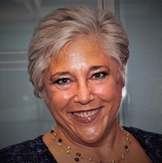Senior Advisor, Global Seaweed Coalition. Nichola is a seasoned international economic development professional with experience spanning the nonprofit, public, and private sectors. Since 2021, she has served as Senior Advisor to the Safe Seaweed Coalition, advising on strategy and governance, designing and moderating events, and representing the coalition, building on 26 years of work with the World Bank Group.

Abstract
This presentation describes the Global Seaweed Coalition (until recently known as the Safe Seaweed Coalition), a member-driven partnership created to facilitate the emergence of an international seaweed sector with global safety standards, grounded in science. It will include: the mission and objectives of the Coalition; key resources for members; the Coalition’s four action pillars - funding, advocacy, science, and policy; and a readout from recent Member Roundtables.

Key Takeaways
- Launched in 2021 as the Safe Seaweed Coalition, the Global Seaweed Coalition is housed in the United Nations Global Compact and aims to help the seaweed sector make a significant contribution to UN Sustainable Development Goals, particularly the goals of improving public health and food security, alleviating poverty, renewing marine ecosystems, and mitigating climate change.
- Since 2021, the coalition has developed calls for proposals based on scientific expertise, advocated for seaweed within international food systems, climate, oceans, and biodiversity policy arenas, and has assisted the FAO to update the Codex Alimentarius to incorporate seaweed.
- To solicit input on the coalition's action pillars, the coalition hosted member roundtables in February 2023, engaging approximately 100 members worldwide. Some examples of recommendations for each of the pillars include:
- Funding: Invest in projects in Latin America, Africa, and the Indian Ocean, including the support of small-scale farmers, and develop and support seaweed-specific incubator/accelerator programs and peer support networks.
- Advocacy: Promote sustainable seaweed sourcing through knowledge sharing and communication; raise awareness of existing funding mechanisms for smallholders; develop an industry-wide model for communication; and use ocean-focused conferences to facilitate information sharing and relationship building.
- Science: Support more science to inform carbon credits; research on genetic resource management; and integration of indigenous knowledge and social science into seaweed research.
- Policy: Harmonize policies globally to provide a good framework for local and national decisions and permitting; improve standardized information at the global level; more research to inform policies on blue carbon and carbon credits; better incorporation of seaweed into blue economy strategies and marine spatial planning; and consistent/better quality global production data.

Highlights and Insights
Cooperative, international networks can help the U.S. sector engage in and align with global seaweed policy discussions and development efforts.
“Because seaweed is somewhat of an institutional orphan, there’s a need for continuous advocacy for issues related to its production and trade.”— Nichola Dyer Resources Shared
- Global Seaweed Coalition Website
- Global Seaweed Coalition Member Platform on Ubuntoo

Hatch’s seaweed insights from the world’s major seaweed producing regions

Presenter: Karlotta Rieve
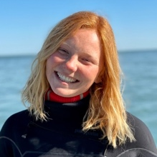Project Manager, Hatch Innovation Services. Karlotta works as a project manager for the Innovation Services business of Hatch Blue - a global accelerator; investment and consultancy company that promotes sustainable aquaculture. Her focus is to support the growing seaweed sector with original industry intelligence, gleaned from on-the-ground research in both principal and emerging seaweed producing nations.

Abstract
This session presents Seaweed Insights - a free and practical knowledge base that compares how the main commercial seaweed species are farmed today and provides practical insights that help identify and verify innovation opportunities for - and investment opportunities in - the global seaweed sector. Karlotta explored data on this website, which she collected during her on-the-ground research in 2022, where she visited over 100 farmers, processors, input suppliers and researchers to capture how the industry is evolving in Asia’s established seaweed farming regions. This presentation addressed relevant topics around site selection, farm design, to seeding, deployment, grow out, harvesting and primary processing methods, as well as sales, farmers socio demographics and challenges.

Key Takeaways
- Seaweed Insights is an analytics dashboard, displaying results of in-the-field surveys of the globe’s major seaweed producing regions. This on-the-ground research aimed to generate reliable and comparable production data and, in some cases, identified where existing production figures were inconsistent.
- These insights represent the accumulation of over 100 interviews across 15 different regions in the main seaweed producing countries. In each country, 2-3 major farms were visited and interviewed with 50 questions covering the entire farming process.
- The report provides production insights for the top five commercially produced seaweed groups (accounting for approximately 95% of global production) including Eucheumatoids, Saccharina, Undaria, Pyropia, and Gracilaria species, with 12 total species. Each species contains subpages describing its characteristics, volumes produced, and a high-level value-chain overview including supply chain bottlenecks. In addition to comprehensive species and farm information, the insights include tables, graphics, and field photos.
- Over the past 20 years Saccharina and Eucheumatoids have been driving production and, in 2020, countries outside of Asia produced less than 2% of the total farmed seaweed volumes. However, the outlook for scaling seaweed production in other parts of the world is promising and additional in-depth insights and analyses can be found on the website.
- It can be difficult to comprehensively quantify the scale of production from individual countries. This process involved working with researchers and translators in addition to farmers and working around travel restrictions. The significant breadth and challenging nature of this field work makes the Seaweed Insights tool valuable.

Audience Question
In seeking farm-level production data, were there difficulties in maintaining transparency?
Because such a large group of farmers was surveyed, the proprietary information was not visible when aggregated and there weren’t issues. However, this is what can make other regional studies with similar goals difficult - if the number of farmers is too few to maintain transparency.

Highlights and Insights
On-the-ground methodology and research focused on seaweed production is critical to building a comprehensive understanding of seaweed farming within and across species and countries.

Resources Shared
Seaweed Insights Website

Seaweed production in Europe and European threshold concentrations on potentially toxic elements as market barriers

Presenter: Susan Løvstad Holdt
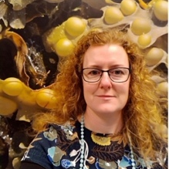Associate Professor, National Food Institute, Technical University of Denmark. Susan, Industrial-PhD, is a biologist whose field of research is within seaweed and microalgae cultivation, composition, bioactives, and technologies for extraction. She’s involved in research on seaweed and microalgae as food, legislation, standardization, retaining the qualities of seaweed while reducing potentially toxic elements. Susan is the Secretary General of the International Seaweed Association.

Abstract
This presentation will provide an update on European seaweed production, including emerging opportunities and relevant market considerations. This includes potentially toxic elements (PTEs) which are market barriers in Europe. The lack of threshold values on using seaweed as food does not make the situation any easier. The European Food Safety Authority has monitored seaweed species and their PTEs which has resulted in recommendations to the European Commission. More data is needed, but the market is still waiting for legislation.

Key Takeaways
- The main actors in European macro and microalgae production are Spain, France, Ireland and Norway, each with over 20 companies producing algae. In the last decade, there’s been a linear increase in the total number of algae producing companies, but there have been fewer new starters in recent years (since 2016).
- The total harvest volume is 300,000 tonnes, of which aquaculture makes up about 0.2% (500 tonnes total). Aquaculture is mostly ocean-based with many fewer species utilized than wild harvest. Wild harvesting is dominant, with the majority of seaweed manually harvested and targeted for alginate.
- Constraints to European sector expansion include the small market size for algae commodities in Europe, variability in the annual biomass supply, the current state of production and processing technological development, and the complexity of navigating regulations around permitting (e.g., limited 5-year terms), harmful metals assessment, and organic certification.
- Due to the absence of a market for whole raw product, companies are typically involved in the whole value chain and must navigate the lack of best manufacturing practices and unclear legislation, which creates a significant burden for businesses.
- Currently, some countries have recommendations but not regulations for potentially toxic elements (PTEs). In 2020, researchers analyzed seaweed from across Europe and found huge geographical and processing differences in whether the product achieved iodine levels below the recommended maximum according to French guidelines. A European Food Safety Authority report of this effort was presented to the EU commission, concluding that threshold values are on the way but not yet there.
- Other considerations include the European Commission’s Novel Food Catalogue, to which producers must prove their product exists in a recipe book or get it formally approved. Additionally, there are efforts to provide product information and branding, like those currently underway by the Norwegian Seaweed Association.

Audience Question
Is there a challenge to getting consistent results from lab to lab in the EU, like we see in the United States?
Yes, the numbers are all over the place and the differences can be significant. In some cases, this even calls the literature into question. There is a need to examine procedural differences between labs.

Highlights and Insights
In the EU, the Food Authority looks to the industry to make guidelines for best practices, a process which the United States can observe and learn from.
“We really need to solve these market constraints in parallel with the politicians.”
— Susan Holdt

Resources Shared
- Barbier, Michèle & Charrier, Benedicte & Araujo, R. & Holdt, Susan & Jacquemin, Bertrand & Rebours, Céline & Chopin, Thierry. (2019). Pegasus - Phycomorph European Guideline for a Sustainable Aquaculture of Seaweeds.
- Seaweed Revolution: A Manifesto for a Sustainable Future. 2020. Lloyd’s Register Foundation.
- Araújo, Rita, Vázquez Calderón Fatima, Sánchez López Javier, Azevedo Isabel Costa, Bruhn Annette, Fluch Silvia, Garcia Tasende Manuel, Ghaderiardakani Fatemeh, Ilmjärv Tanel, Laurans Martial, Mac Monagail Micheal, Mangini Silvio, Peteiro César, Rebours Céline, Stefansson Tryggvi, Ullmann Jörg. (2021). Current Status of the Algae Production Industry in Europe: An Emerging Sector of the Blue Bioeconomy. Frontiers in Marine Science, 7. https://doi.org/10.3389/fmars.2020.626389

Seaweed and Climate
This crosstalk session was hosted by the researchers at Bigelow Laboratories for Ocean Sciences and partner institutions with the goal of highlighting some of the science behind the conversations about climate and seaweed. We heard from experts on five research projects, from ecosystem services to bioremediation to blue carbon, and then held a panel discussion.

About: Bigelow Center for Seafood Solutions
The Bigelow Center for Seafood Solutions is a partnership for problem-solving, informed policy, and public awareness related to fisheries and aquaculture issues, including adaptation to - and mitigation of - climate change. The Center partners with stakeholders around the globe to put this science to work, relieving bottlenecks and helping to feed Earth’s growing population without destroying the oceans.

Presentations
- Working group on research for farming of kelp and seagrass | Nichole Price, Bigelow Laboratory for Ocean Sciences
- Kelp Distribution in Warming Waters: how population genetics can inform the seaweed sector | Carrie Byron, University of New England.
- Blue Carbon: measuring a potentially significant revenue-generating carbon storage pathway in seaweed aquaculture | Robin Sleith, Bigelow Laboratory for Ocean Sciences
- Ability for seaweeds to mitigate coastal ocean acidification and improve shellfish sustainability | Nichole Price, Bigelow Laboratory for Ocean Sciences
- Nutrient Bioremediation: how kelp farms take up excess nutrients in our coastal waters | Brianna Stanley, Bigelow Laboratory for Ocean Sciences
- Coast to Cow to Consumers: feeding seaweeds to dairy cows to enhance milk production and reduce greenhouse gas emissions | Kevin Postman, Bigelow Laboratory for Ocean Sciences.

Cross Talk Facilitators: Parker Gassett, Maine Sea Grant, and Nichole Price, Bigelow Laboratory for Ocean Sciences

Working Group on Research for Farming of Kelp and Seagrass

Presenter: Nichole Price
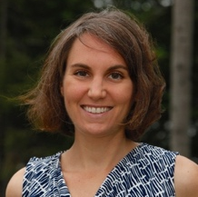Senior Research Scientist and Director of the Center for Seafood Solutions, Bigelow Laboratory for Ocean Sciences. Nichole is a benthic marine ecologist whose work focuses primarily on the eco-physiology of seaweeds and calcifying invertebrates and their current and future role in dissolved inorganic carbon and nutrient cycling.

Key Takeaways
- Bigelow Labs is an independent, nonprofit research institute located in East Boothbay, Maine. The institute has been in operation for over 45 years, using cutting edge technology to conduct ‘blue skies’ and applied oceanographic research.
- The FY2019 Appropriations Bill directed USDA to form and chair a working group that would report on opportunities for farming seaweeds and seagrasses to deacidify ocean environments and provide agricultural products. This led to the formation of the Interagency Working Group for Farming Seaweeds and Seagrasses, which has 46 members from 25 Offices/Divisions representing 8 Departments/Agencies.
- USDA had partnered with Bigelow to advance the Working Group and support research. The Working Group funded six demonstration projects across the United States and is compiling the Report on the State of Seaweed Farming and Information Gaps for Congress to be released in May 2024. Input on the report is welcomed.
- The Working Group hosted regional listening sessions to collect input on topics to be included in the report and priorities for demonstration projects. Additional listening sessions are currently under development.

Highlights and Insights
Directed by Congress, an interagency effort is identifying and documenting gaps in research related to the capacity for seaweeds and seagrasses to deacidify the oceans and opportunities to use farmed seaweeds and seagrasses as feedstock.

Resources Shared
- Bigelow Center for Seafood Solutions
- USDA Interagency Working Group for Farming Seaweeds and Seagrasses

Kelp Distributions in Warming Waters: how population genetics can help inform the seaweed sector

Presenter: Carrie Byron
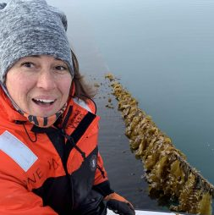Associate Professor of Marine Ecology at the University of New England. Carrie’s research is grounded in marine ecology covering disciplines including aquaculture, fisheries, and coastal management. Carrie works on projects that look at biotic and abiotic dynamics and interactions as they apply to conservation and/or social development issues. Key Takeaways
- The kelp aquaculture industry is dependent on sourcing seed from wild beds; however, abundance of wild kelp is declining in southern Maine due to warming ocean temperatures and little is known about the population genetics of these wild beds.
- Research is underway to document the genetic diversity both among and within these populations and compare sites that are targeted by aquaculturists for sorus tissue collection with those that are not. This research represents a collaborative effort across disciplines and institutions and is closely involves industry partners.
- Thus far, 600 samples of Saccharina latissima and Laminaria digitata have been collected across a number of sites in Maine. The DNA extraction method has been optimized and work is being done with UNH’s Hubbard Center for Genome Studies to optimize next-gen sequencing techniques that will allow researchers to determine genetic diversity within and among populations.

Highlights and Insights
Given the decline in abundance of kelp, documentation and a better understanding of the genetic diversity of kelp are needed to inform science-based decisions for natural kelp beds and aquaculture farms.
“The loss of sugar kelp is of particular concern because farmers rely on wild beds for sorus tissue collection for cultivation.”
— Carrie Byron

Blue Carbon: measuring a potentially significant and revenue-generating carbon storage pathway in seaweed aquaculture

Presenter: Robin Sleith
Postdoctoral Researcher, Bigelow Laboratory for Ocean Sciences. Robin is interested in the many ways in which algae impact our lives. Robin’s research utilized molecular and computational approaches to address questions of algal diversity, evolution, and ecology. Robin’s current work is with the Maine environmental DNA project, a multi-institutional initiative that seeks to better understand Maine’s coastal ecosystems.

Key Takeaways
- ‘Blue carbon’ is a term for the carbon captured by the world’s ocean and coastal ecosystems. Carbon Dioxide Removal (CDR) is the process of measuring and verifying removal of carbon, which then allows corporations, nations, and individuals to seek investable carbon credits.
- Seaweed aquaculture represents a promising method of CDR, since seaweed and seaweed farming are widespread and highly scalable. However, careful consideration of impacts, ethics, and societal benefits of proposed CDR strategies are needed, and there is little scientific evidence to support the viability of sinking seaweed as a proposed CDR strategy. There is interest in CDR routes that support the industry as it currently exists and allows farmers to get credit for “byproducts” of current production.
- Research is underway to verify how much carbon seaweed can sequester from farms and examine the utility of eDNA tools to quantify this carbon. Preliminary data confirms the presence of sugar kelp DNA in sediment cores underneath farms and eDNA results correlate with kelp carbon content. This suggests eDNA analysis may be a cheap, scalable option versus current stable isotope methods. Cost-effective tools that verify carbon sequestered from seaweed farms will allow farmers to capitalize on emergent carbon markets.

Highlights and Insights
For seaweed farms to meaningfully contribute to carbon sequestration and tap into emergent carbon markets, the impacts, ethics, and societal benefits of the end-use and sequestration method must be considered.
“How do we use eDNA to look
at carbon sequestration?”
— Robin Sleith

Ability for seaweeds to mitigate coastal ocean acidification and improve shellfish sustainability

Presenter: Nichole Price
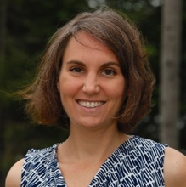Senior Research Scientist and Director of the Center for Seafood Solutions, Bigelow Laboratory for Ocean Sciences. Nichole is a benthic marine ecologist whose work focuses primarily on the eco-physiology of seaweeds and calcifying invertebrates and their current and future role in dissolved inorganic carbon and nutrient cycling.

Key Takeaways
- Collaborative research investigated the ability of sugar kelp to mitigate coastal ocean acidification and improve shellfish resilience in Maine. Over three years, higher pH, higher DO, and lower pCO2 values were observed inside the farm site compared to a control location outside the farm - contributing to a ‘halo,’ or ‘halo effect,’ where seaweed lowers local acidity levels by absorbing nitrogen and CO2.
- Mussels deployed in the seaweed farm had significantly thicker and denser shells compared to those deployed at varying distances outside the farm. In addition to an improved capacity to survive the growing season, thicker and denser shells also mean mussels hold up better in transport and processing, key considerations for shellfish farmers.
- This research indicates that co-culture with seaweed could be a promising strategy for growing healthy shellfish in ocean and coastal waters susceptible to acidification. With evidence of the ‘halo effect’ in Maine, this research is expanding to evaluate collaborating seaweed farms in Alaska and Norway.

Highlights and Insights
Cultivation of seaweed is a promising strategy for mitigating local acidification, and co-cultivation alongside shellfish expands this impact, improving shellfish health and bringing additional benefits to farmers.
“As we look ahead to a more acidic future, we ask ourselves if we can come up with a practical, local remediation strategy.”
— Nichole Price

Nutrient Bioremediation: how kelp farms take up excess nutrients in our coastal waters

Presenter: Brianna Stanley
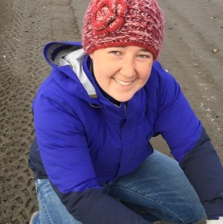Postdoctoral Scientist, Bigelow Laboratory for Ocean Sciences. In her work at Bigelow, Brianna assists with research looking into aquatic nitrogen and carbon cycles. Brianna’s current projects include carbon capture and nitrogen uptake by sugar kelp and freshwater microbialites.

Key Takeaways
- Seaweeds uptake naturally sourced and human-sourced nutrients from the surrounding environment. In order to establish nutrient credit markets, the amount of nutrients (C, N) removed by kelp must be quantified.
- Research assessed the impact of the type of nitrogen and kelp age on nutrient removal by kelp. Preliminary results showed that kelp is an effective mechanism for nutrient (C, N) capture, and that carbon capture is supported by multiple inorganic nitrogen forms (nitrate, ammonia). Carbon and nitrogen uptake was found to be fastest in the meristematic and vegetative tissues, but was detected in all tissues including the holdfast, stipe, and tip.
- Kelp efficiently captures forms of anthropogenic inorganic nitrogen, and tissue content is generally a good representation of nitrogen capture.

Highlights and Insights
By efficiently capturing anthropogenic inorganic nitrogen, kelp may be an asset for nutrient credit programs, though the conditions of this nutrient capture need to be further explored.
“Kelp age, health, and conditions of growth
impact the form and rate of nitrogen acquisition.”
— Brianna Stanley

Coast to Cow to Consumers: Feeding seaweeds to dairy cows to enhance milk production and reduce greenhouse gas emissions

Presenter: Kevin Postman
Senior Research Associate at Bigelow Laboratory for Ocean Sciences. A member of the Air-Sea Interactions Laboratory and the Bigelow Analytics Facilities Service Center, Kevin is focused on evaluating the utility of algae for livestock feed to reduce enteric methane emissions. Key Takeaways
- Global livestock production generates a significant amount of greenhouse gases (GHG), with cattle as the leading contributor of livestock emissions (62%). A large portion of emissions are attributed to enteric fermentation, or direct emission from the animals, and emission of methane is of particular concern given its high warming potential (more than 25 times greater than carbon dioxide).
- Research has shown that certain seaweeds contain compounds that can influence cows’ digestion and reduce their methane production. To continue this research, USDA awarded a $10 million grant to a multidisciplinary team of researchers from schools and laboratories across the country.
- The Coast, Cow, Consumer project (C3) is a five-year project to develop a seaweed feed additive to mitigate methane production in dairy cows. The research is screening candidate algae species and will conduct thorough trials to evaluate animal performance and safety, human food safety, and palatability and intake of cow products. Selection criteria for algae species includes factors such as species suitability, production volumes, environmental sustainability of production, profitability for seaweed and dairy producer, animal and consumer safety, and health or quality co-benefits of algae animal feed.
- Informed by a lifecycle assessment framework and market analysis on profitability, this work aims to benefit seaweed producers, dairy farmers, and end consumers. For seaweed producers, this could mean new markets and demand for seaweed products. For dairy farmers this could mean reductions in greenhouse gases produced on the farm, potentially meeting carbon reduction incentives or regulations, as well as healthier and more productive cows.

Highlights and Insights
Development of seaweed feed additives to reduce methane emissions has potential global impacts on greenhouse gas reduction while also linking local sustainable aquaculture to sustainable agriculture.
“Can we use seaweed to reduce a cow’s carbon hoofprint?”
— Kevin PostmanResources Shared
- Coast Cow Consumer Research Website

Crosstalk Discussion
In this follow-up crosstalk discussion, presenters answered audience questions about their research and discussed opportunities for communication and collaboration.

Highlights
When can the industry start to talk about the benefits of seaweeds without getting ahead of the science?
Presenters acknowledged that, though there’s a lot of excitement and attention around seaweed’s climate-related benefits, many of these projects are just starting. The research teams are working as fast as possible to finish these projects and to get them into peer-reviewed literature. Presenters encouraged folks to follow along with the science as it develops, and to look toward current and upcoming peer-reviewed literature for science-based information to share.
How can research institutions foster good relationships with industry?
Panelists shared their experiences and recommendations for effectively engaging industry in research and building relationships. Recommendations specific to involving industry in research proposals included acknowledging the ‘ask’ being made of industry partners, engaging industry early in the development of proposals (pre-proposal stage), and paying them for their time and expertise. Presenters also noted that research should consider what operational scale is relevant, and industry partnerships can be helpful in achieving this. Finally, panelists stressed the importance of understanding that all farmers are scientists themselves and are often asking the right questions.

Lightning Talks
The symposium’s featured lightning talks highlighted new research, products, and resources to broaden conference programming. Selected lightning talks were capped at 5 minutes and organized by theme, with each theme presented following short networking breaks.

Themes Included
- Resources for Farms and Businesses (6 Talks)
- Innovations in Technology, Gear, and Production (6 Talks)
- Markets and Ecosystem Services (4 Talks)
“The lightning talks were SO engaging — great idea, I want to see
more of that format at conferences.” — Attendee Feedback

Resources for Farms and Businesses

USDA’s Farm Service Agency: Programs and Resources for Aquaculture
Sherry Hamel, State Executive Director, USDA Farm Service Agency
Abstract: FSA representatives discuss programs and resources for aquaculture, including access to capital and disaster recovery.

Key Takeaways
- The Farm Service Agency provides support and programs for aquaculture, including loan opportunities for farms to cover the purchase of seed, rafts, boats, cages, baskets, and other annual operating expenses.
- FSA loans offer lower interest rates than commercial lenders, no application or appraisal fees, payment flexibility, and progression lending.
- Although seaweed is currently not eligible for NAP (Noninsured Crop Disaster Assistance Program), the FSA is hoping to change this. NAP provides financial assistance when low yields, loss of inventory, or prevented planting occur due to natural disasters.

Resources Shared
- FSA Website
- Farmers.gov

Together we are stronger: The International Seaweed Association
Susan Løvstad Holdt, Secretary General, International Seaweed Association
Abstract: The International Seaweed Association (ISA) strives to promote applied phycology on a global basis, and to stimulate interactions among researchers, industrialists, and government representatives in relevant institutions, organizations, and industries across the world. Through these efforts, the ISA seeks to give seaweed a stronger voice globally.

Key Takeaways
- The International Seaweed Association (ISA) is a global community for industry, researchers, students, and professionals.
- The ISA organizes the International Seaweed Symposium every 3 years, which has been held in 6 continents and works with local organizing committees to highlight local strengths and seaweed efforts.
- The next ISS will be held from May 4-9, 2025, in Victoria, British Columbia, and is the symposium's 25th anniversary.

Resources Shared
- International Seaweed Association Website
- ISS 2025 Website
“ISS is the world's oldest seaweed symposium, held in many
locations around the world.” — Susan Holdt

Data Dashboard, assessment of U.S. consumer attitudes and preferences for domestic farm-raised seaweeds
Chris Davis, Executive Director, Maine Aquaculture Innovation Center
Abstract: Following a nationwide consumer survey on edible seaweed and value-added products, survey data has been used to develop an interactive data dashboard that provides searchable consumer preferences and market data for seaweed businesses, retailers, research, and more.

Key Takeaways
- The Maine Aquaculture Innovation Center and Atlantic Corporation, LLC, conducted a survey of 5400 respondents to better understand consumers' familiarity with sea vegetables and buying habits for sea vegetables.
- Questions ranged from eating habits and knowledge of aquaculture to budget and demographic data and were incorporated into an interactive data dashboard.
- The public, web-based interactive data dashboard allows users to explore U.S. seaweed consumer insights as well as tailor results to better understand regional and demographic market composition.

Resources Shared
- Seaweed Consumer Preferences Data Dashboard
- Maine Aquaculture Innovation Center Website
- Maine Aquaculture Innovation Center Facebook

WWF Impact: Deploying catalytic capital for seaweed aquaculture
Struan Coleman, WWF Aquaculture Impact Investor
Abstract: WWF Impact is the impact investment arm of the World Wildlife Fund. WWF Impact backs early-stage seaweed companies by providing flexible, risk-taking capital with the long-term goal of accelerating the development of new technologies, products, and markets.

Key Takeaways
- WWF Impact is investing in for-profit companies to catalyze innovation and impact in the food sector, including in marine aquaculture. With this emerging financial option, early-stage seaweed farms and companies have increased access to the capital they need to create sustainable, long-term businesses.
- WWF Impact’s core strategies include identifying high-leverage market segments, deploying flexible, impact-oriented capital, and accelerating portfolio company growth.

Resources Shared
- WWF Impact Website

Excerpts from a recent knowledge exchange trip: Kelp farming in South Korea
Hugh Cowperthwaite, Senior Program Director, Coastal Enterprises, Inc.
Abstract: During the first week of April 2023, a group of interested parties from all over the globe traveled to South Korea for an intense 5-day tour of the kelp industry in the southern regions of Wando and Mokpo. The World Wildlife Fund (WWF) organized the trip to help kelp growers see and learn firsthand from experts in South Korea, where kelp has been farmed since the 15th century.

Key Takeaways
- During the exchange trip to South Korea, the group had hands-on opportunities to see seaweed nurseries, laboratories, farms, and processing facilities and meet with research and industry experts. Knowledge exchange trips are helpful tools for U.S. researchers and businesses to advance collaboration and spark innovation.
- In South Korea, there is a lot of pride in the industry and seaweed sales are on the rise. Though farming processes in South Korea rely on relatively simple equipment and technology, the nurseries are very technical and complicated, as the farms depend on careful strain selection.

Algae Foundation’s ATEC and AlgaePrize spearheading workforce development
Ike Levine, CEO, The Algae Foundation
Abstract: The Algae Foundation’s Algae Technology Education Consortium (ATEC) and the first edition of the AlgaePrize 2022-2023 was covered as a function of workforce development, education, and training.

Key Takeaways
- The Algae Foundation is working to turn “ick” into “awesome” when it comes to algae, by engaging student groups from second grade to the postgraduate level.
- Educational opportunities through ATEC include in-person academies and online curriculum that focus on the skills needed to support the commercialization of algal products.
- The AlgaePrize is an 18-month contest for high school to graduate students that challenges students to develop creative solutions for real-world issues in the algae value chain, including production, processing, and product development. The 2022-2023 competition was won by a team from University of Alaska Fairbanks, and a high school team also made the top 5.

Resources Shared
- The Algae Foundation Website
- Algae Technology Education Consortium Website
- AlgaePrize 2023-2025 Information Page

Innovations in Technology, Gear, and Production

Composite lines for reduced risk of marine mammal entanglement in aquaculture structures
Zach Moscicki, PhD Candidate, University of New Hampshire
Abstract: Our project team is investigating the use of composite rods to replace ropes in aquaculture structures as a marine mammal entanglement risk mitigation measure. We have developed mechanisms and procedures enabling use of this material in marine aquaculture structures and have tested them as a replacement for mooring lines and cultivation lines on a kelp farm in Saco Bay, Maine. We’re also investigating off-the-shelf composite rod products for their ability to purposely break when interacting with a marine mammal.

Key Takeaways
- In 2022, the project team deployed an experimental kelp farm that used fiberglass rebar as anchor lines and kelp substrate. They tested methods for deploying, seeding, and harvesting kelp from the composite lines and identified some needed improvements.
- Though research is ongoing, replacing rope in kelp farms with composite lines appears feasible and impactful.
- Current and future research includes investigating alternative fiberglass products for durability and breaking performance, testing alternative surfaces and seeding methods for improved holdfast attachment, and testing with a numerical whale simulator.
“We learned a lot about how to work with composite material.”— Zach Moscicki

Following the Snail Trail: Interactions of the marine snail
Lacuna vincta with kelp farms in the Gulf of Maine
Cara Blaine, Graduate Student, University of New England
Abstract: The removal of kelp farms before the summer and rigorous surveying prior to lease placement may help deter fouling by other invertebrates, but the small marine gastropod Lacuna vincta (family Littorinidae) has proved to be an unpredictable and continuous obstacle for kelp farmers in Maine. Our research aims to pinpoint timing of L. vincta settlement on kelp farms, determine if environmental DNA (eDNA) is a useful early detection tool for this species and if the biology of the kelp itself is a factor in snail preference on farms.

Key Takeaways
- Based on industry input and unpredictable snail distribution on farms (anecdotally, heaviest on the perimeter and patchy throughout), grazing trials were conducted to determine if kelp health and species impact snail preference.
- Preliminary results showed that snail preference for healthy versus stressed sugar kelp fluctuates over time, possibly due to changes in anti-herbivory compounds as kelp degrades. Preliminary results also show that snails have a preference for skinny kelp (Saccharina angustissima) versus sugar kelp (Saccharina latissima).
- The project team will conduct additional trials for confidence and hopes this research will contribute to best management practices for kelp farms experiencing interactions with L. vincta.

Turnkey gametophyte bioreactors
Ashley Roulston, Global Business Development, Industrial Plankton
Abstract: Industrial Plankton has developed a seaweed bioreactor (SBR) that controls temperature, pH, light, and blending for optimal seaweed gametophyte growth in a biosecure environment. The SBR grows continuous, high-density cultures of gametophytes, allowing lines to be seeded at any time with selected strains.

Key Takeaways
- Seaweed bioreactors (SBR) provide ideal growing conditions for gametophytes and are modified from 13 years of microalgae technology and design.
- SBR systems incorporate temperature and pH control, blade to shred culture functions, filtration, customizable light spectrum settings, real time data logging and web access, and are autoclavable for easy sterilization.
- These systems allow for separate strains to be maintained, enabling reliable seed sourcing and controlled breeding. This helps to address the current seed bottleneck, reduce dependence on wild populations, and ultimately improve biomass yield on farms.

Resources Shared
Industrial Plankton Seaweed Bioreactor Information Page

Diversifying the New England seaweed industry: Investigating farmer feasibility of tank culturing warm-water species, Graciliaria tikvahiae
Katie Kost, Southern Connecticut University
Abstract: As climate change warms our oceans, commercial production of additional native seaweed species is needed to maximize productivity, grow the industry, and diversify income. This research is investigating different light sources, temperature regimes, and food sources to determine the ideal tank culturing conditions for warm-water species Gracilaria tikvahiae, with a focus on practicalities for seaweed farmers.

Key Takeaways
- From April to October 2022, Gracilaria tikvahiae was cultivated in an indoor system and a greenhouse system, built using practical equipment that would be accessible to farmers. Preliminary results showed that the greenhouse culture grew faster and had higher mass than the indoor culture, likely due to greater natural lighting and higher temperatures. Future cultivation efforts will focus on additional lighting and biofouling mitigation.
- Subsamples of G. tikvahiae were collected for market research with local chefs and at farmers markets. Preliminary market research was positive for this seaweed product, with many restaurants offering it as a salad garnish and home cooks also purchasing it for use.

Assessing heat tolerance in sugar kelp
Sara Gonzalez, Postdoc, Woods Hole Oceanographic Institution
Abstract: Warming sea temperatures are threatening sugar kelp populations, and we need to identify individuals with natural adaptations to cope with heat for future aquaculture operations. We assessed heat tolerance in sugar kelp gametophytes by exposing them to different temperatures and measuring their photosynthetic performance and fertility following heat stress and identified potential genetic loci of interest related to heat tolerance. We will work to assess the relationship between gametophyte and sporophyte heat tolerance.

Key Takeaways
- Some sugar kelp may have useful adaptations to cope with warmer temperatures, given the genetic diversity in Northeastern kelp populations. Identifying individuals with existing adaptations to heat, and the genes responsible, makes it possible to breed more heat-tolerant kelp, which will be critical for farms as Gulf of Maine ocean temperatures are predicted to exceed the mortality threshold for sugar kelp by 2050.
- The experiment to evaluate heat tolerance exposed gametophytes to control temperatures, current anomaly temperatures for the Gulf of Maine, and future expected temperatures. Heat negatively impacted photosynthetic performance, however many individuals in the heated treatments were still able to produce sporophytes (though the quality is unknown). Future efforts will measure how well sporophytes perform in warm conditions to assess how heat tolerance in gametophytes relates to heat tolerance in sporophytes.

Update on Alaska’s Macroalgae Cultivation Industry
Melissa Good, Mariculture Specialist, Alaska Sea Grant
Abstract: This presentation provided background on the seaweed mariculture industry in Alaska; reported on the strength, weakness, opportunities, and threats to this nascent industry; and concluded with the types of projects that mitigate weakness and threats and take advantage of Alaska’s strengths and opportunities.

Key Takeaways
- In 2022, Alaska saw the greatest year of production and the industry is growing very rapidly. There is significant state support for developing Alaska mariculture industries, which could help increase sales of Alaska seaweed and increase capacity and capability of new and existing companies.
- Current barriers include a lack of processors and processing capacity, supply chain logistics and costs to export product out of state, limited local markets due to lower population density, and minimizing permitting conflicts and simplifying the revision process for permits.

Markets and Ecosystem Services

Building the domestic market for seaweed: Lessons learned from five years of value chain coordination
Sam Garwin, Director of Market Development, GreenWave
Abstract: Seaweed is the fastest growing aquaculture sector in the United States according to NOAA, and yet connecting farmers and buyers remains a struggle. To address this issue, GreenWave has invested heavily in value chain coordination - the development of relation-based infrastructure for a supply chain - through a combination of resources, programming, and technology. This lightning talk shared lessons learned from five years of this work.

Key Takeaways
- GreenWave’s value chain coordination efforts have been formalized into a program called Seaweed Source which includes hands-on support, relationship facilitation, partnerships for start-up accelerators, industry cohorts, a sampling program connecting farmers to buyers, and a web app.
- Lessons learned in this work include the importance of building relationships versus one-off transactions, growing market opportunities together, understanding details and advanced planning in working with farmers, that vertical integration leads to fluidity of supply chain roles, the vital role of collaborative regional networks in the value chain, and that approaches to build the value chain should consider how to keep power in the hands of the farmers.

Resources Shared
- GreenWave Website
- GreenWave Seaweed Source
- GreenWave Ocean Farming Hub

Increasing consumer demand through ecosystem services provided by farmed seaweed
Carrie Byron, Associate Professor, University of New England
Abstract: Ecosystem services are benefits humans derive from ecosystems, which can include seaweed farms. Providing education on ecosystem services of seaweeds increases willingness to pay for seaweed products. Maine seaweed farms provide several ecosystem services, and a recent study demonstrates that Maine farms are not interfering with wild species due to harvest and gear removal in the spring.

Key Takeaways
- One way to build social license for aquaculture is to increase the breadth of understanding of the concept of ecosystem services, which includes provisioning services, regulating services, cultural services, and supporting services provided by aquaculture products. Education on ecosystem services significantly increased consumer willingness to pay for kelp products, across price points and sectors.
- Researchers utilized visual observations and eDNA methods to see if kelp farms increased biodiversity by providing seasonal habitat but saw no difference in wild species between farm sites and reference sites during the growing season. This is promising, as it demonstrates that kelp farms may not impact or disturb the natural biodiversity of species in an area.

Resources Shared
- Bolduc, W., Griffin, R.M. & Byron, C.J. Consumer willingness to pay for farmed seaweed with education on ecosystem services. J Appl Phycol 35, 911–919 (2023). https://doi.org/10.1007/s10811-023-02914-3
- Schutt, E., Francolini, R., Price, N., Olson, Z. & Byron, C.J. Supporting ecosystem services of habitat and biodiversity in temperate seaweed (Saccharina spp.) farms. Marine Environmental Research 191 (2023). https://doi.org/10.1016/j.marenvres.2023.106162
“Even with a brief introduction into ecosystem services, consumers surveyed were willing to pay more for kelp products.”— Carrie Byron

Ecosystem service evaluation of kelp farms versus natural kelp beds in Kodiak, Alaska
Alix Laferriere, Supervisory Research Fisheries Ecologist, Alaska Fisheries Science Center
Abstract: This project conducted in Kodiak, Alaska examines habitat provisioning of kelp farms. Do kelp farms provide habitat for juvenile or adult fish during the growing season? How does this habitat use compare to natural kelp beds?

Key Takeaways
- In the 2022-2023 season, the Alaska Fisheries Science Center initiated a small-scale study, partnering with Alaska Ocean Farm, to assess juvenile and adult fish habitat use of kelp farms. Methods for this work include visual surveys with GoPro cameras, eDNA sampling, and fish collection via Standard Monitoring Units for Recruitment of Fishes (SMURFs).
- GoPros were set to be deployed at farm sites and wild beds through June 2023. Next steps for this work will be review and analysis of the footage, deployment of SMURFS, and incorporation of eDNA sampling next year to cross-validate results.

Restorative Seaweed Aquaculture Initiative in the
Pacific Northwest
Megan Considine, Global Aquaculture Program Coordinator, The Nature Conservancy
Abstract: The Pacific Northwest coast of North America has been identified as a top marine ecoregion where seaweed aquaculture could be environmentally beneficial, socially acceptable, and economically viable. Despite interest and high environmental and social potential for seaweed farming in this region, the industry faces several challenges. This lightning talk covered three seaweed aquaculture projects The Nature Conservancy is partnering on to help catalyze a restorative aquaculture industry in the Pacific Northwest: seaweed situation analysis for Oregon and Washington and an open-source blue carbon model for seaweed aquaculture.

Key Takeaways
- TNC’s situation analysis for seaweed cultivation in Oregon explores species options, site selection, production methods, market opportunities, supply chain analysis, ecological considerations, policy needs, tools developed by university and state programs for farmers, and the landscape of current and potential partners. This effort is being replicated for Washington, with an additional emphasis on understanding tribal perspectives and interest. Washington has a developed permitting system for ocean farms, two farms in operation, and additional research and collaborative efforts.
- TNC is working with SciTech Environmental Consulting to develop a web-based, interactive model that uses scientific literature to estimate kelp production, associated emissions, and the potential for marine carbon sequestration or emissions avoided by seaweed replacement products.

Resources Shared
- Situation Analysis for Oregon’s Emergent Seaweed Aquaculture Industry

Symposium Events and Activities
In addition to topic-based sessions, the symposium provided unique opportunities for attendees to develop professional connections and engage firsthand with Maine’s active seaweed industry. Symposium events included networking receptions, field trips, workshops, and an interactive exposition. A summary of each activity and attendee engagement are included below.

Events and Activities
- Opening Reception
- Boat tours, field trips, and workshops
- The Seaweed Showcase
- Closing Seaweed Social

Opening Reception
The opening reception of the conference was hosted at Portland’s Hunt + Alpine Club. Attendees enjoyed seaweed bites and beverages like seaweed-dusted popcorn, kelp-topped hot dogs, oysters with seaweed mignonette, and seaweed daiquiris and mocktails. This opening event provided an opportunity for attendees to meet and network before the conference and experience Portland’s local restaurant and seafood scene. The reception was sponsored by the World Wildlife Fund and GreenWave.

Field Trips and Workshops
On Wednesday, April 26th, conference attendees participated in hands-on field trips and workshops that provided a firsthand look at Maine’s seaweed sector, from kelp farms being harvested to local businesses bringing seaweed to end consumers. There were no additional costs for attendees to participate in these opportunities. They included:
- Boat Tours to Kelp Farms Harvesting in Casco Bay
- Guided Tours of Maine’s Working Waterfront and Infrastructure
- Culinary and Product Development Workshop
- Self-Guided Seaweed Week Walking Tour
“Having a day in the middle to interact with people in a different
way—either through field trips or just having down time to set up meetings with people in person—was so valuable.”
— Attendee Feedback

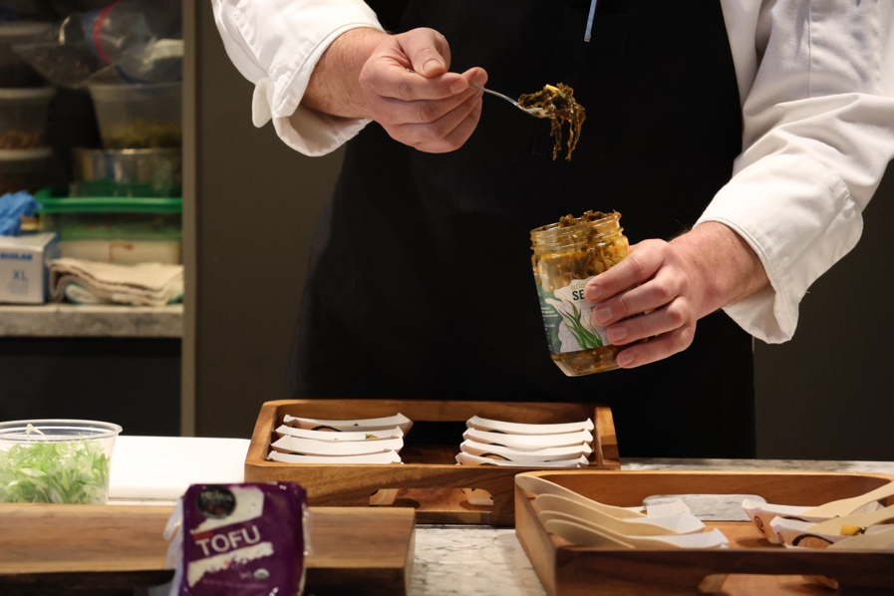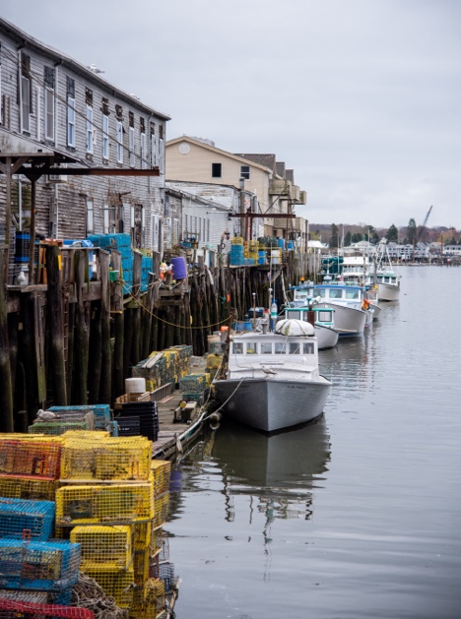

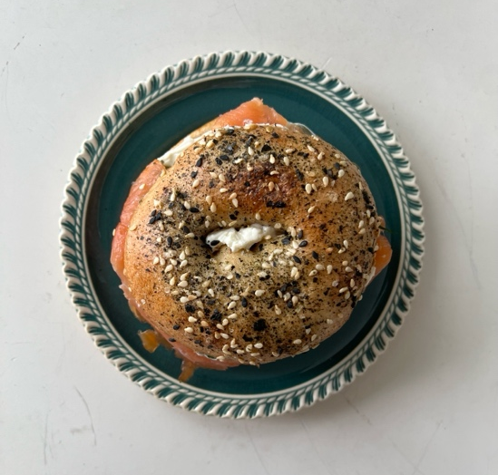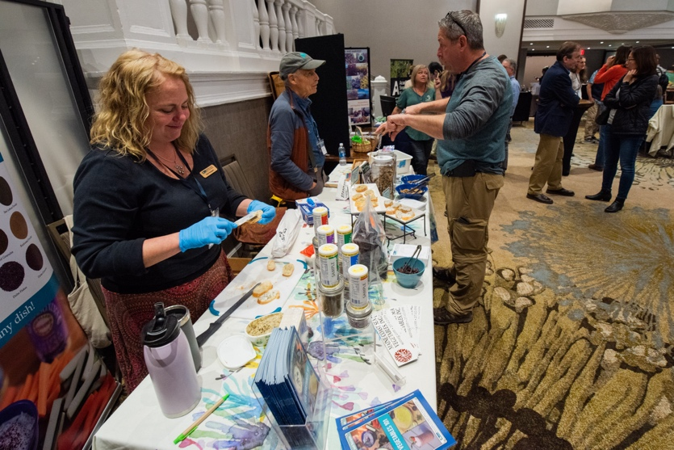
Photos — Chef: Matthew Ornduff, AgencyOf; pier and showcase: Tim Briggs, New Hampshire Sea Grant; Bagel: Jaclyn Robidoux, Maine Sea Grant.

Boat Tours to Kelp Farms Harvesting in Casco Bay
Ninety-eight attendees joined us for two 3-hour boat tours out to kelp farms across Casco Bay. Symposium participants were hosted at the kelp farm sites of Bangs Island Mussels and Spartan Sea Farms, where participants got to see active harvest operations, chat with farmers, and have some kelp delivered! Given the short kelp harvest season and unpredictable Maine weather, participants were excited and fortunate to spend some time on the water and see a kelp harvest in action.

Participant Feedback
“This was as close as you could get to actually seeing and experiencing kelp harvest without being on a [harvest] boat. The interaction with the crews was great and having Sea Grant staff onboard to answer questions was a plus!”
“It was interesting to see the different harvesting methods based on boat size.”
“I loved getting on the water to see the seaweed farms. It was my first time seeing a farm and talking to the harvesters was super helpful.”
Special thank you to the following supporting businesses and organizations:
- Maine Sea Grant (Sponsor)
- New Hampshire Sea Grant (Sponsor)
- Bangs Island Mussels (Farm Host)
- Spartan Sea Farms (Farm Host)
- Fogg’s Water Taxi (Charter Boat)
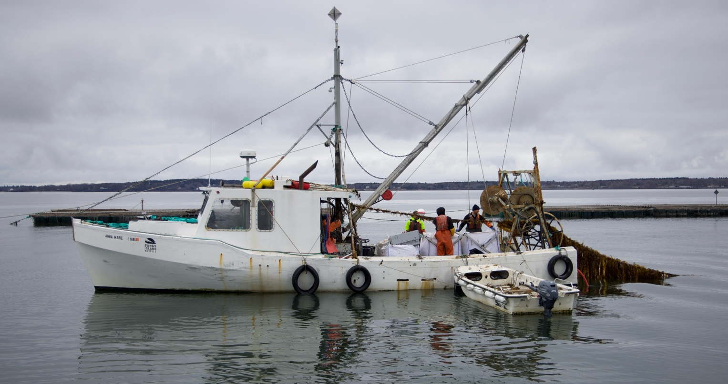
Photo: Matthew Ornduff, AgencyOf.

Guided Tours of Portland’s Working Waterfront and Infrastructure
Eighty-nine attendees joined us for two 1.5-hour tours of Portland’s working waterfront. We were guided by the City of Portland’s Waterfront Coordinator, Bill Needelman, around the historic working waterfront, including the infrastructure and dockside facilities that support Maine's kelp industry. Memorable stops included the Portland Fish Exchange, a major marine service and storage facility for our local kelp farms and processors, and Custom House Wharf, which supports a number of fishermen and waterfront businesses.
Special thank you to the following supporting businesses and organizations:
- Maine Sea Grant (Sponsor)
- New Hampshire Sea Grant (Sponsor)
- City of Portland (Tour Lead)
- Portland Fish Exchange (Host Business)
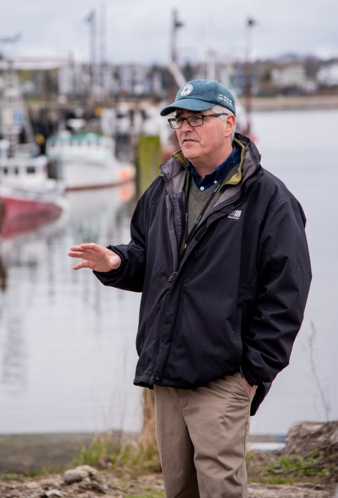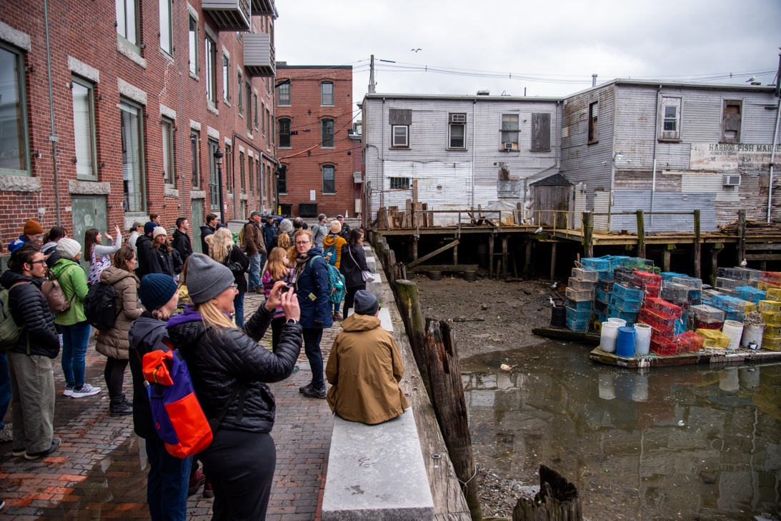
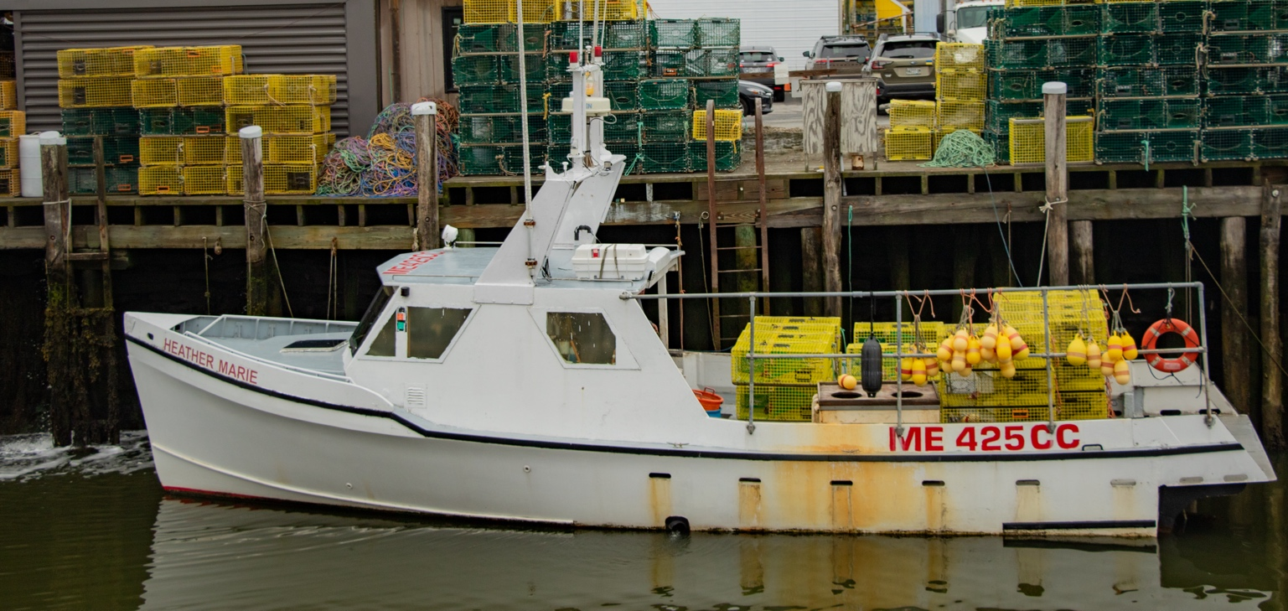

Culinary and Product Development Workshop
Twenty-five attendees joined this fun and interactive 3-hour culinary workshop led by Kara Ibarguen, seaweed culinary expert from Maine Coast Sea Vegetables, and chef Rob Dumas, Food Science Innovation Coordinator at the University of Maine School of Food and Agriculture. During the workshop, attendees explored the culinary differences between seaweed species, explored product development, and cooked up a unique seaweed tasting menu, including Korean-style seasoned tofu atop spicy seaweed salad and kelp-beans with sea lettuce chimichurri over rice. This workshop was hosted by the Maker’s Galley, a kitchen and event space on the Portland waterfront.

Participant Feedback
“Grateful for this eye-opening adventure that expanded my culinary horizons!”
“I had an unforgettable experience attending a field trip focused on the culinary wonders of seaweed. From innovative recipes to expert techniques, we explored the endless possibilities of incorporating this oceanic treasure into delectable dishes.”
“The workshop was great – future cooking workshops should focus on hands-on activities and get folks to work directly with seaweed products.”
Special thank you to the following supporting businesses and organizations:
- Maine Coast Sea Vegetables (Sponsor & Workshop Lead)
- University of Maine School of Food and Agriculture (Workshop Lead)
- The Maker’s Galley (Host)
- Atlantic Sea Farms (Product Donated)
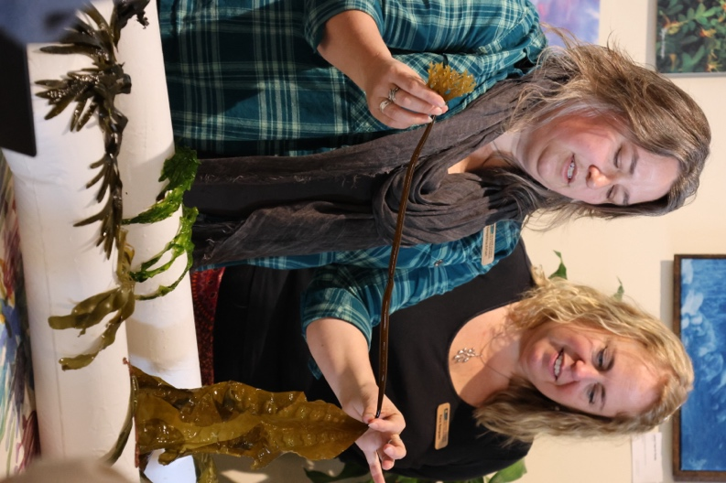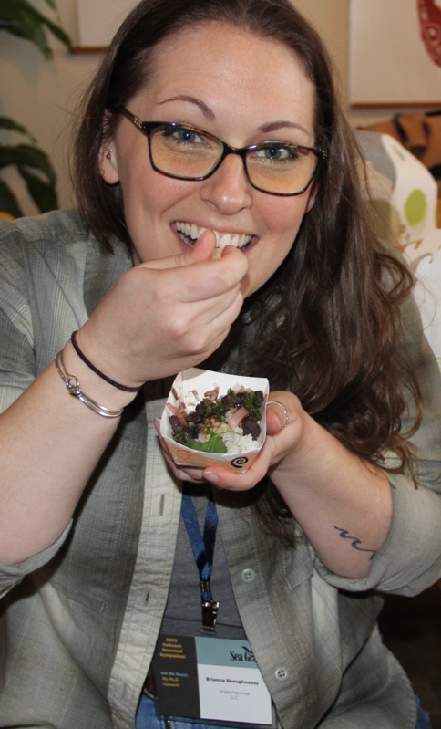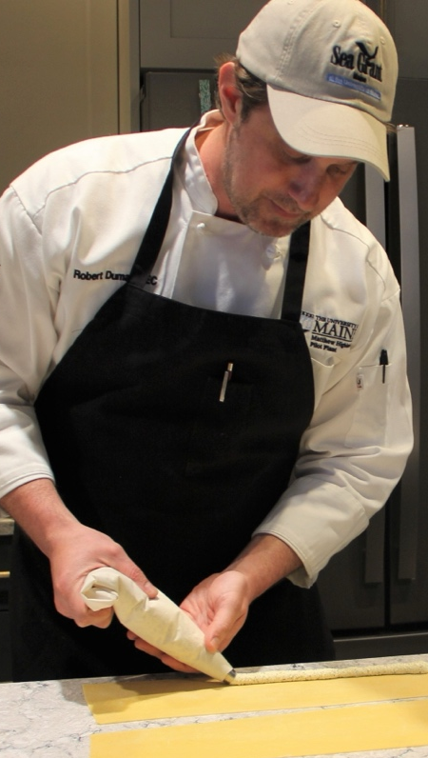
Photos — Left and right: Matthew Ornduff, AgencyOf; middle: Judy Benson, Connecticut Sea Grant
.

Self-guided Seaweed Week Walking Tour
Symposium participants who wanted to explore Portland’s well-known food, beverage, and maker scene on their own time partook in self-guided walking tours of Seaweed Week locations across the city. Participants were provided with a map of 30 walking-distance locations serving up seaweed snacks, beverages, and more. In locations throughout the city, folks were able to find kelp bagels, seaweed-themed stores, kelp burgers, even kelp-infused coffee.
Special thank you to the following supporting businesses and organizations:
- Seaweed Week 2023
- Participating Seaweed Week Businesses
- Maine Sea Grant (Seaweed Week Organizer)
- Heritage Seaweed (Seaweed Week Organizer)
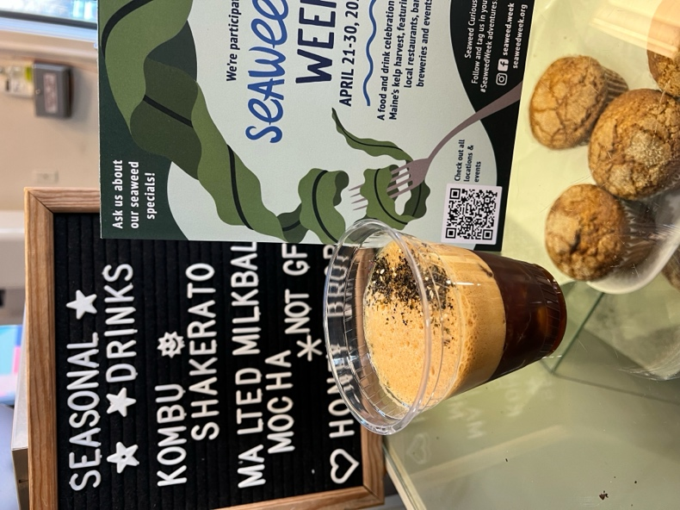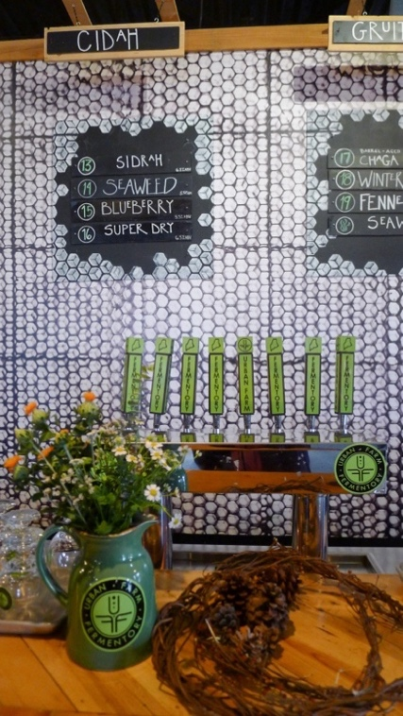
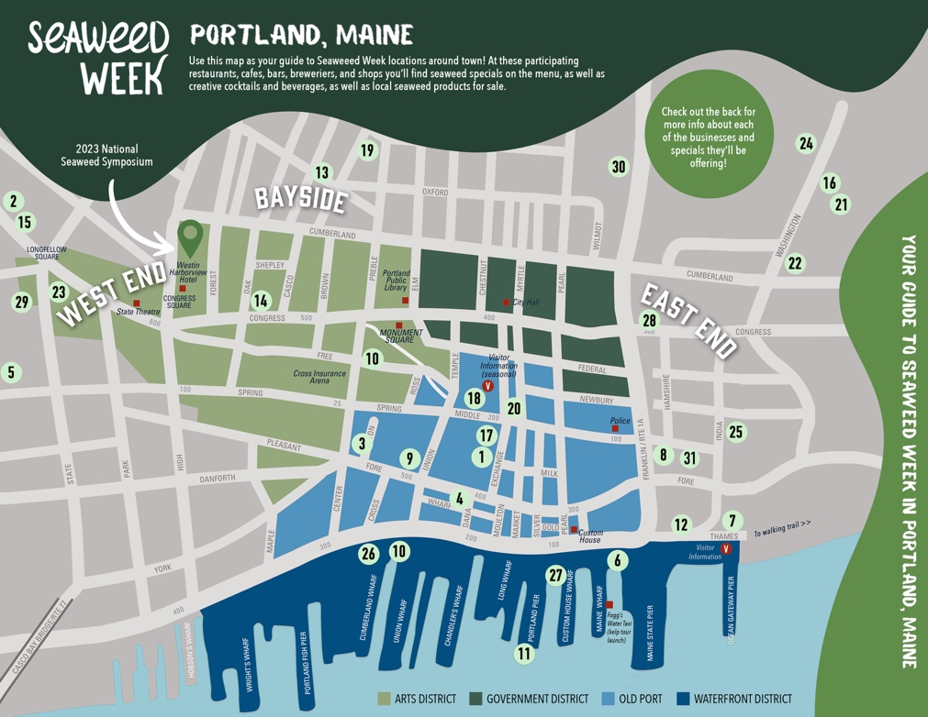
Photos —Muffins: Jaclyn Robidoux, Maine Sea Grant; taps: Kathy Tenga-González, Maine Sea Grant

The Seaweed Showcase
The Seaweed Showcase was the symposium’s interactive exhibition event, highlighting over 35 seaweed businesses, product producers, local artists, researchers, nonprofit organizations, and more. This showcase featured new seaweed products and samples, research and gear demos, seaweed-inspired art, tools and take-home resources, and the opportunity for attendees to chat with seaweed farms, research teams, business planners, marketing professionals, and more. The Seaweed Showcase was sponsored by the Maine Seaweed Council and Acadian Sea Plants.

Attendee Feedback
Participant feedback reflected that the interactive format of the showcase was energetic and informative, and there was excitement to see seaweed-inspired art incorporated into the event alongside science and research.
“What I enjoyed most was getting to interact with others in the seaweed business on a social as well as business level. I especially thought the evening reception was a great idea.”
“The seaweed artists were incredible. A great reminder of the link between art and science and real-time example of how art reaches and inspires the public (and builds social license!)Participating Exhibitors
Seaweed Businesses
- Acadian Sea Plants
- Cold Current Kelp
- Kelpful Cooperative, Inc.
- Latitude 43 Farms
- Maine Coast Sea Vegetables
- North American Kelp
- Ocean’s Balance
- Source Micronutrients
- Spartan Sea Farms
- The Maine Family Sea Farm Cooperative
Seaweed Artists
- Oriana Poindexter/Pelagic Projects LLC
- Saltwater Studio Newport
- The Maine Seaweed Council Arts Committee including demonstrations and works by artists Celeste Roberge, Joel LeVasseur, Krisanne Baker, Marjorie Moore
Research and Technology
- Coast to Cow to Consumer Project at Bigelow Labs
- Dulse Aeroponics at Oregon State University
- Industrial Plankton, Inc.
- Kelson Marine Co.
- Woods Hole Oceanographic Institute
- WL Gore & Associates
Extension, Education, and Business Support
- Belfast Marine Institute/Belfast Area High School
- California Seaweed Festival
- Coastal Enterprises, Inc.
- Greenwave
- Kelp Business Planning with UConn/Keene State
- Leap_year Branding
- Maine AgrAbility
- Maine Sea Grant
- The Maine Aquaculture Association
- The Maine Seaweed Council
- NOAA/NMFS Fisheries Finance Program
- The Seaweed Hub
- USDA Farm Service Agency
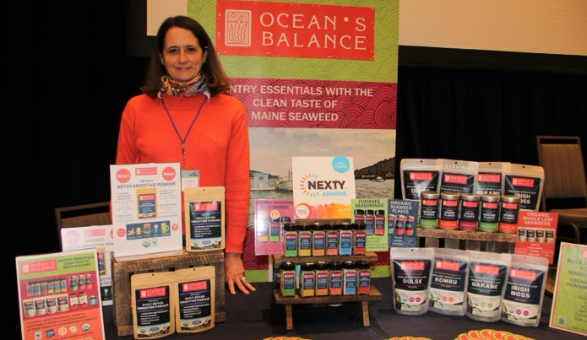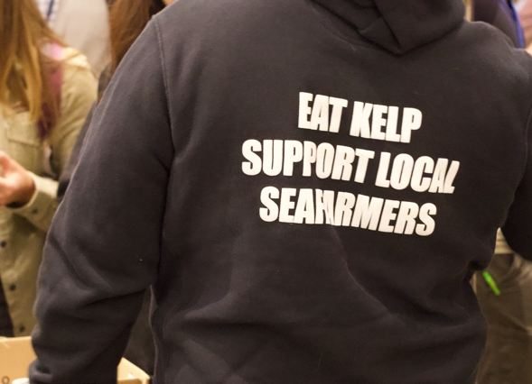
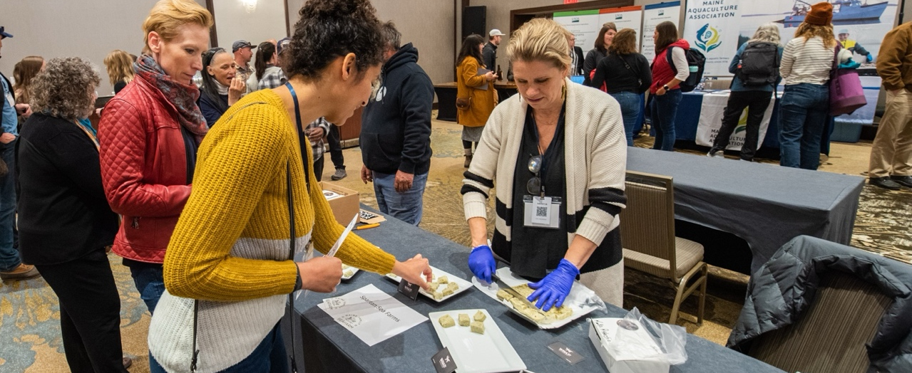
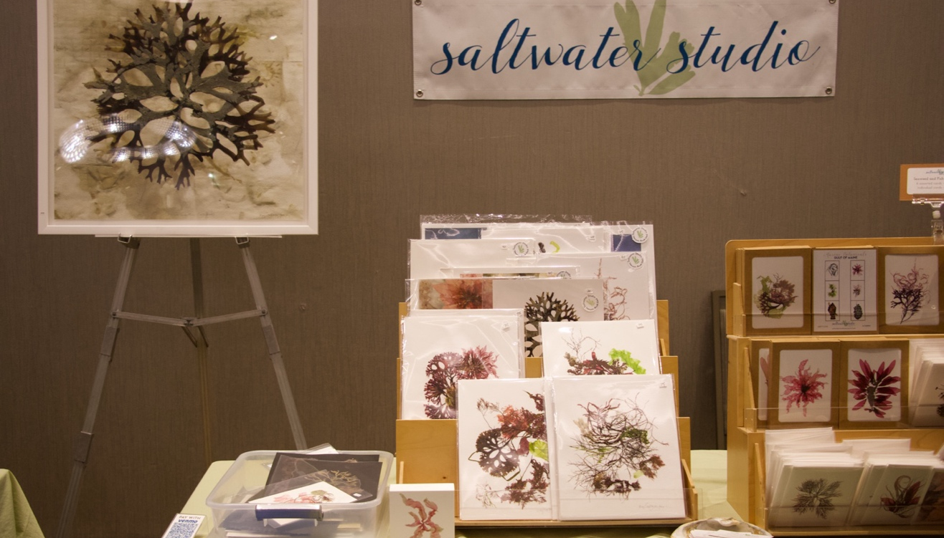
Photos — Product display and sampling fudge: Judy Benson, Connecticut Sea Grant; sweatshirt and artwork: Kathy Tenga-González, Maine Sea Grant

Closing Seaweed Social

The Seaweed Social celebrated the end of the 2023 National Seaweed Symposium. The social was hosted by Oxbow Blending and Bottling and participants enjoyed a final bit of seaweed fun including special-release kelp beer and a seaweed t-shirt giveaway.
Special thank you to the following supporting businesses and organizations:
- North American Kelp (Sponsor)
- Oxbow Blending and Bottling (Event Host)

Participant Feedback and Recommendations

A follow-up survey provided participants the opportunity to reflect and provide feedback on the event. Participants reflected positively on the symposium, highlighting the practical knowledge and connections gained and requesting the event be held again in the future. To describe their experience in a word, participants responded that the symposium was “educational,” “informative,” and “energizing.”
Participants expressed appreciation for:
- The diversity of information and voices reflected in the programming
- The space to create new connections and foster existing relationships
- The opportunity to learn about efforts from outside their state or region
- The firsthand experiences that featured the state seaweed sector in operation
Some of the sessions that participants found the most interesting included:
- The Seaweed Farmer Panel
- The State of the States: Status of U.S. Seaweed Aquaculture
- The Lightning Talks
- The Post-Harvest and Processing Session
- The Field Trips and Workshops
- The Social License Interactive Session
Participants recommended that future opportunities consider:
- More time for small-group discussions and/or breakout sessions
- Hosting the event at another time of the year to minimize conflicts with the spring harvest season
- Increased accessibility across event space and materials (some spaces were noisy, name tag font was small, etc.)
- Recording the sessions and utilizing virtual tools to expand engagement for participants
“Discussions and presentations provided a comprehensive overview of the state of the industry with a wide breadth of insights and perspectives.”
“As a wild harvester it was great to hear more about the aquaculture industry, and how we can all learn from each other.”

What did you appreciate most?
“The opportunity to speak with members of the seaweed industry and have a forum to voice questions and concerns in a meaningful way was so important. We have our own organizations in my state, but to talk with other operations outside of the state was eye-opening.”
“I was very impressed with the organization, selection of presenters, balance of topics and overall efficiency of the event. Everything was very well thought out and executed.”
“[This] provided a balanced overview of the current state of industry as well as the potential and challenges for growth in the sector.”

What recommendations do you have for future events?
“Having a virtual space where people can connect with fellow attendees and/or presenters as well as access presentations/materials throughout the event could be beneficial to expand on the networking and engagement opportunities.”
“If there could be just a bit more guided group discussions, that would be great.”
“Like other conferences I've attended, the receptions are often very loud and difficult to move around in. It's so important to have those networking times, and to be able to hear who you're speaking with… perhaps breakout times for networking could be factored into the conference schedule.”
NA18OAR470081 CT • MSG-E-23-16

