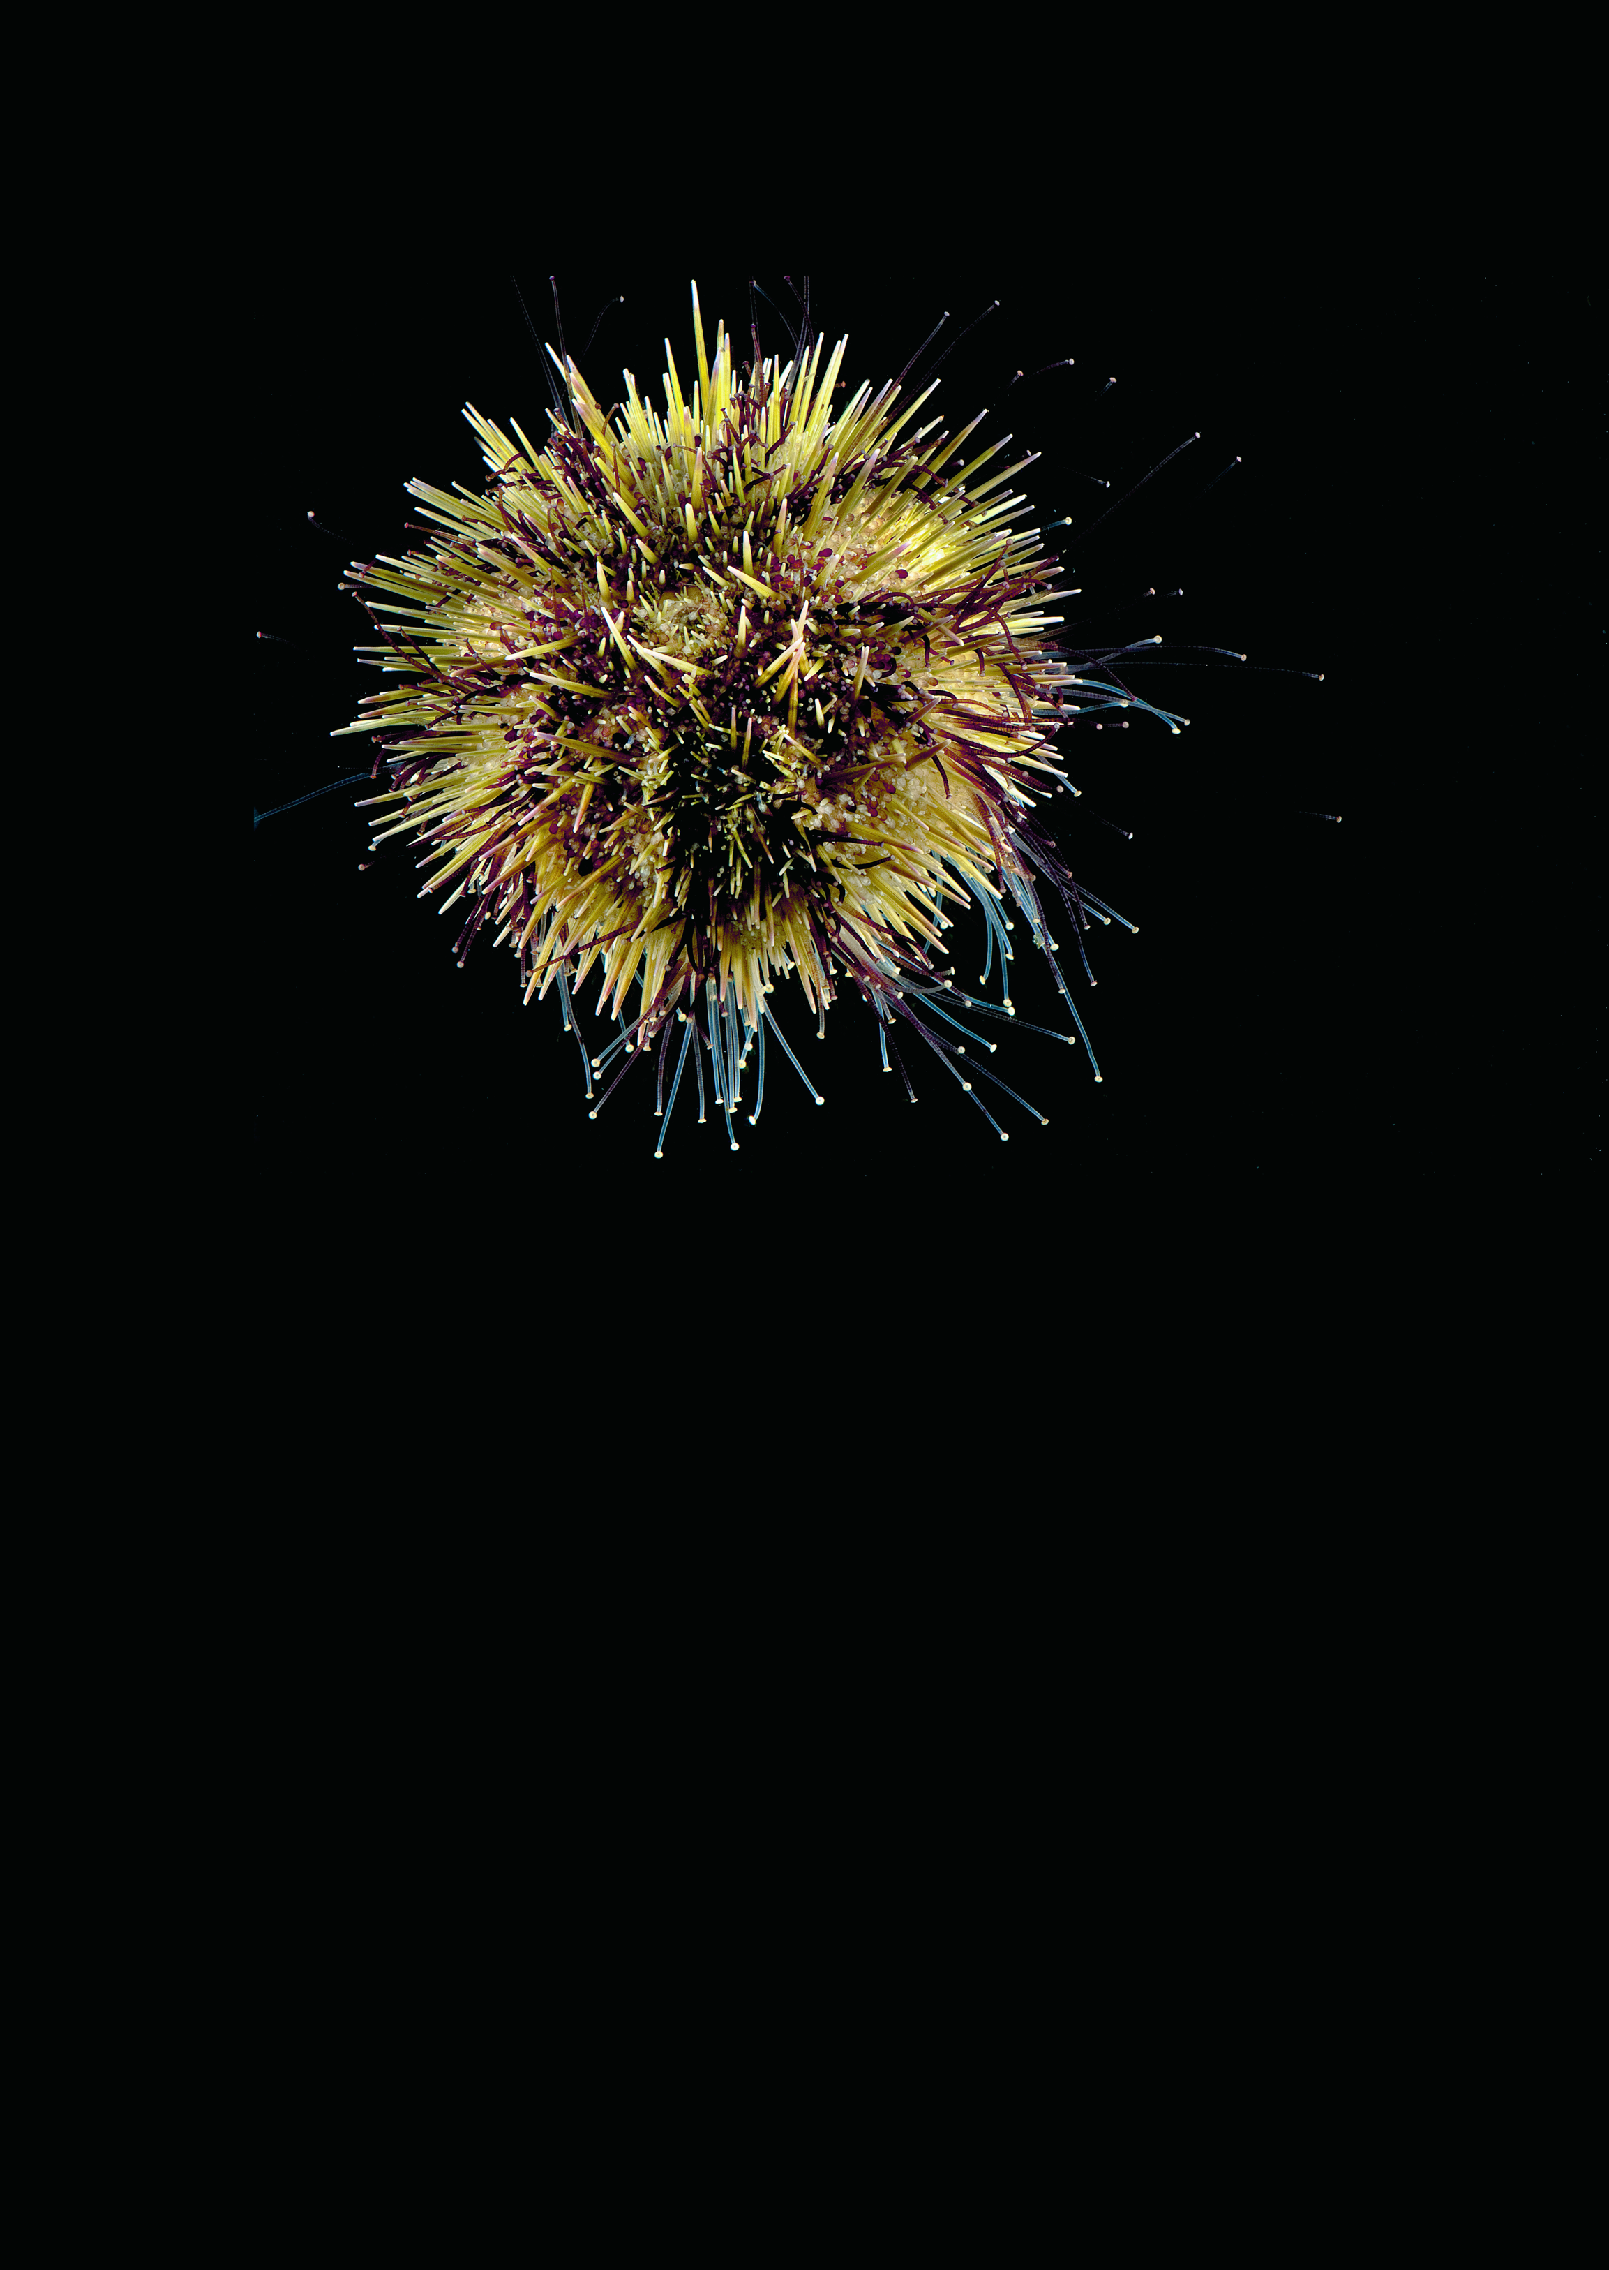

# Green Sea Urchin Aquaculture in the Northeast US Hatchery, Nursery, and Growout

Stephen D. Eddy • Dana L. Morse • Luz M. Kogson • Coleen C. Suckling

**Table of Contents**

Rationale and background 3

Biology of green sea urchins 4

Development of green sea urchins 6

Hatchery production: broodstock and larval food 7

Post-settlement management 8

Growout to market 9

Permit requirements 10

Sea ranching 10

Tank culture for grow-out to market 10

Gonad enhancement 11

Bottom cages 12

Pearl and lantern nets 12

Sea urchin and bivalve co-culture 12

Sea urchin and seaweed co-culture 13

Disease and handling 13

Marketing 13

Summary 15

Authors 16

Literature Cited 16

Additional reading 17

Acknowledgments 17

**Please cite this report as:**

Eddy, S.D., Morse, D.L., Kogson, L.M., Suckling, C.C. 2023. Green sea urchin aquaculture in the Northeast US: Hatchery, Nursery and Growout. Maine Sea Grant Information Booklet. 16pp.

Front photo: Brian Kingzett

## Rationale and background

Green sea urchins (Strongylocentrotus droebachiensis) are prized for the premium quality of their edible gonads, known by the Japanese word uni (Figure 1) Male and female gonads are both referred to as roe, and both are equally desirable as uni (Figure 2). Green sea urchins are a

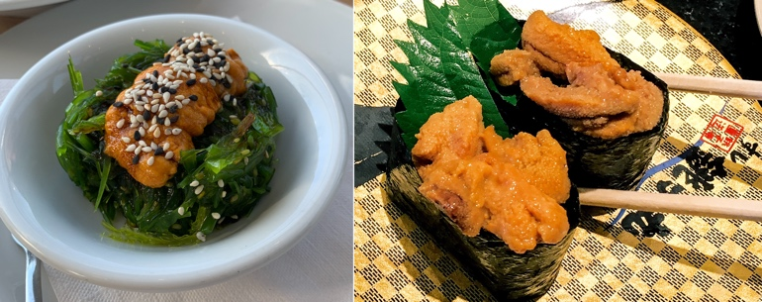

Figure 1 Uni sushi. Left: green urchin roe on a bed of seaweed. Photo: C. Suckling. Right: uni wrapped in seaweed paper. Photo: J. Cant.

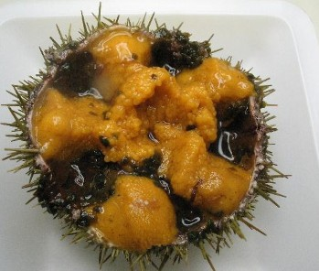

Figure 2 Green sea urchin gonads. Both male and female gonads can be this color and are equally desirable as food. Photo: S. Eddy

cold-water species distributed throughout the northern Pacific and Atlantic oceans, and are commercially fished throughout their range. About eighteen sea urchin species are harvested worldwide, mostly to supply Japanese and other Asian markets, though uni is also consumed in many Western countries, including the US, and demand remains strong as more people discover the unique culinary attributes of sea urchin roe.

The most significant green sea urchin fisheries occur in maritime Canada, Iceland, Norway, Russia, and in the Gulf of Maine, where they were once harvested as far south as Massachusetts. Green sea urchin fisheries are in global decline, and Massachusetts and New Hampshire, the only other New England states to have had commercial urchin fisheries, no longer participate. Maine landings have declined from about 18,000 annual metric tons in the 1990s to about 1,000 metric tons in 2022 (Figure 3). Dock prices for whole, live animals have averaged about $7/kg in recent years, but processed uni fetches anywhere from $20 to $250 per kg. Thus, while landings in Maine are currently valued at about $2–3 million per year, the added value of the fishery through processing is much higher. At 10% roe-yield and $100/kg for processed uni, 1,000 metric tons of sea urchins would be worth about $10 million. The fishery is co-managed by the Maine Department of Marine Resources and the Sea Urchin Zone Council, which consists of harvesters, processors, and scientists, including an aquaculture representative (Johnson et al., 2012). The urchin page on the DMR website is: [maine.gov/dmr/fisheries/commercial/fisheries-by-species/sea-urchins](http://maine.gov/dmr/fisheries/commercial/fisheries-by-species/sea-urchins)

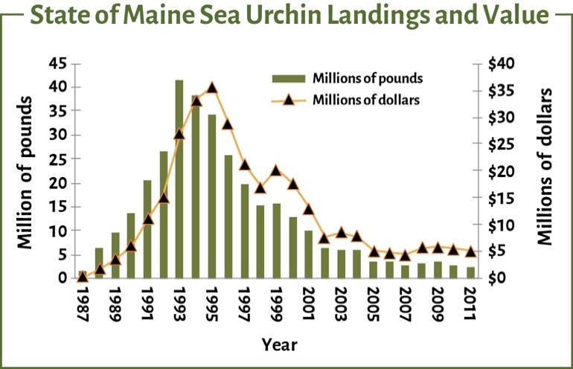

Figure 3 Landings and value. Maine Department of Marine Resources (Adapted by S. Eddy )

The combination of diminished fisheries and strong demand is an opportunity for sea urchin aquaculture, or echinoculture (a term which includes sea cucumber culture), and the availability of hatchery seed has stimulated research and commercial interest in sea urchin production for almost every edible species, including green sea urchins. Researchers and commercial ventures in Norway, Canada, Maine, New Hampshire, and now Rhode Island have tested various approaches to farm green sea urchins since 2000. This document outlines the major processes, equipment, and considerations involved in sea urchin echinoculture.

## Biology of green sea urchins

Sea urchins are spiny, globe-shaped echinoderms with a hard shell, known as a test. In between the spines are flexible tube feet, which the animals use for attachment, locomotion, and as sensory organs. The mouthparts, known as Aristotle’s Lantern due to their shape, are located centrally on the underside of the animal. Five triangular ‘teeth’ are present, which sea urchins use to feed upon macroalgae, microbial biofilms, and small organisms such as barnacles and snails. The mouthparts are very hard and can chew into calcareous algae and even soft rock. The digestive system is simple and exits to an anal pore centrally located on the animal’s dome. The internal compartment of the animal is divided into five chambers, where the reproductive gonads develop as five separate lobes. These can make up 20–30% of the sea urchin’s weight when fully mature, and predators prize them for their high nutritional value. Sea otters, crabs, lobsters, and various fish species all prey upon green sea urchins.

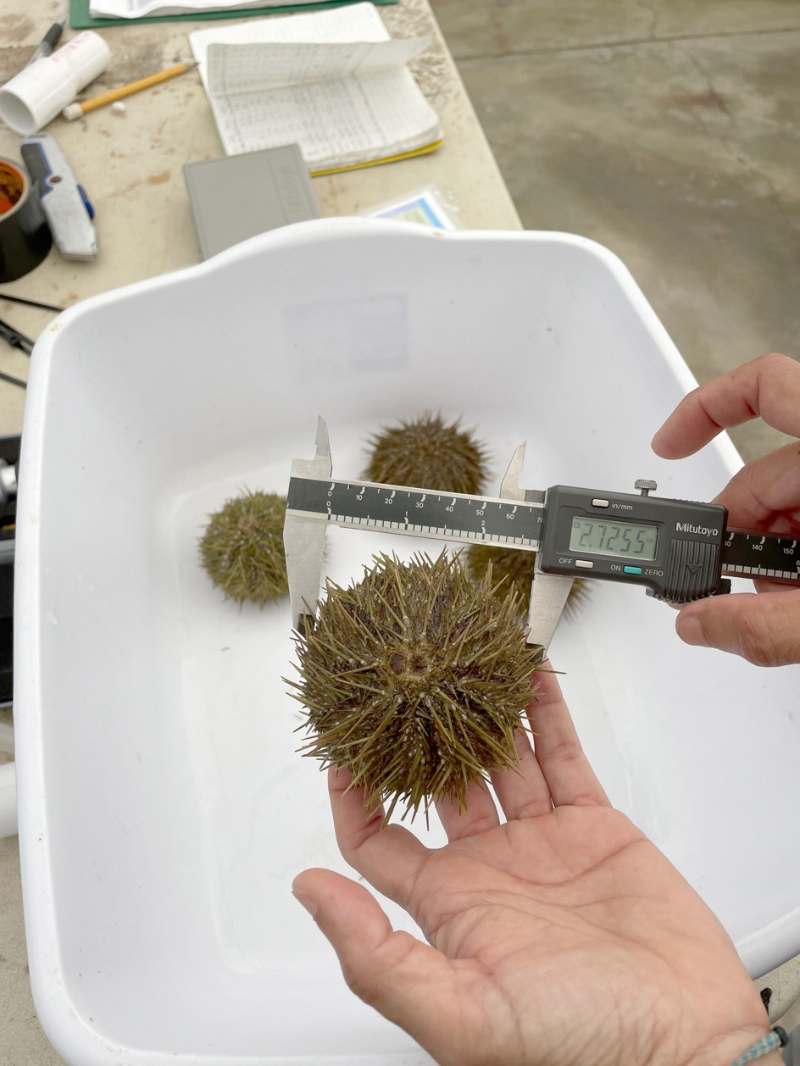

Figure 4. Measuring urchin test diameter with a set of calipers. Photo: S. Eddy

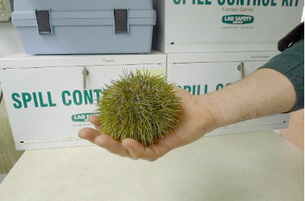

Figure 5. A very large green sea urchin. Photo: S. Eddy

Green sea urchins may live for 20+ years, though growth in the wild can be variable (Vadas et al., 2002). Size is typically measured as test diameter (TD) in inches or millimeters (mm), using calipers positioned on either side of the broadest width of the test, not including the spines (Figure 4). Green urchins may grow as large as 135mm TD, though it can take 10+ years to attain this size (Figure 5). Fecundity (fertility output) is a function of test size, and there is no evidence that reproductive output declines with age or in larger urchins (Vadas and Beal, 1999). Green sea urchins ripen for spawning in the Gulf of Maine in late winter/early spring, with most spawning occurring in March and April at water temperatures between 3 to 7°C (Stephens, 1972). This pattern may change as the Gulf of Maine experiences warming conditions.

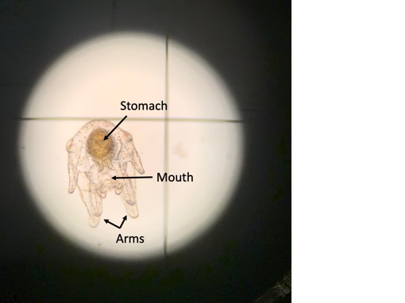

Figure 6. Left: Green sea urchin echinopluteus larva nearing metamorphosis. Photo: S. Eddy. Right image shows the stomach, mouth and arms of 6-armed stage pluteus. Photo: C. Suckling.

Green sea urchins are free spawners, meaning males and females release gametes into the water column for fertilization. Fertilization success improves with proximity, and during spawning season populations often aggregate. Fertilized eggs are buoyant and drift with the currents. Hatching occurs 2–4 days following fertilization, and the buoyant larvae, known as an echinopluteus (Figure 6), may drift many miles from where they were spawned. The larvae feed on phytoplankton as they develop through several stages characterized by having more appendages (from four arm buds to eight arms), larger size (from 120 µm to 400+ µm), and more pigmentation (from transparent to speckled brown). As the larvae near the end of development, a small dome-shaped structure, known as the rudiment, develops alongside the stomach, and at this stage, the small urchins are called ‘competent’ to settle, as they prepare for metamorphosis. The echinopluteus body is shed during metamorphosis and the larvae transform into ‘pinhead urchins’ that settle onto suitable substrates. Preferred substrates include shell hash and cobble coated with natural marine biofilms. The cycle from hatched egg to settlement can take anywhere from three weeks to three months, depending upon factors such as water temperatures and food availability.

Following settlement, juvenile urchins rely upon microbial films for nourishment for their first 2–3 months. Growth rates typically decline when the juveniles attain 20–30mm TD, regardless of food availability, and a sizable percentage of the population may never experience fast growth. Minimum reproductive size is regarded by scientists as being about 30mm (Walker and Lesser, 1998), which may be attained in as little as 2–3 years under optimal conditions.

At 10–20mm TD the juveniles can transition onto macroalgae as a preferred food source, though they can and will eat a much more varied diet. Sugar kelp (Saccharina latissima), winged kelp (Alaria esculenta), and horsetail kelp (Laminaria digitata) are most preferred, although red seaweeds such as dulse (Palmaria palmata) and laver (Porphyra spp.) are also desirable, and green sea lettuce (Ulva sp.) is suitable. Tough, fibrous species such as rockweed (Ascophyllum nodosum) and bladderwrack (Fucus vesiculosus) are less preferred and of lower nutritional value (Swan, 1961). Sea urchins are opportunistic feeders throughout their life history and are known to consume non-algal organisms such as small snails, limpets, barnacles, and organic detritus. In captivity, they readily consume vegetables such as carrots and cabbage.

Sea urchins are often the most significant herbivorous grazers of kelp and other macroalgae in marine ecosystems. In nature, sea urchin populations are held in check through predation and consequently, kelp beds can thrive. Loss of predators such as sea otters or cod, in combination with other factors, can cause sea urchin populations to explode and over-graze kelp beds. This leads to a phenomenon known as an ‘urchin barren’— open sea bottom covered with sea urchins and devoid of macroalgae. Over time, the lack of macroalgae results in urchins with low roe yield and little to no economic value. Urchin barrens arose in the Gulf of Maine in the 1980s, leading to the rise of Maine’s sea urchin fishery as fishermen learned of the lucrative Japanese market for what they had considered to be a nuisance species. Similar scenarios have played out in Japan, California, and other places where sea urchins are found.

Sea urchins can subsist entirely on biofilms and detritus for extended periods, but gonad yield and quality typically suffer under such circumstances, which in turn reduces the economic incentive to harvest them. Without fishing pressure, urchin barrens can persist, with adverse ecosystem effects (Steneck et al., 2013). In recent years, attempts have been made to restore kelp beds by removing wild urchins from barrens and bringing them into captivity to improve their gonad yield and market quality with optimized feeding. This approach is described in more detail later.

## Development of green sea urchins

### Fertilization and Incubation

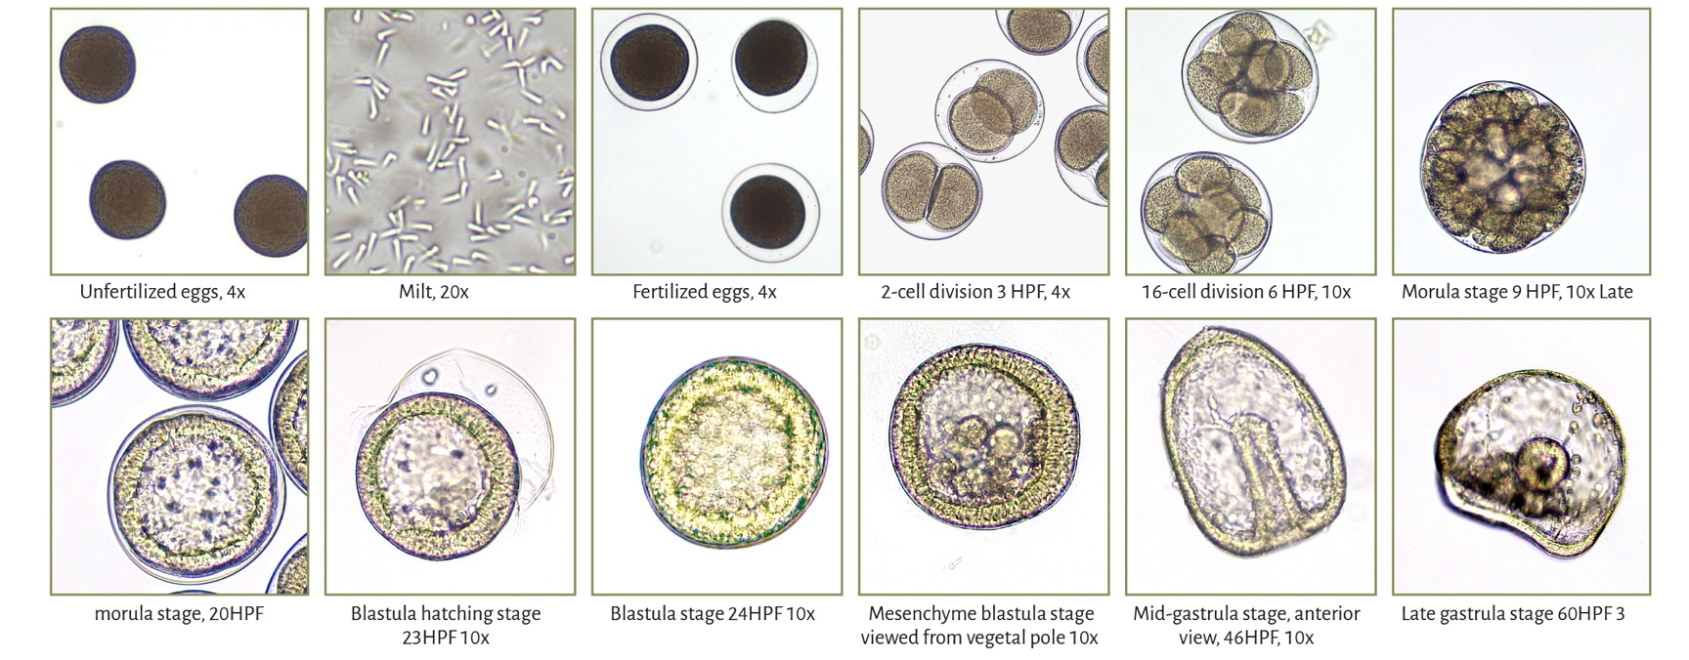

### Pluteus Stages and Rudiment Development

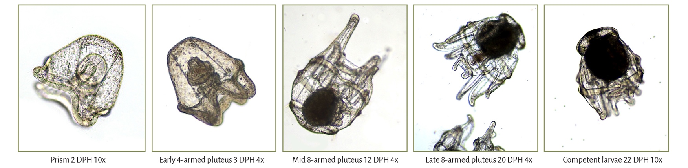

### Settlement and Metamorphosis

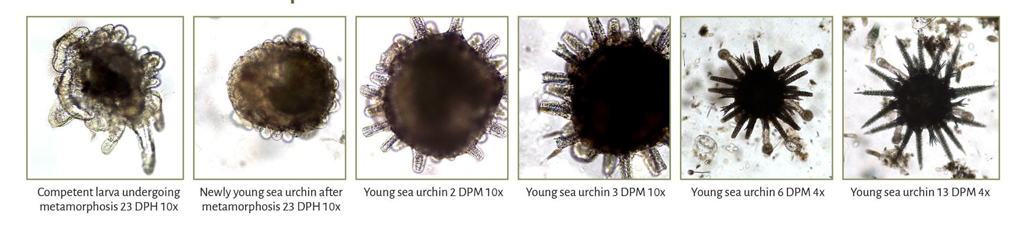

Photos by L. Kogson from **Developmental Stages Of The Green Sea Urchin** (***Strongylocentrotus Droebachiensis*) In Maine: The UMaine CCAR Hatchery Experience** by Luz Kogson, Christopher Teufel, and Steve Eddy, University of Maine Center for Cooperative Aquaculture Research. For a video, visit youtu.be/9PAdbDwPKTM.

## Hatchery production: broodstock and larval food

Sea urchin hatcheries were established throughout Japan beginning in the 1970s to produce juvenile urchins, referred to as seed, for restocking depleted fisheries. Japan has major fisheries for six edible sea urchin species, with hatcheries established for all of them.

Japanese hatchery production has long been publicly subsidized by the federal government and prefectures (states), often through local fisheries cooperatives supported by fishermen and university researchers. Japan has developed highly efficient and effective seed production, which peaked in 1996 at about 90 million seed, ranging in size from 10–25mm. Basic hatchery protocols are similar in most respects for many urchin species, enabling technology transfer to other areas of the world. China, South Korea, and Chile have taken similar approaches as Japan, and these nations now produce large numbers of seed.

Broodstock are typically sourced from the wild and brought into the hatchery for each season’s production. This can either be done several months in advance of spawning or just before spawning. The first approach adds cost but allows farmers to optimize feeding to increase gonad yield and quality and to manipulate the timing of spawning, using temperature and photoperiod cues, to align with hatchery schedules. The second approach of capturing broodstock from the wild during spawning season is less costly because it doesn’t require as much maintenance, but the gonad quality and reproductive timing of wild populations must be predictable and well understood to ensure success. So far, there have been just limited attempts to establish domesticated breeding lines and no efforts at selective breeding programs (Brown and Eddy, 2015).

Broodstock urchins may be spawned using one of three methods. In the first method, which is favored in Japan, the animals are dissected and the gonads removed for fertilization. In the second method, the broodstock are injected with a dilute potassium chloride solution (2–3 mls of 0.5M KCl) to induce gamete release. After injection, they can either be placed upside down over a small dry bowl for 10–20 minutes, or placed upright into a 1L jar containing 0.2μm filtered and UV sterilized seawater for up to 45 minutes as the gametes are released. Sperm motility is microscopically assessed, and satisfactory sperm from 2–3 males are combined for each female to ensure fertilization. The sperm should be diluted to prevent polyspermy; one ml of sperm is diluted in four liters of seawater, and then one ml of the diluted sperm is used to fertilize eggs from one female mixed in four liters of seawater. In the third method, which is less common, ripe urchins are induced to freely spawn in a tank, using a thermal shock (rapid temperature increase) or water shock (rapid drain and refill). This method requires collecting fertilized eggs from the water column for incubation.

Fertilized eggs are incubated in either static buckets or in conical tanks where they can be kept suspended and moving with gentle aeration. Hatcheries typically rinse the eggs on a 105µm screen first to clean them and to remove small eggs that are presumably low quality. The eggs can be incubated at relatively high densities of about 120 eggs/ml and up to 2.4 million eggs can be kept in a 20L conical tank. Green sea urchin egg incubation temperatures can be as low as 4–5°C (39° to 41°F), but they develop faster at 10–12°C (50°–54°F). At 10°C, the eggs hatch in two days, whereupon they are rinsed with filtered seawater and transferred to larval rearing tanks. Eggs can be incubated directly in larval tanks, although this approach may increase microbial loads in the rearing environment. Larvae are sensitive to ciliates and bacteria such as various Vibrio spp., so the use of 0.2µm filtered and UV irradiated seawater is recommended at all stages. Microbial populations can be held in check throughout larval rearing using antibiotics, regular water exchanges, or both.

At the University of Maine hatchery, hatched eggs are stocked at about 7/ml into conical tanks ranging in volume from ≈200 liters to 1m3. Other hatcheries report success with incubating eggs in static containers and stocking out at lower initial densities of 3–5 per ml. Regardless of initial stocking density, numbers typically decline during the larval rearing cycle to ≤1/ml at settlement. Stocking at higher densities can be counterproductive, though the factors leading to loss remain speculative. The rearing cycle for green sea urchin larvae from hatched egg to competent larvae takes 21–27 days at temperatures of 10–12°C.

Sea urchin larvae naturally feed on microalgae. Attempts at the University of Maine hatchery to use commercial algae pastes have been unsuccessful, so live phytoplankton are used. This requires a lead time of 4–6 weeks to establish and scale phytoplankton cultures before the broodstock are spawned. A variety of single-celled, photosynthetic algal species are used around the world and research is still ongoing to determine optimum algal diets. Sea urchin hatcheries usually culture the same species widely used in shellfish and finfish hatcheries, and Dunaliella, Rhodomonas, Isochrysis, and Chaetoceros are some of the more widely used genera. Many Japanese hatcheries rely exclusively upon Chaetoceros gracilis to rear sea urchin larvae.

Phytoplankton densities in the rearing tanks must be closely monitored, as excess feed compromises water quality. As the larvae develop, cell densities are gradually increased from about 5,000 cells per ml to 60,000 cells per ml at the end of the rearing cycle. Larvae can consume 80% of their daily feed ration within 8 hours. To minimize feed loss and fulfill daily ration, water flow can be shut off for 8 hours after feed is added and then resumed for 16 hours until the next feeding. Constant aeration ensures the microalgae remain in suspension and that tank water continues to circulate. Tanks should receive one full water exchange every 24–36 hours. This can be accomplished through a constant slow drip or by daily batch water exchanges. Larvae are evaluated daily to assess competence as they near the end of the larval stage. The goal is to transfer them to new tanks just before settlement. If done too soon, transfer can cause high mortality. If done too late, competent larvae may settle in the larval rearing tank, which is not desirable for hygiene reasons and because feed quality may be less than optimal for the newly settled juveniles.

## Post-settlement management

In nature, chemical cues given off by diatoms and other microscopic organisms found in biofilms induce competent larvae to settle and metamorphose onto suitable surfaces. These biofilms are the larvae’s primary food source for the next few months following settlement and are thus key to survival and growth (Miller and Emlet, 1999). The hatchery nursery environment attempts to replicate natural conditions by providing artificial settlement surfaces coated with biofilms that offer the necessary chemical cues to induce settlement while also being nutritious. Artificial settlement substrates can simply be tank walls, but maximizing settlement surface area in relation to water volume is key for efficient operation. Consequently, settlement tanks (usually raceways) include additional surface area in the form of wavy polycarbonate plates, plastic beads, bricks, pipes, etc. (Figure 7). It is important to note that, in tanks, competent larvae prefer to settle onto vertical surfaces. This is because horizontal surfaces, such as tank bottoms, tend to accumulate fine sediments that inhibit biofilm formation and that may suffocate the newly settled larvae. Likewise, shell hash placed on tank bottoms is also susceptible to silt accumulation, with adverse effects on survival and handling (Brown and Eddy, 2015).

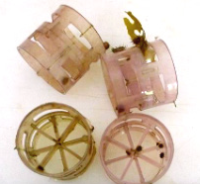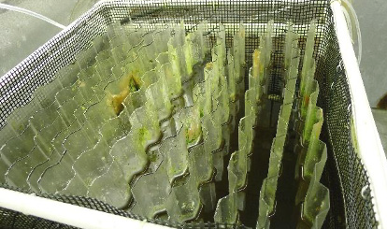

Figure 7. Sea urchin settlement substrates. Left: rack of wavy polycarbonate plates Right: plastic bio-barrels (note the attached juveniles). Substrates must have an established biofilm as feed for the newly settled juveniles. Photos: S. Eddy

In the hatchery, suitable biofilms must be encouraged to flourish on settlement surfaces (a process referred to as ‘conditioning’) before competent larvae are added. Conditioning may require 1–4 months, and it can be accomplished using either natural or selected biofilms. In many regions, a preferred settlement species is Ulvella lens, which is readily cultured, although this is not an option in regions where Ulvella is not naturally found, such as the Gulf of Maine. Various lab-cultured macroalgal species that attach to surfaces, such as Ulva spp., can also be used, though some hatcheries prefer to simply encourage growth of natural biofilms present in unfiltered seawater. Conditioning substrates with selected cultured species has been trialed with some success with green sea urchins by Coleen Suckling et al. at the University of Rhode Island. This approach requires that additional algal species be maintained under culture in the lab.

Newly settled pinhead green sea urchins can’t feed until they develop functional mouthparts, which takes about 7–10 days. This suggests that having adequate nutritional reserves going into settlement is crucial, and indeed, very high mortality often occurs during early settlement. For the first 1–2 months following settlement, the pinheads are microscopic, making evaluation and enumeration difficult. Once they become visible to the unaided eye, it becomes easier to evaluate success. Survival of competent larvae to fully developed seed can be <1%, though Japanese hatcheries using Ulvella lens as the biofilm species report survival rates of about 65% through this stage (Unuma et al., 2015).

For stock enhancement (outplanting) purposes, Japanese and other researchers target a minimum seed size of 15–25mm TD, about the size of a dime, because juveniles of this size are more resistant to predation and handling. When urchin seed is intended for on-growing in enclosed culture gear such as lantern nets or wire cages, then the minimum seed size at transfer depends more on practical considerations such as ease of handling and preventing escape by using small-size mesh enclosures. These considerations might permit the transfer of smaller seed to growers, but nonetheless, a minimum size of about 10mm TD is recommended. Experience shows that most of a hatchery cohort of green sea urchins reach 10mm TD in about 4–6 months following settlement, though it can also take up to a year for some. Nursery culture adds considerably to seed costs since most of it currently takes place in land-based facilities, and the longer it takes, the more it costs to produce the seed. Sea-based nursery methods have been trialed with some success by Larry Harris et al. at the University of New Hampshire, though these approaches entail their own logistical challenges, such as monitoring and preventing biofouling and having suitable lease sites.

Currently, the University of Maine Center for Cooperative Aquaculture Research (CCAR) operates the only sea urchin hatchery in the Northeast US. Seed is offered to growers at little to no cost when CCAR hatchery operations are funded through research grants. However, when research funding is not available, hatchery production must be funded by industry partners. Seed costs are not well established, but are likely to be 2–3 times higher than similarly sized oyster seed. In 2022, Springtide Seaweed established a private sea urchin hatchery in Gouldsboro, Maine. It is anticipated that, over time, this hatchery could provide growers with seed as a commercial venture.

## Growout to market

Green sea urchin farming in the Northeast is still in the early stages of development, and currently there is no commercially successful venture that can be pointed to as a model approach. The various approaches described below have been tested in Maine since 2000 by various researchers, with varying degrees of success (Brown and Eddy, 2015). Though they all show promise, no one has yet demonstrated profitability rearing sea urchins. Regardless of approach, sea urchin growers need to keep the following environmental parameters in mind:

* Water temperature should not exceed 18°C (64°F), and ideally should be <16°C (61°F) most of the time.
* Sea urchin seed should not be planted out on ocean sites in warm summer months (July – October), as this may result in high mortality rates if temperatures exceed tolerance.
* Salinity should be at least 20ppt, and preferably 30ppt to full-strength seawater.
* Water flow should be moderate to strong. Sea urchins do poorly at low water exchange rates.

## Permit requirements

Sea urchin fishery and aquaculture regulations may differ between Northeast US states. In Maine, it is unlawful to possess sea urchins without having a sea urchin harvester license, dealer or processor license, or aquaculture permit. Harvesters may only possess sea urchins of legal harvest size, and they may not hold more than their daily zone allowance. Prospective sea urchin growers are not subject to these same possession limits, but must either have a permitted lease site or a land-based aquaculture license from the Maine Department of Marine Resources. The permit must include or specify sea urchins as a culture species. In addition, a discharge permit may be required from the Maine Department of Environmental Protection if growers intend to feed their sea urchins with algae sourced from outside the sites’ boundaries or with formulated feed. Additional regulations and permit information may be found on each state agency’s respective web site.

## Sea ranching

Sea ranching is the least costly and simplest approach for growing seed urchins to market. The seed is simply distributed on-bottom at a lease site to ‘free-range.’ The urchins are not fed, constrained, or handled by the grower, so main expenses are limited to hatchery seed, aquaculture lease permitting, and diving/harvesting. Optimal lease sites have moderate to strong currents; ledge, cobble, or shell hash bottom; abundant growth of preferred macroalgal feed species such as sugar kelp or Alaria; and depths that don’t exceed those for comfortable diving (i.e., <20m). The minimum permitted lease area in Maine is one acre, but three to five acres are probably better for sea ranching, to allow room for roaming. There is no formula for determining how many seed should be released per unit area, as this will widely vary depending on local conditions and feed availability. Likewise, growth and survival rates are unpredictable, though it’s likely that it will take at least three years for the seed to reach the minimum market size of about two inches TD. This unpredictability is one of the main disadvantages of sea ranching. Other challenges include preventing poaching and controlling out-migration. Sea urchins can migrate considerable distances and leave the lease site altogether. However, five years’ experience at a commercial lease near Lamoine, Maine shows that sea urchins will remain within a lease area when food resources (primarily sugar kelp in this instance) are abundant. The lease area consists of hard bottom, while the area surrounding it is soft mud. These factors may have also contributed to retention. Those interested in bottom culture may face opposition from fishermen if their site occupies fishing habitat. Site selection is a critical step in developing a farming business (Morse and Davis, 2016), and existing uses are an important factor in decision-making.

## Tank culture for grow-out to market

Tank culture is at the opposite extreme of sea ranching. It is the costliest and most labor-intensive approach, while also offering the most capacity to control environmental factors such as temperature, water flow, and feeding to facilitate fast growth and high survival. Under optimum tank-culture conditions, 20–40% of the population can attain market size within two years, and up to 80% of the seed can survive past three years (as observed at the CCAR). Optimum conditions include maintaining water temperatures between 10°C to 15°C (50 to 59°F) year-round, providing moderate to high flow rates, and feeding to satiation. Successful tank farms will maximize efficiency by minimizing their footprint, i.e., by growing as many urchins as possible in the smallest area possible. Stacked raceways or troughs are advised. Large tanks or raceways with a high proportion of bottom area in relation to side walls are not advisable because urchins prefer vertical surfaces. Vertical structures can be added to tanks and/or tanks with sloping sides can be used (Figure 8).

Urchin tank stocking density is a function of test diameter and surface area coverage, and not of weight. As urchins grow and test diameter increases, fewer urchins can occupy any given surface area, but there is no formula currently available to cover the range of test diameters. Based on over ten years of growing sea urchins in tanks at the CCAR, growers should try to maintain about 80% surface coverage with 20% open area. Unfortunately, there is no easy way to measure this other than subjectively by eye. Regular size grading and thinning is essential to allow each urchin enough space to access feed while avoiding spine injury from neighbors. Fresh macroalgae is a suitable feed for tank culture and dried seaweed can also be used, but better performance is seen with formulated diets having higher protein content than seaweed. At present, a diet sold by the Urchinomics group is the only commercially available formulated feed for sea urchins, and it can only be obtained under special license. Catfish diets containing about 20% protein have been successfully used at the CCAR, and they have the advantage of being relatively low cost compared to salmonid diets. Note that protein and carotenoid pigment composition strongly influence uni quality, and formulated diets intended for fish may impart a bitter taste or brown coloration. Gonad yields, flavor, and color can all be improved by feeding the urchins for 6–12 weeks before harvest with fresh macroalgae or with properly formulated diets. One strategy is to feed the urchins a low-cost formulated diet with moderately high protein content to encourage fast growth, followed by a finishing diet to optimize gonad yield and quality (Eddy et al., 2012).

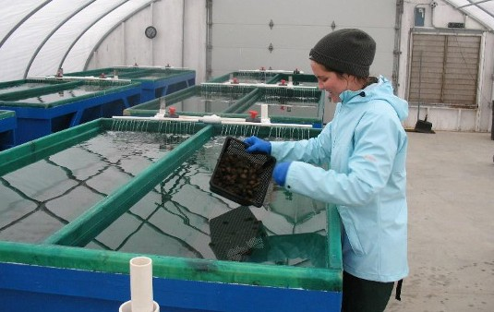

Figure 8. Green sea urchins can be grown in V-shaped raceways. Photo: S. Eddy

## Gonad enhancement

Gonad enhancement, also known as bulking, is a hybrid fisheries/aquaculture approach in which wild urchins are captured from the fishery, brought into captivity, and fed an optimized diet for 6–12 weeks to improve (bulk up) their gonad yields and quality for market (James and Evenson, 2022). Bulking may be an economically viable approach to enhance any commercial sea urchin fishery, and it is also being trialed by some as a way to mitigate the environmental consequences of sea urchin barrens in an approach known as Urchinomics. Under Urchinomics, sea urchins are removed from barrens for gonad enhancement with the idea that the kelp can regrow when urchin abundance is reduced. The increased market value derived from gonad enhancement encourages divers to remove what are otherwise low-value urchins from the barrens.

Gonad enhancement is probably a necessity for anyone growing sea urchins from seed to market, as their profits largely depend on gonad yield and quality. Gonad enhancement can be done in land-based tank systems or in sea-based cage systems, and it can potentially improve yields from <10% to 20–25% within 12 weeks, while also improving color and flavor attributes. The key requirement is that the urchins are kept constantly supplied with fresh, high-quality macroalgae such as sugar kelp, Alaria, or dulse, or with a specialty formulated feed.

A proprietary diet specifically designed for sea urchins has emerged in recent years. This was initially developed by the Norwegian Nofima group and was thus initially referred to as the ‘Nofima’ diet (e.g., Siikavuopio and Mortensen, 2015). It has since been globally licensed to Urchinomics (https://www.urchinomics.com) and undergone further formulation refinements (Suckling et al., 2022). This diet can yield marketable uni in wild-collected sea urchins within as little as 8–12 weeks. At present, this feed is not available off-the-shelf, but rather only through selective commercial agreements that align with the company’s intent to harvest sea urchins as a means to protect diminishing kelp forests (Suckling et al., 2022).

## Bottom cages

Bottom cages are currently being tested by some growers. These can vary in size and material, and are accessible by diver or by lifting the cage onto a work vessel. Since urchins are not filter feeders, they will need to be periodically supplied with fresh macroalgae (perhaps once per week), ideally sourced from the site itself. Sea urchins will also graze upon fouling organisms that attach to the cage, making biofouling control less of a concern. Access to fouling organisms as feed can reduce the need to add seaweed, especially for smaller urchins. Growers report placing seed urchins into bottom cages or other enclosures in the fall, leaving them alone and unfed over the winter, and finding the urchins have doubled in size by early spring. As seed urchins grow, they will need to be thinned into new cages with progressively larger mesh sizes that continue to prevent escapement but facilitate maximum water flow.

## Pearl and lantern nets

Some growers are also experimenting with pearl and lantern nets normally used for bivalve culture. Feeding requirements are the same as with bottom cages, and the same observation regarding utilization of fouling organisms as feed by the sea urchins also apply. The potential utility of sea urchins for biofouling control in bivalve aquaculture is currently under investigation, as described next.

## Sea urchin and bivalve co-culture

Co-culture of sea urchins in enclosed gear with bivalves such as oysters, mussels, or scallops shows promise for biofouling control and enhanced income (Bartsch, 2011). Under this approach, urchin seed are included in the enclosed gear (bottom cages, lantern nets, etc.) with similarly-sized shellfish seed (Figure 9). The optimum sea urchin-to-bivalve ratio has yet to be determined, but it is unlikely to be 1:1 and more likely to fall in the range of one sea urchin to every 5–20 bivalves. Another important consideration is that large sea urchins may prey upon smaller bivalves, but the size differential at which this may be a concern hasn’t yet been established. If urchins are not fed while co-cultured with bivalves because the grower wishes to encourage grazing upon biofouling organisms, then large, hungry sea urchins could turn their attention to small shellfish. As the urchins approach market size, they will need to be segregated from the bivalves and fed for gonad enhancement as described earlier. Importantly, many shellfish farms are located where water temperatures are too warm (>18°C/64°F)  
 for the co-culture approach.

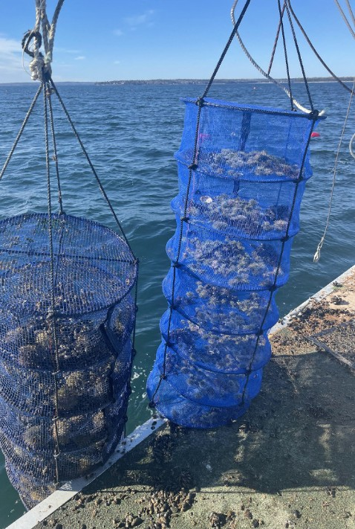

Figure 9. Green sea urchins in lantern nets at seaweed farm. Photo: S. Redmond

## Sea urchin and seaweed co-culture

Raising sea urchins as part of a seaweed farming operation is another possible approach. Seaweed species currently under cultivation in the Northeast, such as sugar kelp, skinny kelp, and winged kelp, are preferred feeds for green sea urchins. The urchins can be grown in lantern nets, pearl nets, or other enclosed gear suspended from the same lines used to grow the seaweed, suspended on separate lines, or in bottom cages. During the seaweed growing season (December – May), urchins can be fed with trimmed, thinned, or fouled seaweed from the farm site. During the off-season when seaweed isn’t being grown at the site, they can either be left unfed to subsist on fouling organisms and detritus, or they can be fed dried seaweed from the harvested crop that the grower may not be otherwise able to market (e.g., has inferior quality for human consumption; stipes and trimmings). As with sea urchin/bivalve co-culture, sea urchins would be a secondary crop but with the advantage that the main crop (seaweed) happens to be their preferred food.

## Disease and handling

There have been few observations of widespread disease in cultured sea urchins. Frequent or rough handling is often the primary stressor leading to bacterial infections, usually from marine Vibrio spp. Sea urchins should be handled as little as possible, and when they are, care should be taken to avoid spine breakage. Bacterial infections usually appear as areas of purplish bruising on the test, and these bruises likely originate at broken spines (Figure 10). Sea urchins with this condition should be removed from the population to avoid bacterial proliferation, as there is currently no treatment.

In the summers of 1980 and 1981, mass mortalities of green sea urchins were observed along the southern coast of Nova Scotia. The cause was proposed to be an amoeba identified as Paramoeba sp. Researchers hypothesized that the amoeba had been stirred up from ocean sediments following unusually strong coastal storms. Disease symptoms included muscle degeneration in the tube feet, spines, and mouthparts, resulting in loss of attachment, cessation of feeding, immobility, and death (Jones and Scheibling, 1985). Farmed sea urchins may possibly be susceptible to infections from this amoeba or from similar species.

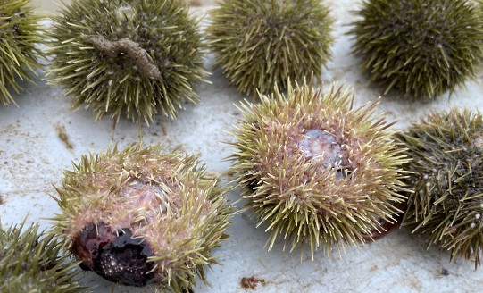

Figure 10. Green sea urchins with purple spot bacterial infection. Photo: L. Kogson

## Marketing

Echinoculture offers some marketing advantages over the traditional fishery. Urchin farmers do not have the same constraints as harvesters regarding legal size and possession limits. Legal capture size in Maine is between a minimum 52mm (2 1/16 inches) and a maximum of 76mm (about 3 inches), but growers can possess and sell any size, so long as it comes from a farm. Growers can also potentially market year-round, unlike fishermen who operate between September and March.

Quality is critical when marketing sea urchins, and aquaculture potentially gives growers more control over gonad yield and quality. Premium sea urchin roe has a pale yellow to orange or even gold color, while brownish hues indicate poor quality. The texture should be firm but have a soft, smooth mouthfeel. A runny texture is undesirable and indicates the urchin is approaching spawning. The best flavor is described as umami, a savory/sweetness known as the ‘fifth taste’ in humans, complementing the other tastes of sweet, sour, bitter, and salty. In urchin roe, umami is accompanied by the briny flavor associated with oysters, with a subtle hint of sweet aftertaste. There should be no trace of bitterness or fishiness. Using the simple gonad enhancement methods described previously, growers can practically guarantee their green sea urchins meet these criteria while yielding up to 25% roe by weight. A major caveat, however, is that sea urchin gonad development is seasonal. Under ambient (natural) conditions, green sea urchins enter reproductive condition beginning in March and their roe becomes runny and unmarketable. Gonad development occurs in the summer following each spawning cycle, with peak yields and flavor occurring during cold winter months. This is a primary reason why the fishery takes place from September through March, and sea-based growers are subject to the same seasonal pattern. However, growers with land-based facilities can use chillers and lighting control to manipulate the normal reproductive pattern and market high-quality roe out of season.

Sea urchin growers are advised to develop new markets beyond traditional uni processing. As of this writing, just two sea urchin processors remain operating in the Portland area out of the dozen or so that once served the industry in its heyday. Most of Maine’s original sea urchin processors were established by Japanese and other Asian businesspeople with a deep knowledge of product quality and respect for tradition. The traditional view is that wild-sourced sea urchins are superior to farmed sea urchins, which have sometimes been found to have off-color or bitter taste. Processors are unlikely to accept farmed sea urchins (other than from sea ranching), or to pay the premium price needed to make farming operations profitable. In addition, processors require very high volumes of sea urchins 2–3 times per week over the course of several months to profitably operate. Purchasing a few thousand sea urchins from a grower is simply not worth the trouble. Sea urchin farming at a scale large enough to satisfy processing demand will likely take years to develop.

Growers might also find it challenging, and quite labor intensive, to profitably process urchins into uni themselves as part of their farming operation. Extracting, processing, and marketing finished uni is an art carried out at factory-scale. It is mostly done by hand by skilled workers, and at this point mechanization doesn’t seem feasible (Figure 11).

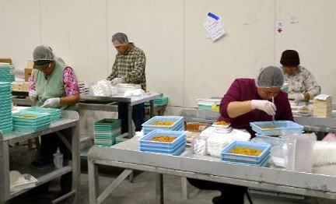

Fortunately, urchin farmers have opportunities other than the traditional uni tray market. One potentially lucrative approach is to market farmed sea urchins by the piece as whole live animals directly to end users. Although sea urchin roe quality rapidly deteriorates once the animal dies, the animals can be kept alive out of water for a week or more without affecting roe quality, so long as they are held under moist, refrigerated conditions. This means they can be successfully shipped long distances, much like lobsters or shellfish. Indeed, during the early years, Maine’s fishery companies found it quite profitable to ship live sea urchins to Japan for processing. Today, an internet search can provide examples of companies from Maine and elsewhere offering live sea urchins for sale.

Figure 11. Green sea urchin roe being processed in Portland, Maine. Photo: S. Eddy

In Japan, whole, live sea urchins are served live to be opened at the table. Diners pay a premium of $5–10 per animal for this experience, and a similar market could be developed in the US. Japanese people also use sea urchin roe in condiments such as preserved jarred pastes. Similarly, in Italy, Spain, Greece, and other Mediterranean countries, sea urchin roe is used as a condiment and ingredient in various dishes and sauces. Numerous internet articles and YouTube videos describe how creative chefs in the US use sea urchin roe to add flavor, body, and novelty to dishes. These are all marketing opportunities for enterprising growers.

## Summary

Green sea urchin gonads, known as roe or uni, are a high value fishery product, but wild stocks have declined due to overfishing and other causes. Hatchery methods developed in Japan since the 1960’s have made full-cycle aquaculture of this species feasible, and the University of Maine Center for Cooperative Aquaculture Research (CCAR) operates a small hatchery for green sea urchins to encourage commercial development in the Northeast US. However, grow-out methods are still under development, and it is unclear if sea urchin farming can be profitable. Grow-out methods include free-range sea ranching, tank culture, gonad enhancement, and methods adapted from shellfish aquaculture, including co-culture of shellfish, seaweed, and urchins (Figure 12). Juvenile urchins achieve market size of about two inches in diameter in 2–5 years depending on rearing temperatures, feeding, and genetic variables. Optimum rearing temperatures are 12–15°C (54–59°F) with mortality occurring above 18°C (64°F). Green urchins prefer kelp and red seaweed species but can eat a variety of foods, including fouling organisms often found on shellfish cages. Attention to roe quality and targeted marketing to select consumers will help ensure maximum economic return

|  |  |  |  |  |  |  |  |
| --- | --- | --- | --- | --- | --- | --- | --- |
|  | **Sea ranch** | **Tank farm** | **Gonad enhancement** | **Bottom cages** | **Hanging gear** | **Bivalve co-culture** | **Seaweed co-culture** |
| Permit & lease requirement (Maine) | 1+ acre bottom lease | land-based permit; DEP discharge permit | LPA or land-based permit; DEP dis- charge permit | LPA or 1+ acre | LPA or 1+ acre | multi-species LPA or 1+ acre | multi-species LPA or 1+ acre |
| Labor inputs | minimal | labor-intensive; capital-intensive | labor-intensive | low | moderate | moderate | moderate |
| Equipment | boat, diving | extensive: building, tanks, pumps, heating/chilling | LPA: cages land- based: extensive | wire cages, boat, diving | lantern nets, pearl nets | sea urchins are included with shellfish | lantern nets, pearl nets, or bottom cages |
| Feed | none | seaweed + formulated diets | seaweed and/or formulated diets | seaweed or natural biofilms and detritus | natural biofilms; seaweed | natural biofilms; seaweed | seaweed from site |
| Growing season | year-round | year-round | Sept-May | year-round | year-round | with shellfish | year-round |
| Time to market | 3+ years | 2-3 years | 12 weeks | 3+ years | 3+ years | 3+ years | 2-3 years |
| Market & value | processors dock value (per lb.) | specialty high value (per piece) | specialty high value (per piece) | specialty high value (per piece) | specialty high value (per piece) | specialty high value (per piece) but fewer animals are grown than with other methods | specialty high value (per piece) |
| Main advantages | low cost | fast growth, high return | fast to market, can use wild urchins | low cost | can be used with other species | add-on to shellfish gear, biofouling mitigation (unproven) | uses farmed seaweed waste trimming from site as feed |
| **Main disadvantages** | potentially low return | most costly | costly, labor- intensive | requires diving on or lifting cages | biofouling could be an issue | biofouling could be an issue; modest revenue source | additional gear for seaweed farmer |

Figure 12. Table of methods for urchin production. Note that these are tailored for Maine, USA; requirements and conditions in other locations may be different. S. Eddy

## Authors

Stephen D. Eddy, University of Maine Center for Cooperative Aquaculture Research, 33 Salmon Farm Rd., Franklin, ME 04634 [steve.eddy@maine.edu](mailto:steve.eddy@maine.edu)

Dana L. Morse, Maine Sea Grant College Program and University of Maine Cooperative Extension, 193 Clarks Cove Road, Walpole, ME 04573 [dana.morse@maine.edu](mailto:dana.morse@maine.edu)

Coleen C. Suckling, University of Rhode Island, 129 Woodward Hall, 9 East Alumni Ave, Kingston, RI, 02881 [coleensuckling@](mailto:coleensuckling@uri.edu) [uri.edu](mailto:coleensuckling@uri.edu)

Luz M. Kogson, University of Maine Center for Cooperative Aquaculture Research, 33 Salmon Farm Rd., Franklin, ME 04634 [luz.kogson@maine.edu](mailto:luz.kogson@maine.edu)

## 

## Literature Cited

Bartsch, A., 2011. Co-culturing green sea urchins, Strongylocentrotus droebachiensis, with blue mussels, Mytilus edulis, to control biofouling at an integrated multi-trophic aquaculture site (Doctoral dissertation, University of Victoria).

Brown, N.P. and Eddy, S.D. eds., 2015. Echinoderm aquaculture. Hoboken: Wiley Blackwell.

Eddy, S. D., Brown, N.P., Watts, S. A., and Kling, A., 2012. Growth of juvenile green sea urchins Strongylocentrotus droebachiensis fed formulated feeds with varying protein levels compared with a macroalgal diet and a commercial abalone feed. Journal of the World Aquaculture Society 43(2):159–173.

James, P. and Evensen, T., 2022. Live transport of the green sea urchin (Strongylocentrotus droebachiensis) in air and immersed in seawater and the impact on subsequent roe en- hancement after in‐water transport. Aquaculture Research, 53(15), pp.5205–5213.

Johnson, T.R., Wilson, J.A., Cleaver, C. and Vadas, R.L., 2012. Social-ecological scale mismatches and the collapse of the sea urchin fishery in Maine, USA. Ecology and Society, 17(2).

Jones, G.M. and Scheibling, R.E., 1985. Paramoeba sp.(Amoe- bida, Paramoebidae) as the possible causative agent of sea urchin mass mortality in Nova Scotia. The Journal of Parasitology, pp.559–565.

James, P., Siikavuopio, S.I. and Mortensen, A., 2015. Sea urchin aquaculture in Norway. Echinoderm Aquaculture, pp.147–173.

Miller, B.A. and Emlet, R.B., 1999. Development of newly metamorphosed juvenile sea urchins (Strongylocentrotus franciscanus and S. purpuratus): morphology, the effects of temperature and larval food ration, and a method for deter- mining age. Journal of Experimental Marine Biology and Ecology, 235(1), pp.67–90.

Morse, D.L. and Davis, C.V., 2016. Site Selection. Fact Sheet: Aquaculture in Shared Waters program. Island Institute, Rockland, ME. 4p.

Steneck, R.S., Leland, A., McNaught, D.C. and Vavrinec, J., 2013. Ecosystem flips, locks, and feedbacks: the lasting effects of fisheries on Maine’s kelp forest ecosystem. *Bulletin of Marine Science*, 89(1), pp.31–55.

Stephens, R.E., 1972. Studies on the development of the sea urchin Strongylocentrotus droebachiensis. I. Ecology and nor- mal development. TheBiologicalBulletin, 142(1), pp.132–144.

Suckling, C.C., Zavell, M, Byczynski, A, Takeda, B., 2022. Assessing the market potential for the unexploited Atlantic purple sea urchin, Arbacia punctulata. Frontiers in Marine Science. 9: 895061.

Swan, E.F., 1961. Some observations on the growth rate of sea urchins in the genus Strongylocentrotus. TheBiologicalBulletin, 120(3), pp.420–427.

Unuma, T., Sakai, Y., Agatsuma, Y., and Kayaba, T., 2015. Sea Urchin Aquaculture in Japan. In: N.P. Brown and S.D. Eddy eds., Echinoderm Aquaculture. John Wiley Publishers, New York. Pp. 77–126.

Vadas, R.L. and Beal, B.F., 1999. Temporal and spatial variability in the relationships between adult size, maturity and fecundity in green sea urchins: the potential use of a roe- yield standard as a conservation tool. Report to the Maine Department of Marine Resources, 136.

Vadas Sr, R.L., Smith, B.D., Beal, B. and Dowling, T., 2002. Sympatric growth morphs and size bimodality in the green sea urchin (Strongylocentrotus droebachiensis). EcologicalMonographs, 72(1), pp.113–132.

Walker, C.W. and Lesser, M.P., 1998. Manipulation of food and photoperiod promotes out-of-season gametogenesis in the green sea urchin, *Strongylocentrotus droebachiensis*: implications for aquaculture. *Marine Biology*, 132, pp.663–676.\

## 

## Additional reading

Brown, N.P. and S.D. Eddy, eds., 2015. Aquaculture of Echinoderms. John Wiley and Sons, New York, NY.

Redmond, S., 2021. Development of Integrated Seaweed and Green Sea Urchin Nursery Strategies for the Northeast. Sustainable Agriculture Research and Education Projects (SARE). [https://projects.sare.org/project-reports/fne21-992/](https://projects.sare.org/project-reports/fne21-992/" \o "Link to project)

Redmond, S. and A. Angera., 2021. Sea Urchins: Integrating New Crops into Seafarms in Maine. Sustainable Agriculture Research and Education Projects (SARE). [projects.sare.org/ information-product/sea-urchins-integrating-new-crops-into- seafarms-in-maine/](https://projects.sare.org/information-product/sea-urchins-integrating-new-crops-into-seafarms-in-maine/)

## 

## Acknowledgments

This work was produced with support from the Northeastern Regional Aquaculture Center (NRAC), which not only directly funded this publication but also funded previous research into green sea urchin aquaculture. Portions of this work and ongoing studies were funded by the Atlantic States Marine Fisheries Commission (ASMFC).